Data Aquisition Measurements

Donnerstag, 12. März 2020

10:16

|  |  |  |  |  |  |  |  |  |  |  |  |
| --- | --- | --- | --- | --- | --- | --- | --- | --- | --- | --- | --- |
| **Nr** | **Angle** | **Dir** | **Freq** | **Limit** | **Preamp** | **Rate** | **Struct** | **Temp** | **Time** | **Voltage** | **dB** |
| **430** | 45 | Down | 17 | 0.20 | False | 8 | Plusses | 30 | 600 | 2.5 | 0.0100 |
| **431** | 45 | Up | 17 | 0.20 | False | 8 | Plusses | 30 | 600 | 2.5 | 0.0100 |
| **432** | 45 | Down | 17 | 0.10 | True | 16 | Plusses | 30 | 1024 | 2.5 | 0.0025 |
| **433** | 45 | Up | 113 | 0.10 | True | 16 | Plusses | 30 | 1024 | 2.5 | 0.0020 |
| **434** | 45 | Up | 113 | 0.20 | True | 32 | Plusses | 30 | 512 | 2.5 | 0.0200 |
| **435** | 45 | Down | 113 | 0.10 | True | 16 | Plusses | 30 | 1024 | 5.0 | 0.0050 |
| **436** | 45 | Down | 113 | 0.20 | True | 8 | Plusses | 30 | 1024 | 5.0 | 0.0050 |
| **437** | 45 | Up | 113 | 0.15 | False | 8 | Plusses | 30 | 768 | 5.0 | 0.0050 |
| **438** | 45 | Down | 113 | 0.10 | False | 4 | Plusses | 30 | 2048 | 5.0 | 0.0100 |
| **439** | 45 | Down | 113 | 0.10 | False | 16 | Plusses | 30 | 1024 | 5.0 | 0.0050 |
| **440** | 45 | Up | 113 | 0.10 | False | 32 | Plusses | 30 | 512 | 5.0 | 0.0050 |
| **441** | 45 | Down | 113 | 0.10 | False | 32 | Plusses | 30 | 512 | 5.0 | 0.0050 |
| **442** | 45 | Up | 113 | 0.10 | False | 4 | Plusses | 30 | 2048 | 5.0 | 0.0050 |
| **443** | 45 | Down | 113 | 0.10 | False | 8 | Plusses | 20 | 2048 | 5.0 | 0.0050 |
| **444** | 45 | Up | 113 | 0.10 | False | 8 | Plusses | 20 | 2048 | 5.0 | 0.0050 |
| **445** | 45 | Down | 113 | 0.10 | False | 2 | Plusses | 10 | 2048 | 5.0 | 0.0050 |
| **446** | 45 | Down | 113 | 0.10 | False | 8 | Plusses | 15 | 2048 | 5.0 | 0.0050 |
| **447** | 45 | Up | 113 | 0.10 | False | 8 | Plusses | 15 | 2048 | 5.0 | 0.0050 |
| **448** | 45 | Down | 113 | 0.10 | False | 4 | Plusses | 15 | 2048 | 5.0 | 0.0050 |
| **449** | 45 | Up | 113 | 0.10 | False | 4 | Plusses | 15 | 2048 | 5.0 | 0.0050 |
| **450** | 45 | Down | 113 | 0.10 | False | 8 | Empty | 15 | 2048 | 5.0 | 0.0050 |
| **451** | 45 | Up | 113 | 0.10 | False | 8 | Empty | 15 | 2048 | 5.0 | 0.0050 |
|  |  |  |  |  |  |  |  |  |  |  |  |
| **452** | 80 | Down | 17 | 0.30 | False | 8 | Plusses | 15 | 1024 | 5.0 | 0.0150 |
| **453** | 80 | Up | 17 | 0.30 | False | 8 | Plusses | 15 | 1024 | 5.0 | 0.0150 |
| **454** | 80 | Down | 17 | 0.15 | False | 8 | Plusses | 15 | 2048 | 5.0 | 0.0050 |
| **455** | 80 | Up | 17 | 0.15 | False | 8 | Plusses | 15 | 2048 | 5.0 | 0.0050 |
| **456** | 80 | STATIC | 17 | 0 | False | 8 | Plusses | 15 | 2048*60 | 5.0 | 0 |

SR830 as DAQ

Donnerstag, 12. März 2020

10:16

Using the SR830 internal Storage as DAQ. Getting data via FAST mode.

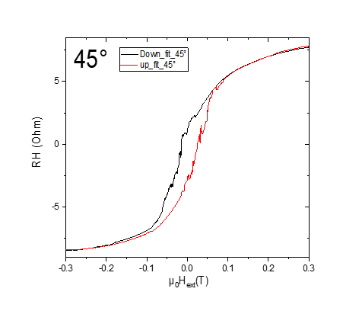

m430: SR830DAQ scheduled without preamp

Donnerstag, 12. März 2020

10:17

|  |  |
| --- | --- |
| Angle of sensor θ | *+45* |
| Temp | 30 K |
|  | **Plusses** |
|  | |  |  |  |  | | --- | --- | --- | --- | |  | ***1-13*** |  | *8-6* | | ***Gate (0V)*** | ***9 - 4*** |  | ***14 - 7 (no Preamp)*** | |
|  | *sweeping from +200mT → -200mT*  *measuring every 10mT steps* |
| Resistance Box | |  |  |  |  |  |  | | --- | --- | --- | --- | --- | --- | |  | *1 MΩ* |  | 13,5 |  |  | |  | *1 MΩ* |  | *1* |  | *1* | |
|  | |  |  |  |  |  |  | | --- | --- | --- | --- | --- | --- | | Sens | 20 μV |  | 2,5 V | *f* | *17 Hz* | | *τ* | *100 ms* | *Input A-B* | *AC* | *Ground* | *Normal Reserve* |   *DAQ settings: Rate: 8 Hz* |
| Period of measurement (min) | *600 sec for each field* |
| Data files | in Folder NewMeasurements2020\m430\m430.5* |

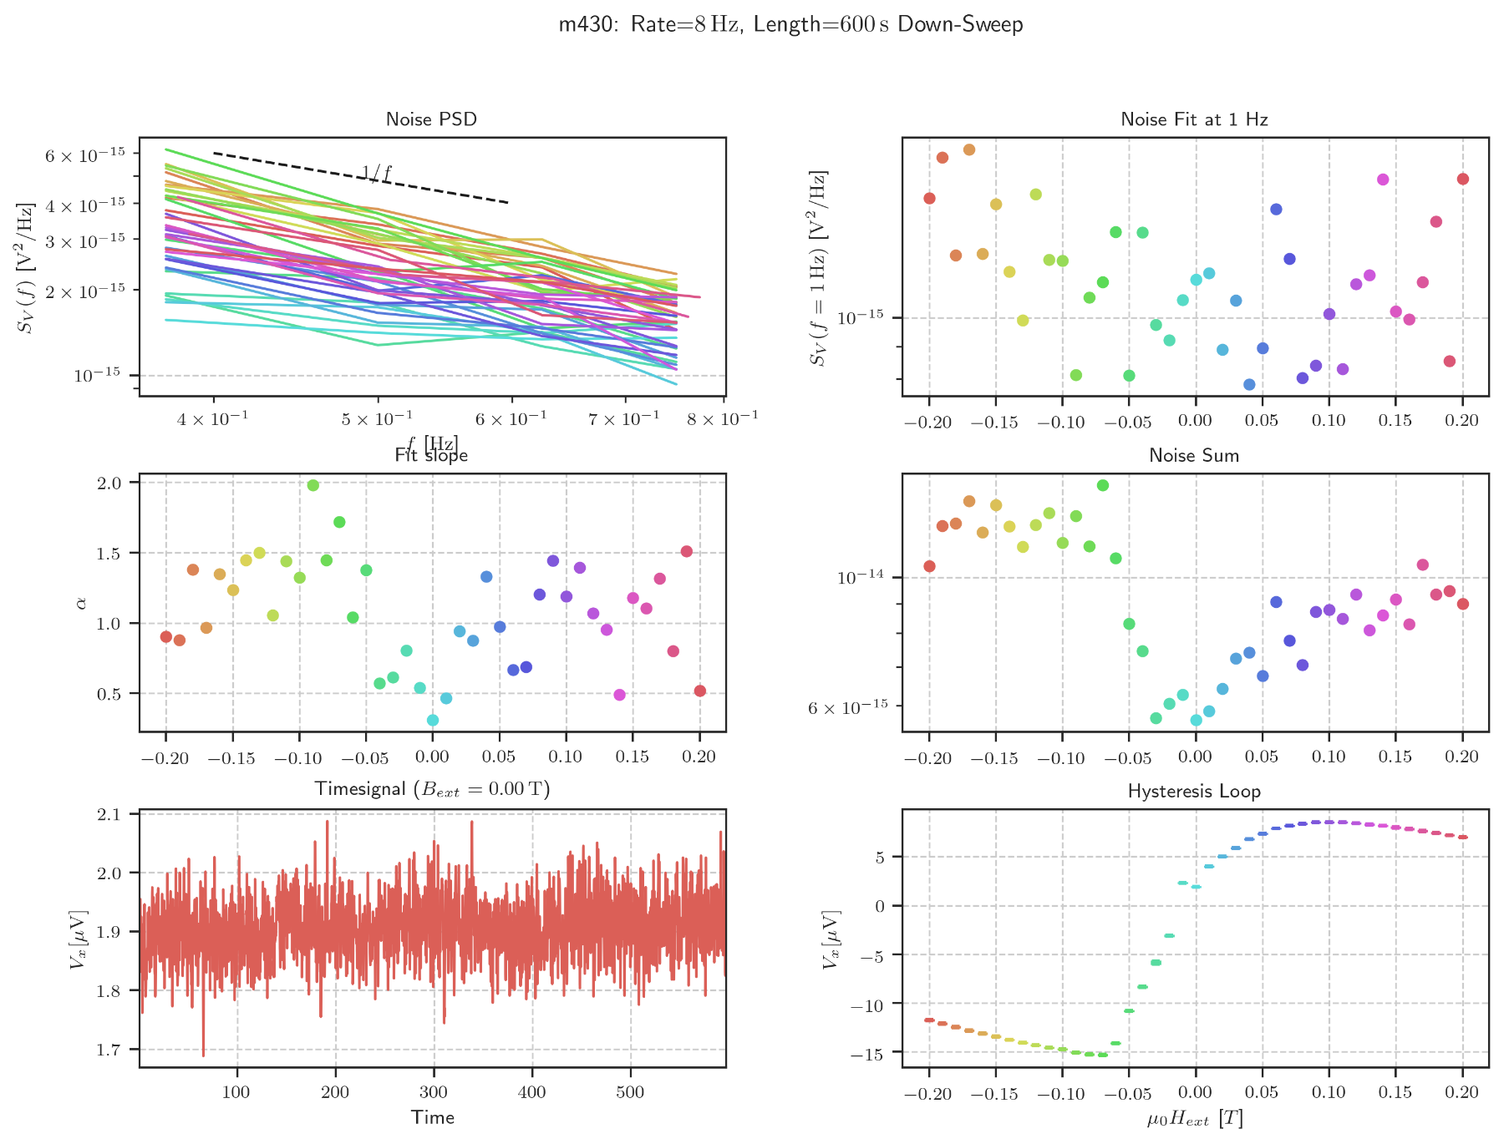

m430: Problem not stopping SR830DAQ

Donnerstag, 12. März 2020

12:21

At some field vaules the measurement didn't stop, but continue for the next field (e.g. this data contains field .2T in range 0-600s and field .19T in the second half):

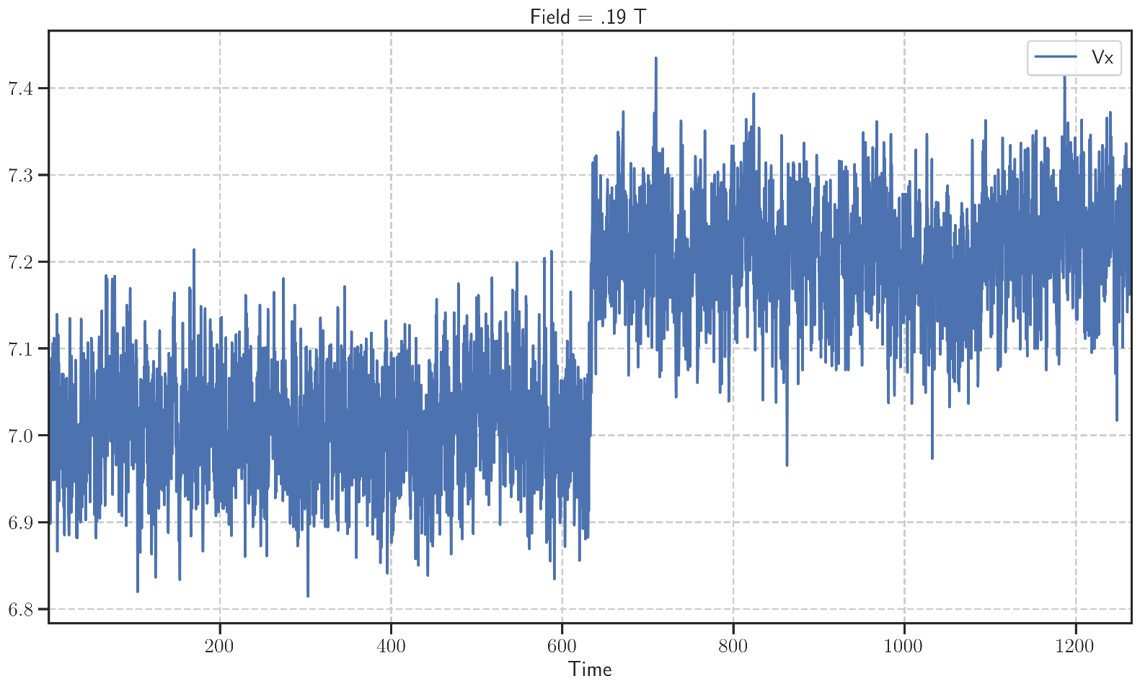

Splitting these data files manually.

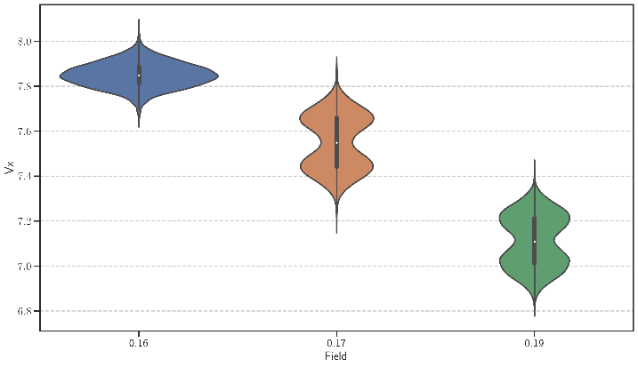

Fields to split:

* .19
* .17
* -.2

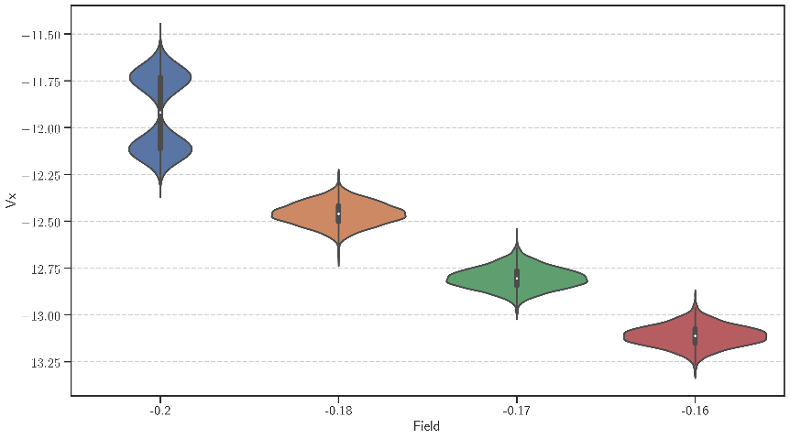

m431: SR830DAQ scheduled without preamp

Donnerstag, 12. März 2020

10:17

|  |  |
| --- | --- |
| Angle of sensor θ | *+45* |
| Temp | 30 K |
|  | **Plusses** |
|  | |  |  |  |  | | --- | --- | --- | --- | |  | ***1-13*** |  | *8-6* | | ***Gate (0V)*** | ***9 - 4*** |  | ***14 - 7 (no Preamp)*** | |
|  | *sweeping from +200mT → -200mT*  *measuring every 10mT steps (41 different steps)* |
| Resistance Box | |  |  |  |  |  |  | | --- | --- | --- | --- | --- | --- | |  | *1 MΩ* |  | 13,5 |  |  | |  | *1 MΩ* |  | *1* |  | *1* | |
|  | |  |  |  |  |  |  | | --- | --- | --- | --- | --- | --- | | Sens | 20 μV |  | 2,5 V | *f* | *17 Hz* | | *τ* | *100 ms* | *Input A-B* | *AC* | *Ground* | *Normal Reserve* |   *DAQ settings: Rate: 8 Hz* |
| Period of measurement (min) | *600 sec for each field* |
| Data files | in Folder NewMeasurements2020\m431\m431* |

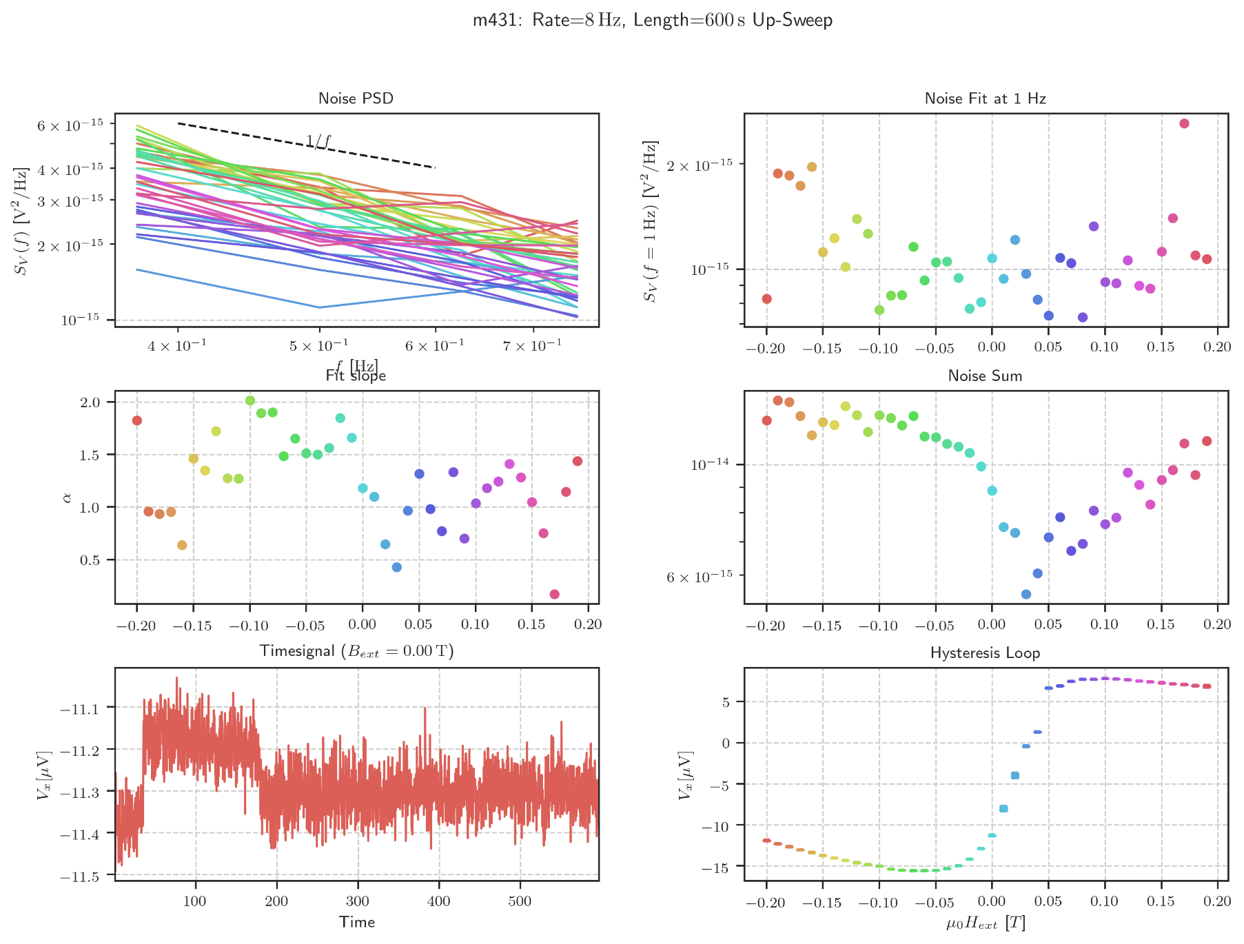

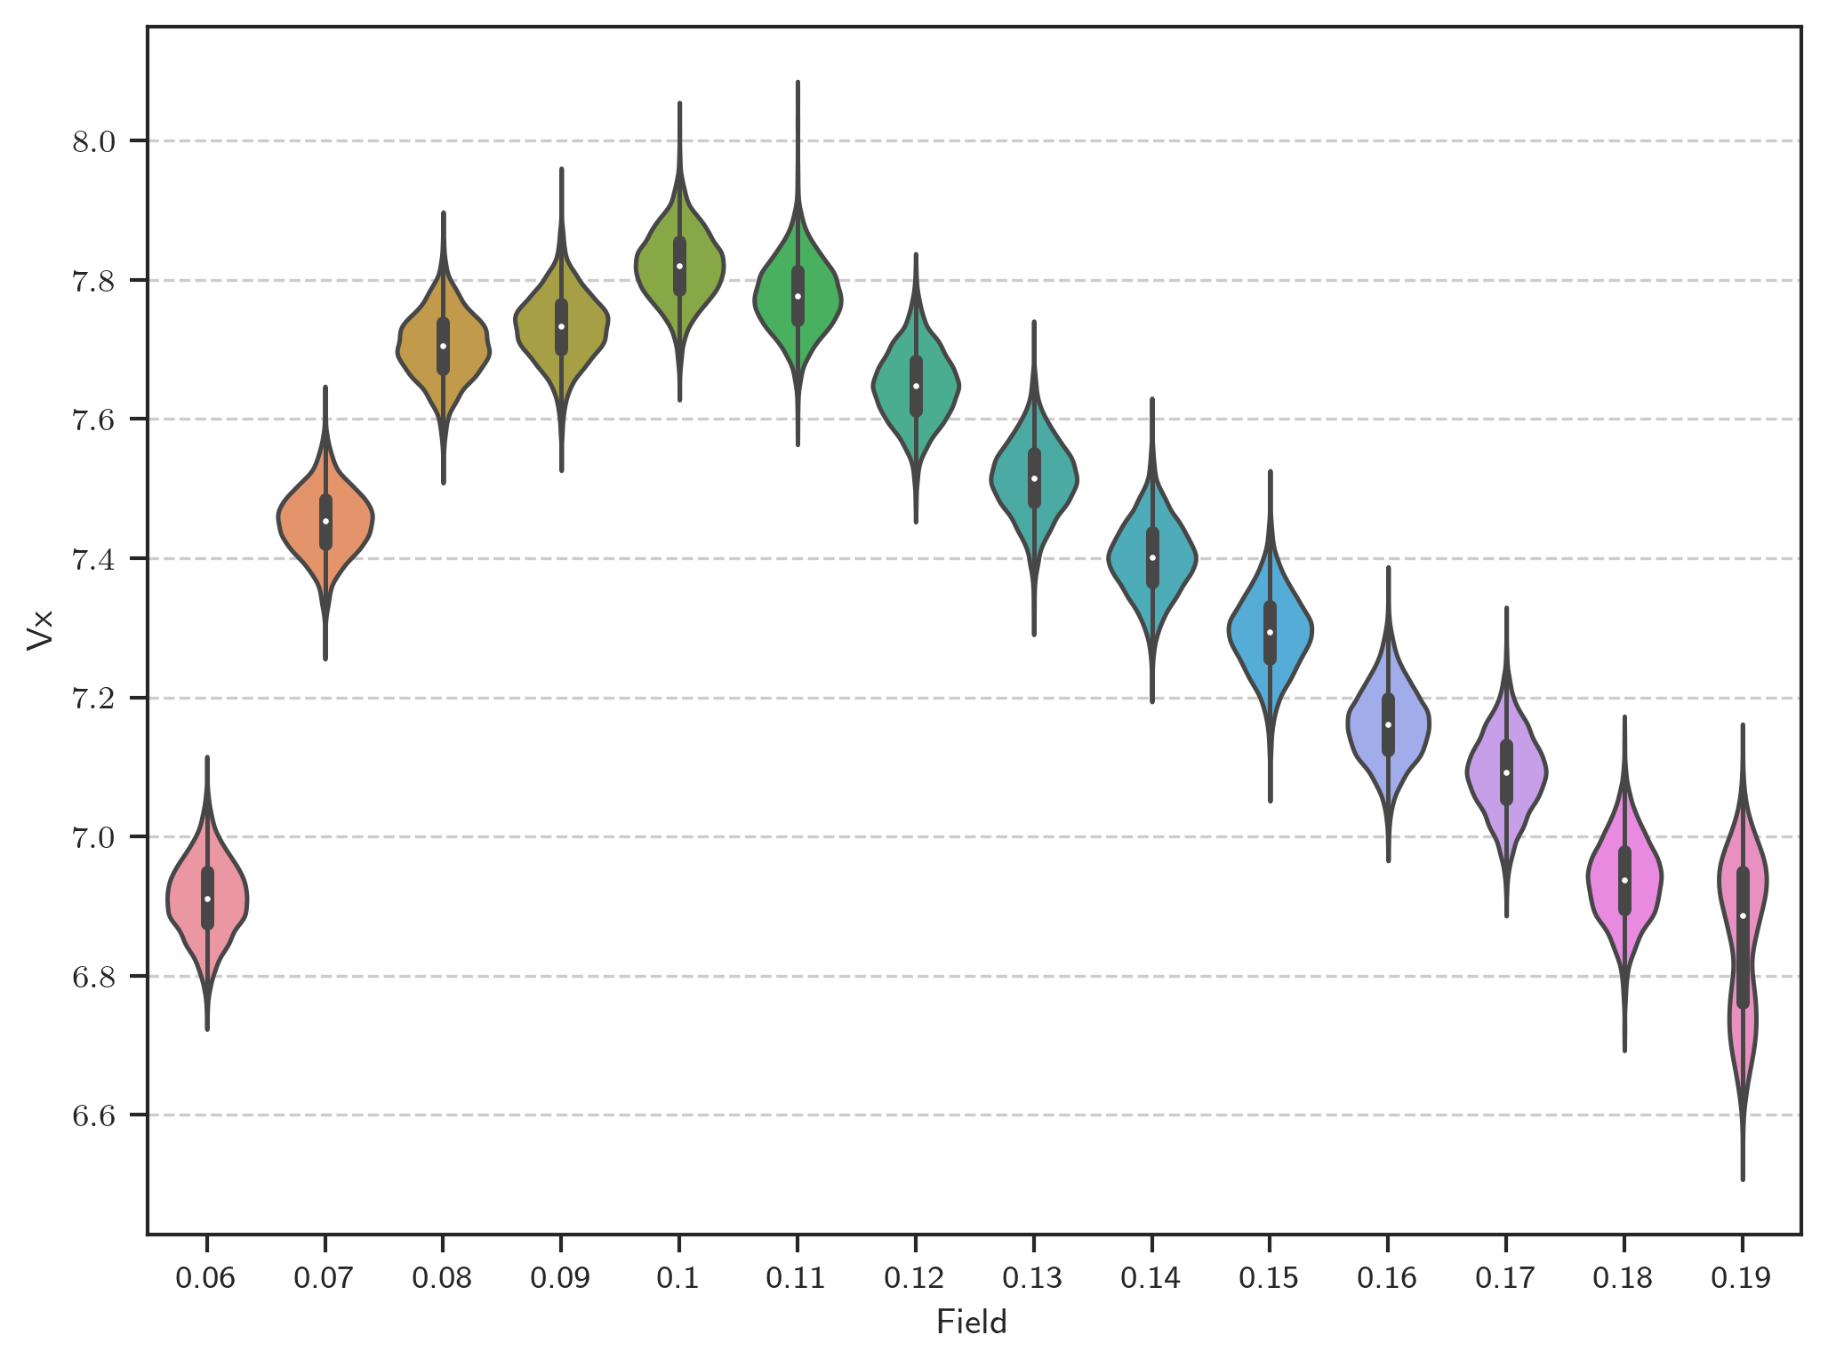

Time signal

Freitag, 13. März 2020

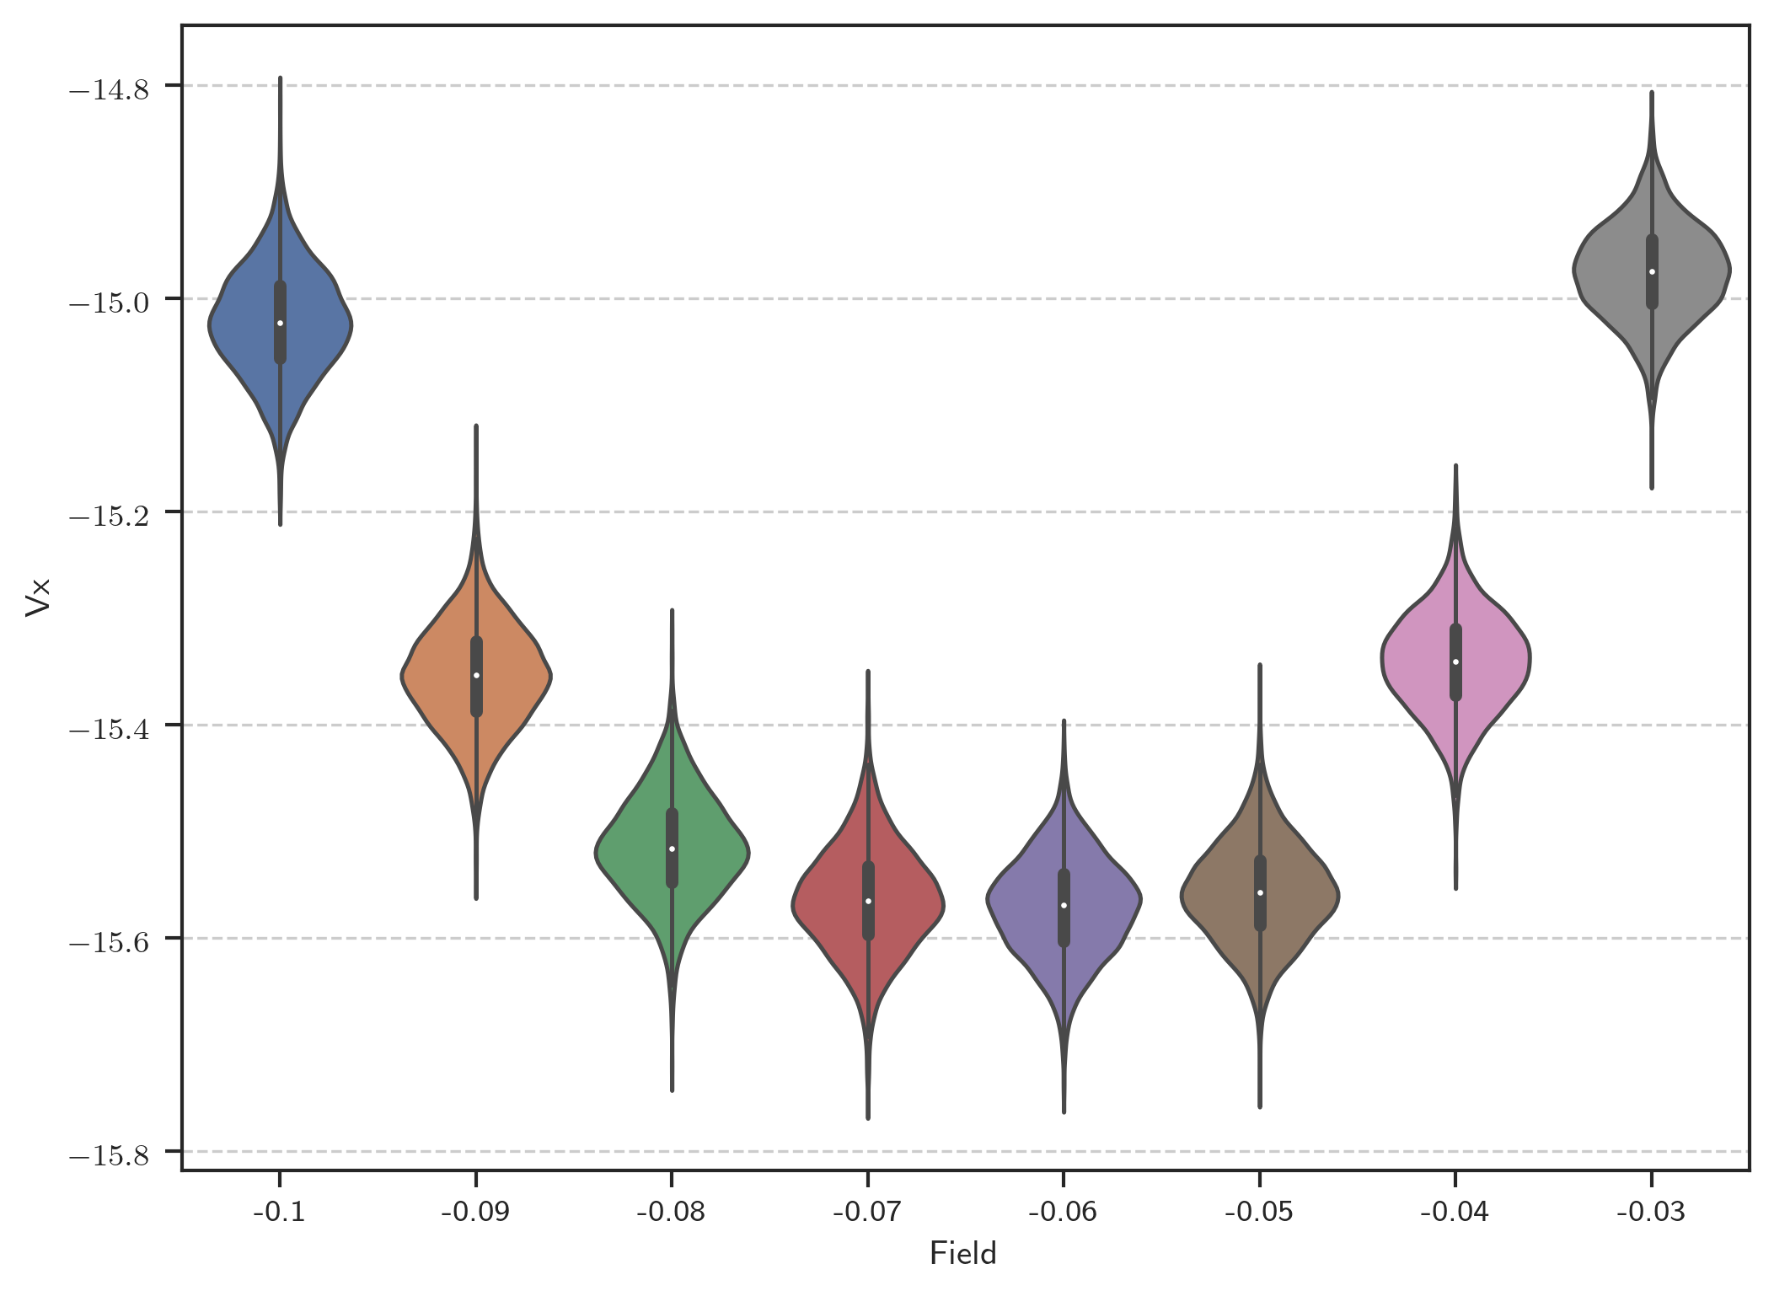

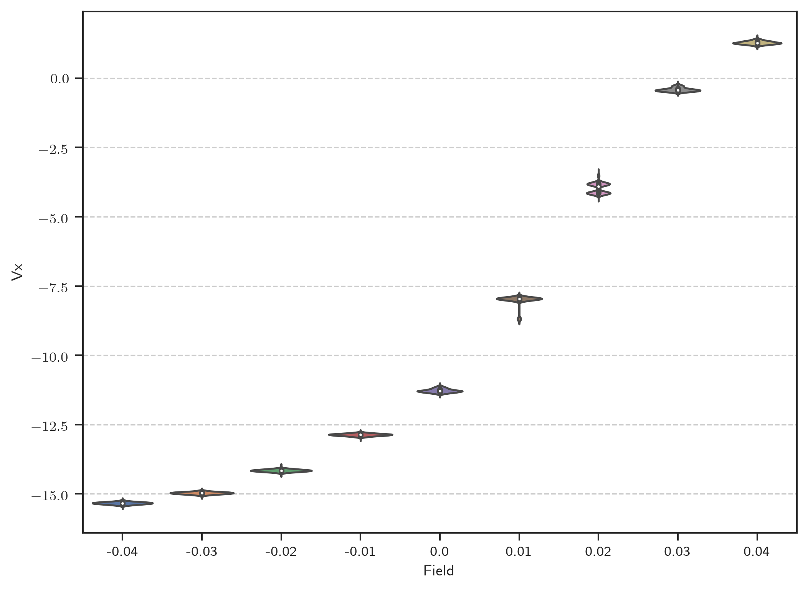

Distribution of Time signal

Freitag, 13. März 2020

12:34

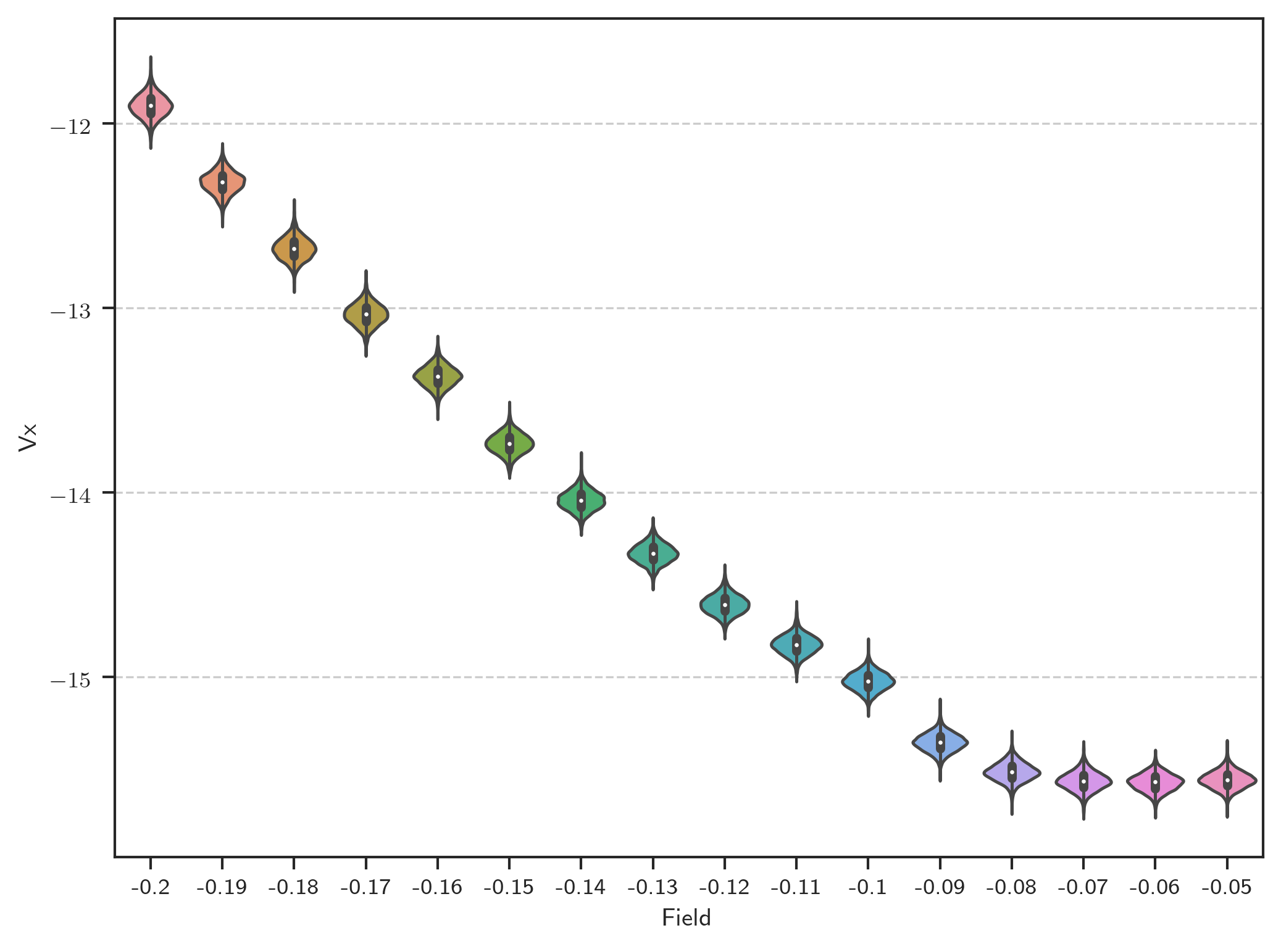

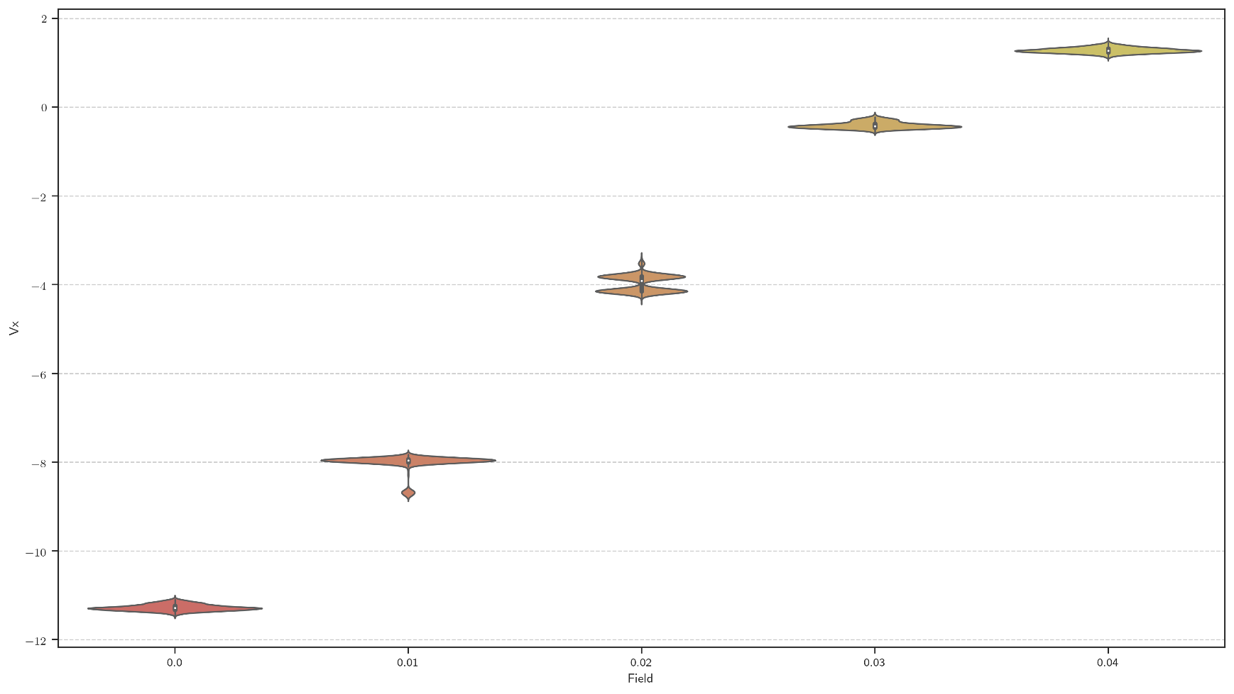

Evaluate m431 (Development of the time signal)

Donnerstag, 12. März 2020

16:08

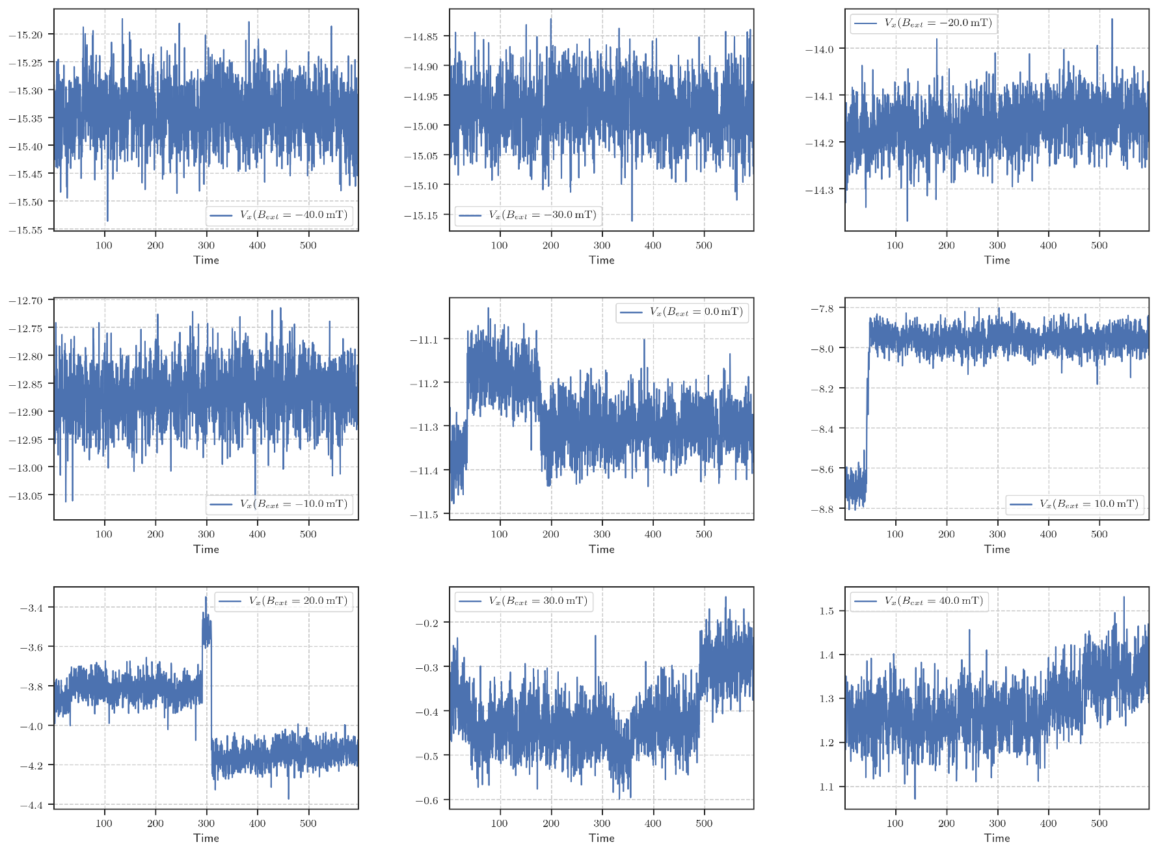

Evaluate m431 (Noise representation)

Freitag, 13. März 2020

10:40

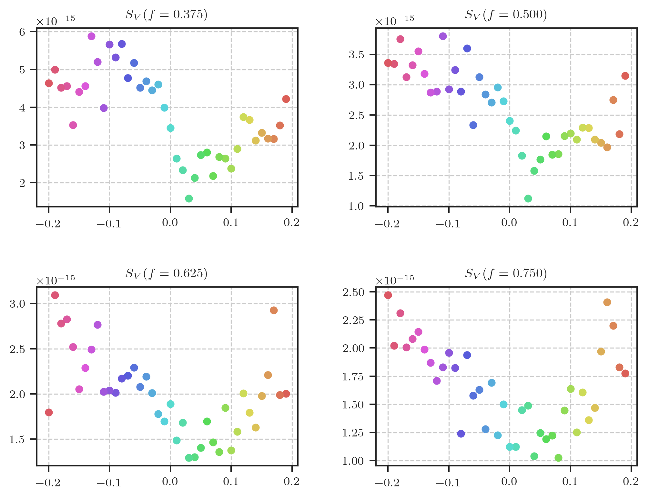

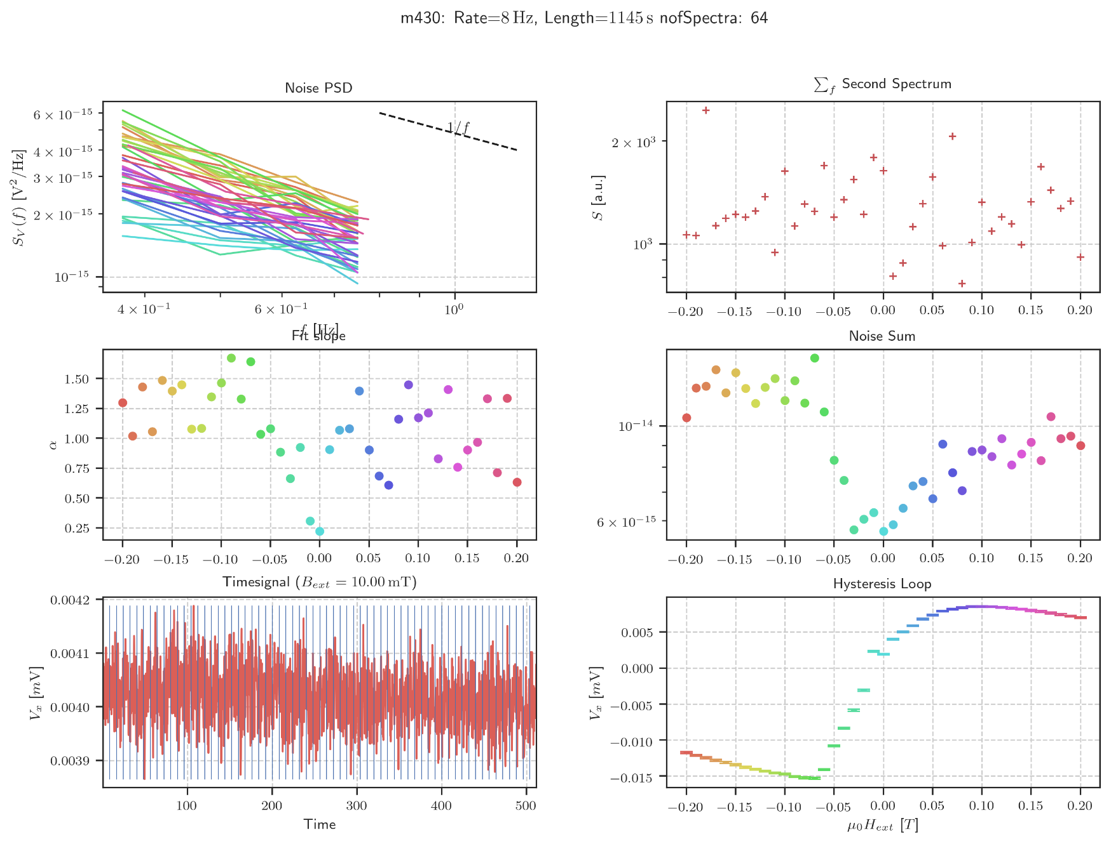

Info with second spectrum

Mittwoch, 22. April 2020

09:59

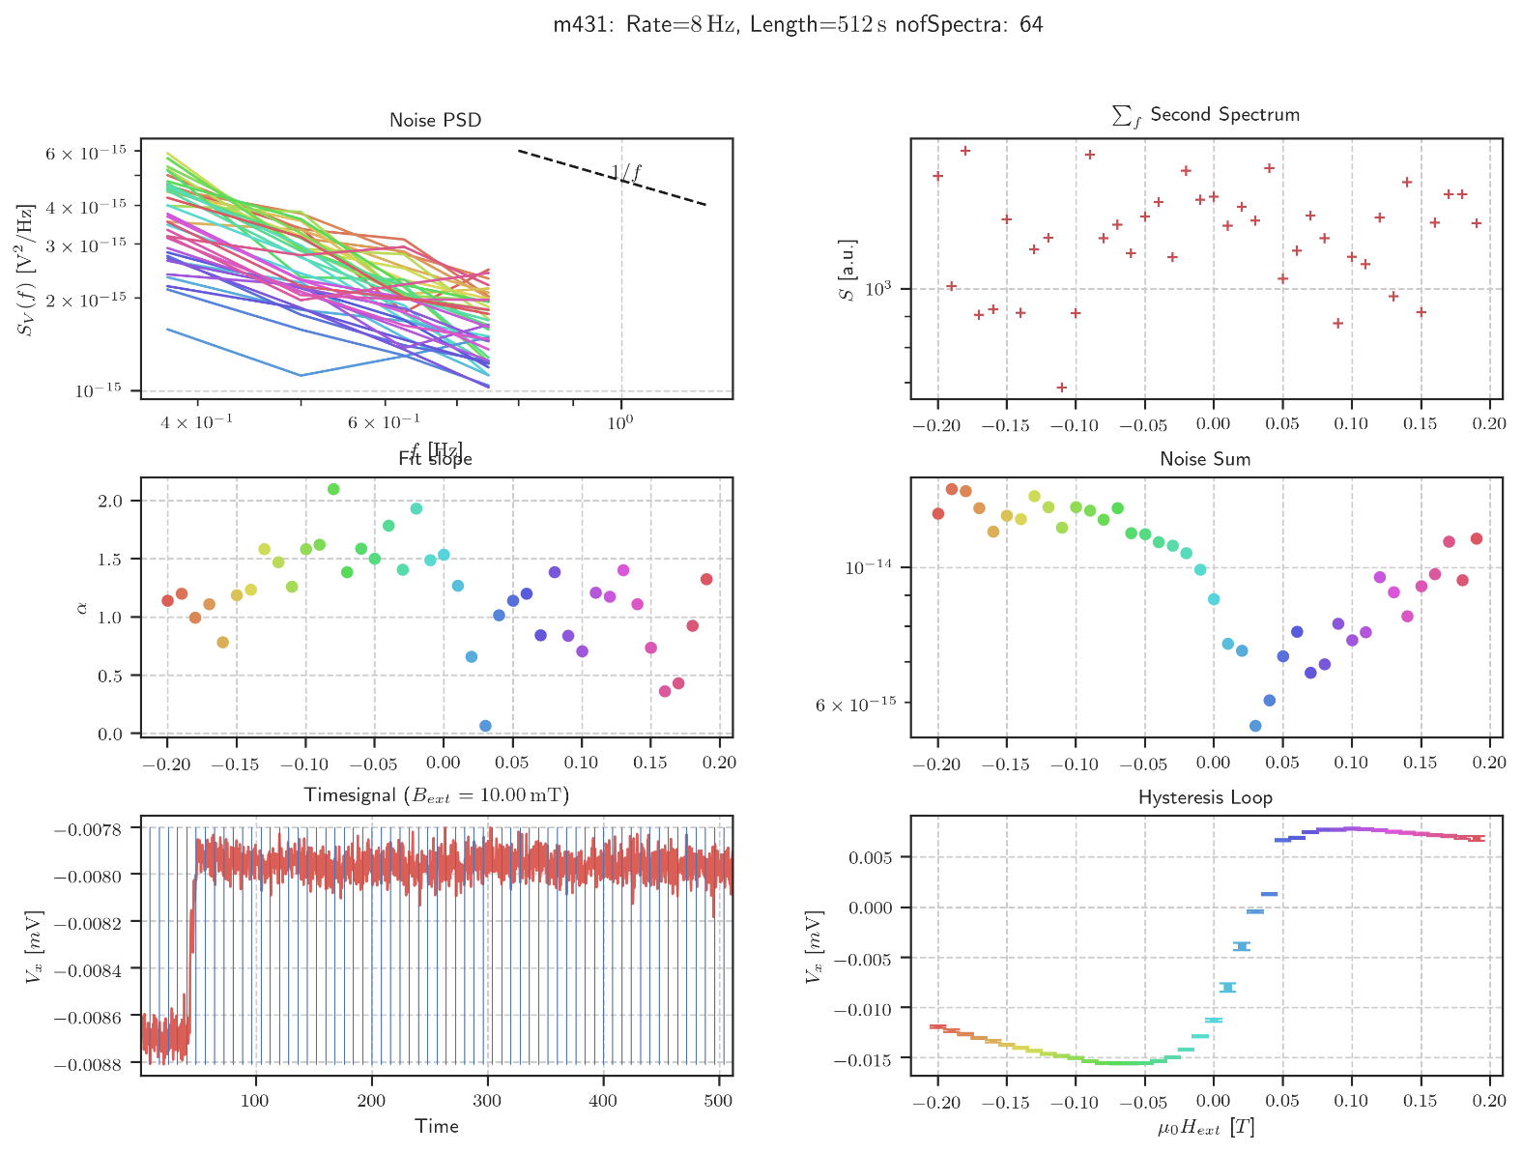

Noise Hysteresis (430/431)

Montag, 20. April 2020

17:10

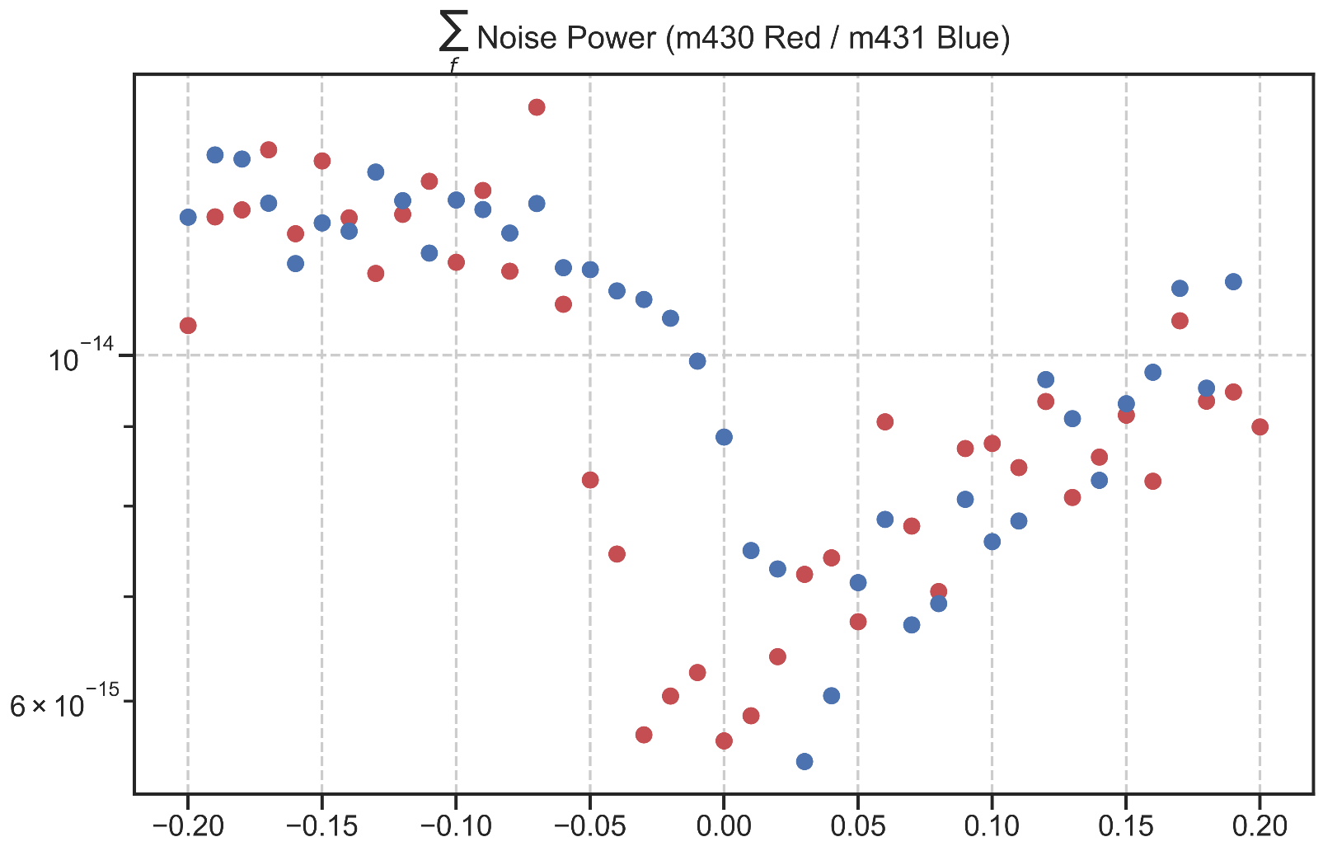

m432: rate:16 Hz length:1024 s with preamp (Down Sweep)

Donnerstag, 12. März 2020

10:17

|  |  |
| --- | --- |
| Angle of sensor θ | *+45* |
| Temp | 30 K |
|  | **Plusses** |
|  | |  |  |  |  | | --- | --- | --- | --- | |  | ***1-13*** |  | *8-6* | | ***Gate (0V)*** | ***9 - 4*** |  | ***14 - 7 (Preamp)*** | |
|  | *sweeping from +100mT → -100mT*  *measuring every 2.5mT steps (81 different steps)* |
| Resistance Box | |  |  |  |  |  |  | | --- | --- | --- | --- | --- | --- | |  | *1 MΩ* |  | 13,5 |  |  | |  | *1 MΩ* |  | *1* |  | *1* | |
| *Pre Amplifier (SR560)* | *Gain Mode: Low | Output: 50O -> Lock In Input A | Gain: 1e2*  Filter Cutoffs:  *Off | Coupling: AC* |
|  | |  |  |  |  |  |  | | --- | --- | --- | --- | --- | --- | | Sens | 1 mV → 20 mV |  | 2,5 V | *f* | *17 Hz* | | *τ* | *30 ms* | *Input A* | *AC* | *Ground* | *Normal Reserve* |   *DAQ settings: Rate: 16 Hz* |
| Period of measurement (min) | *1024 sec for each field* |
| Data files | in Folder NewMeasurements2020\m432\* |
| *Notes* | Badly choosen Sensitivity resulted in Overload! Not usable! |

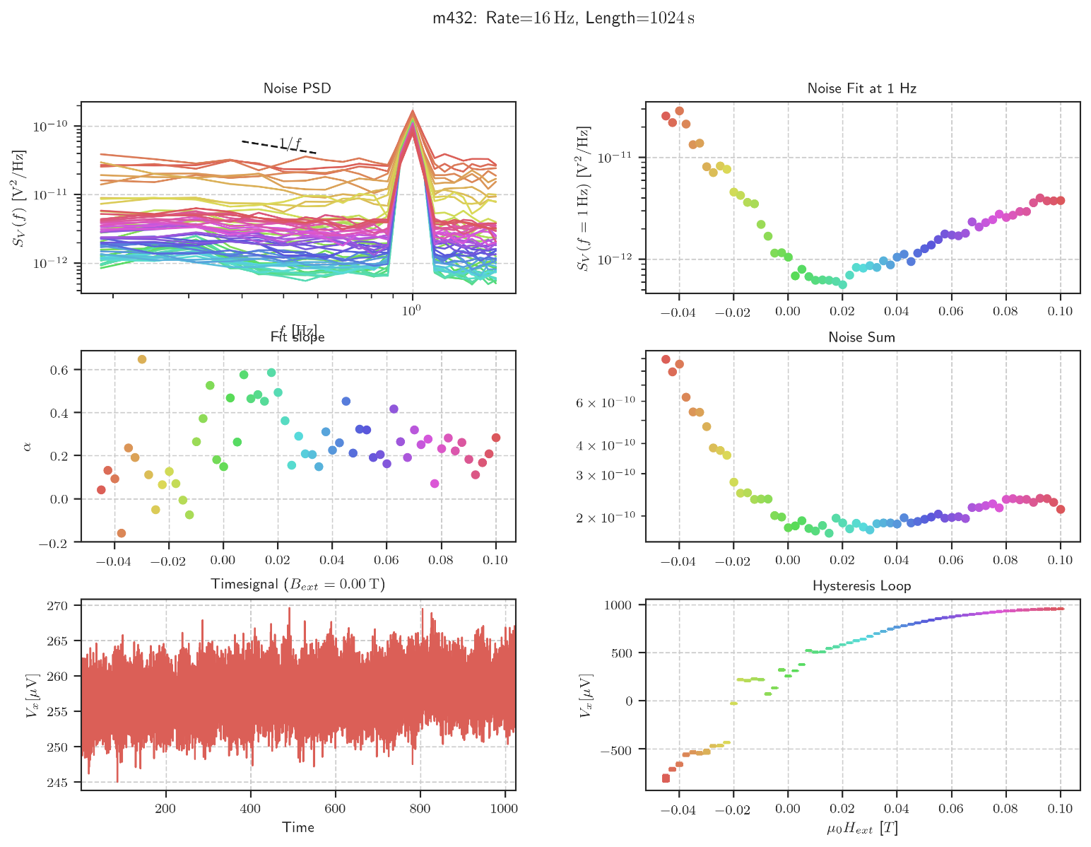

m432: Overload B <= -50mT

Freitag, 13. März 2020

15:20

Changed the Sensitivity to 20mV

Need to Remeasure Values

* + -.0475
  + -.05
  + -.0525
  + -.055
  + -.0575
  + -.06

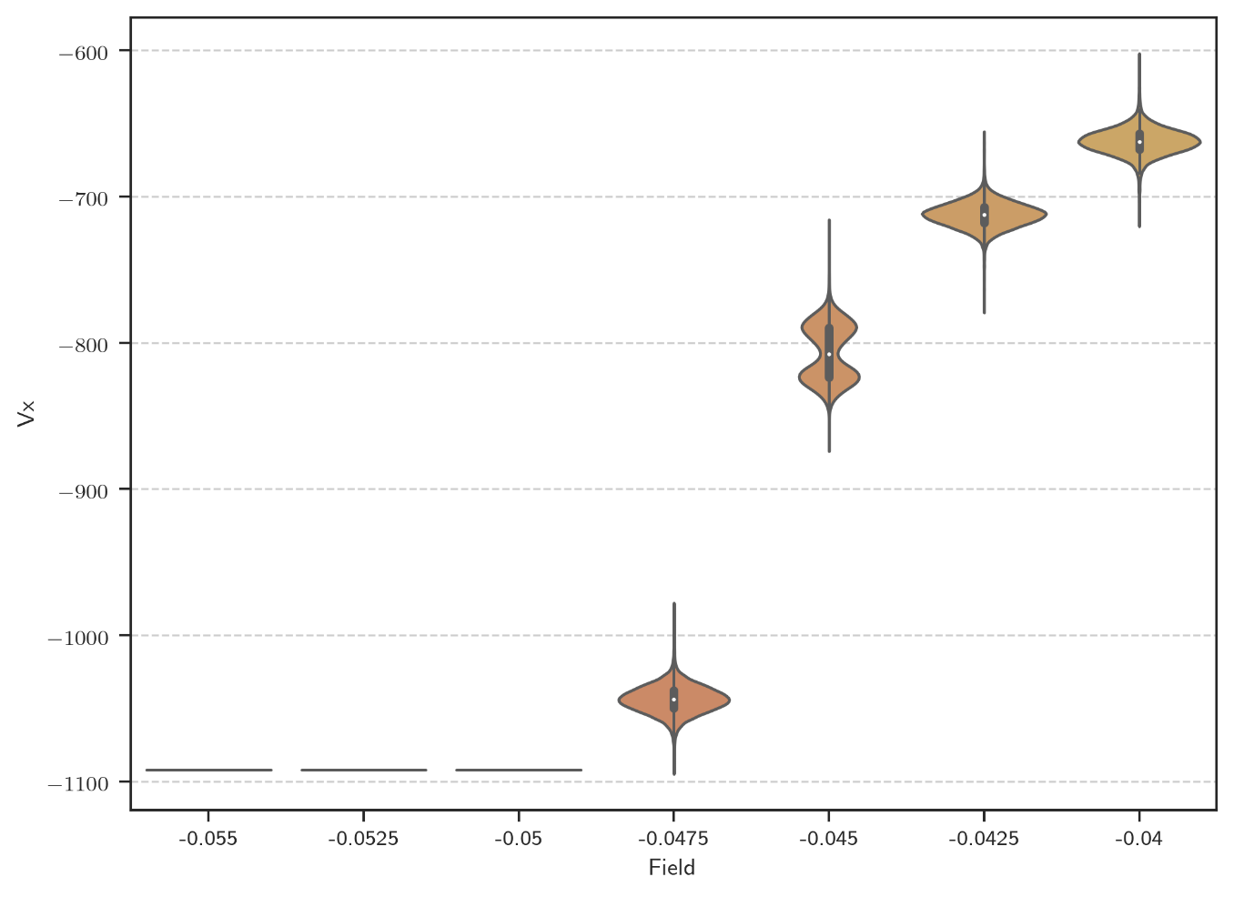

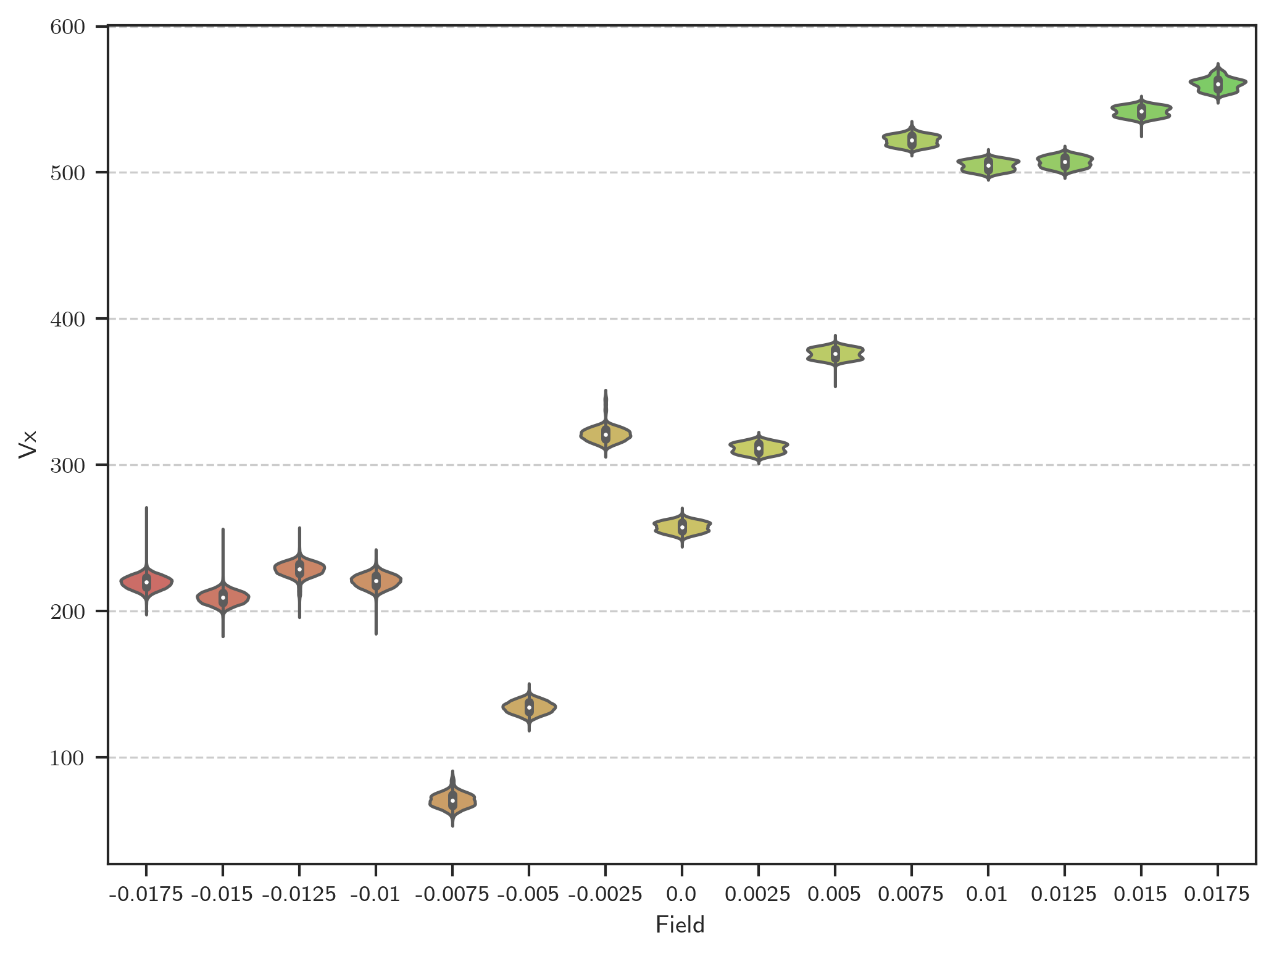

Evaluate m432 (Timesignal near 0)

Freitag, 13. März 2020

11:08

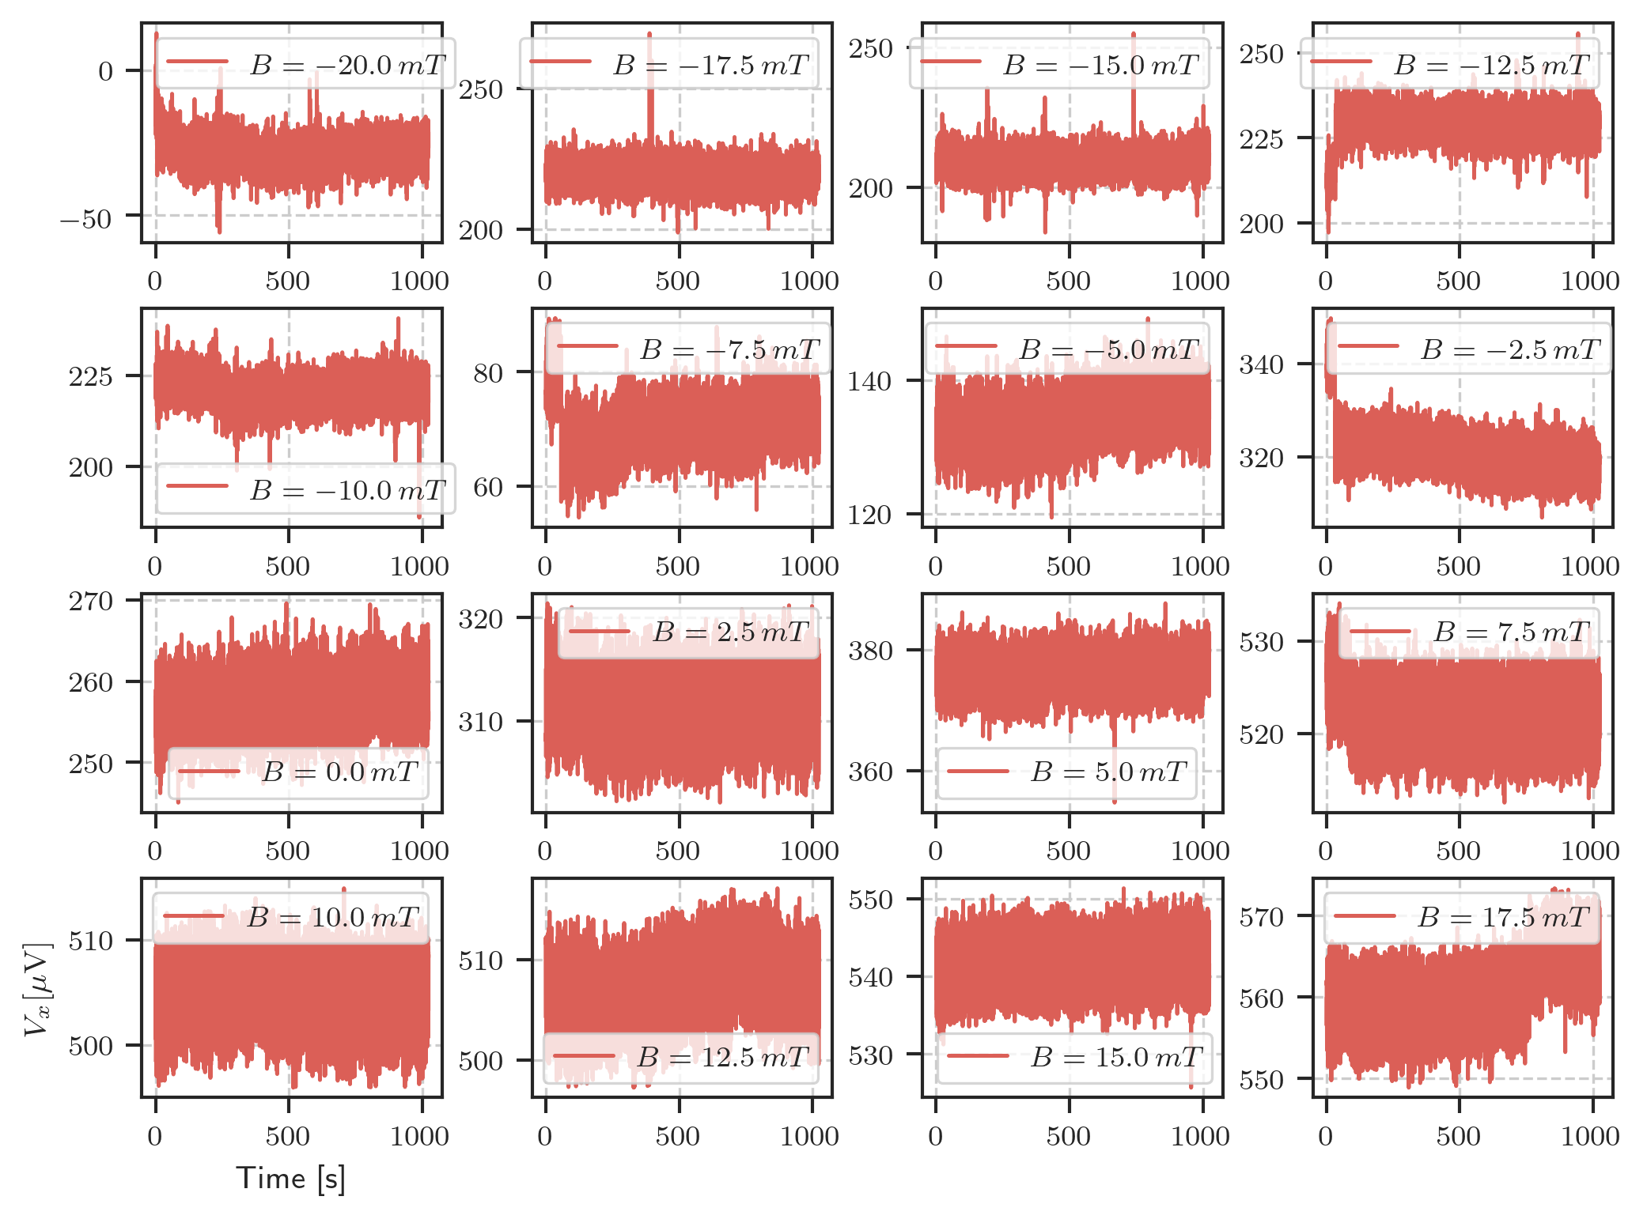

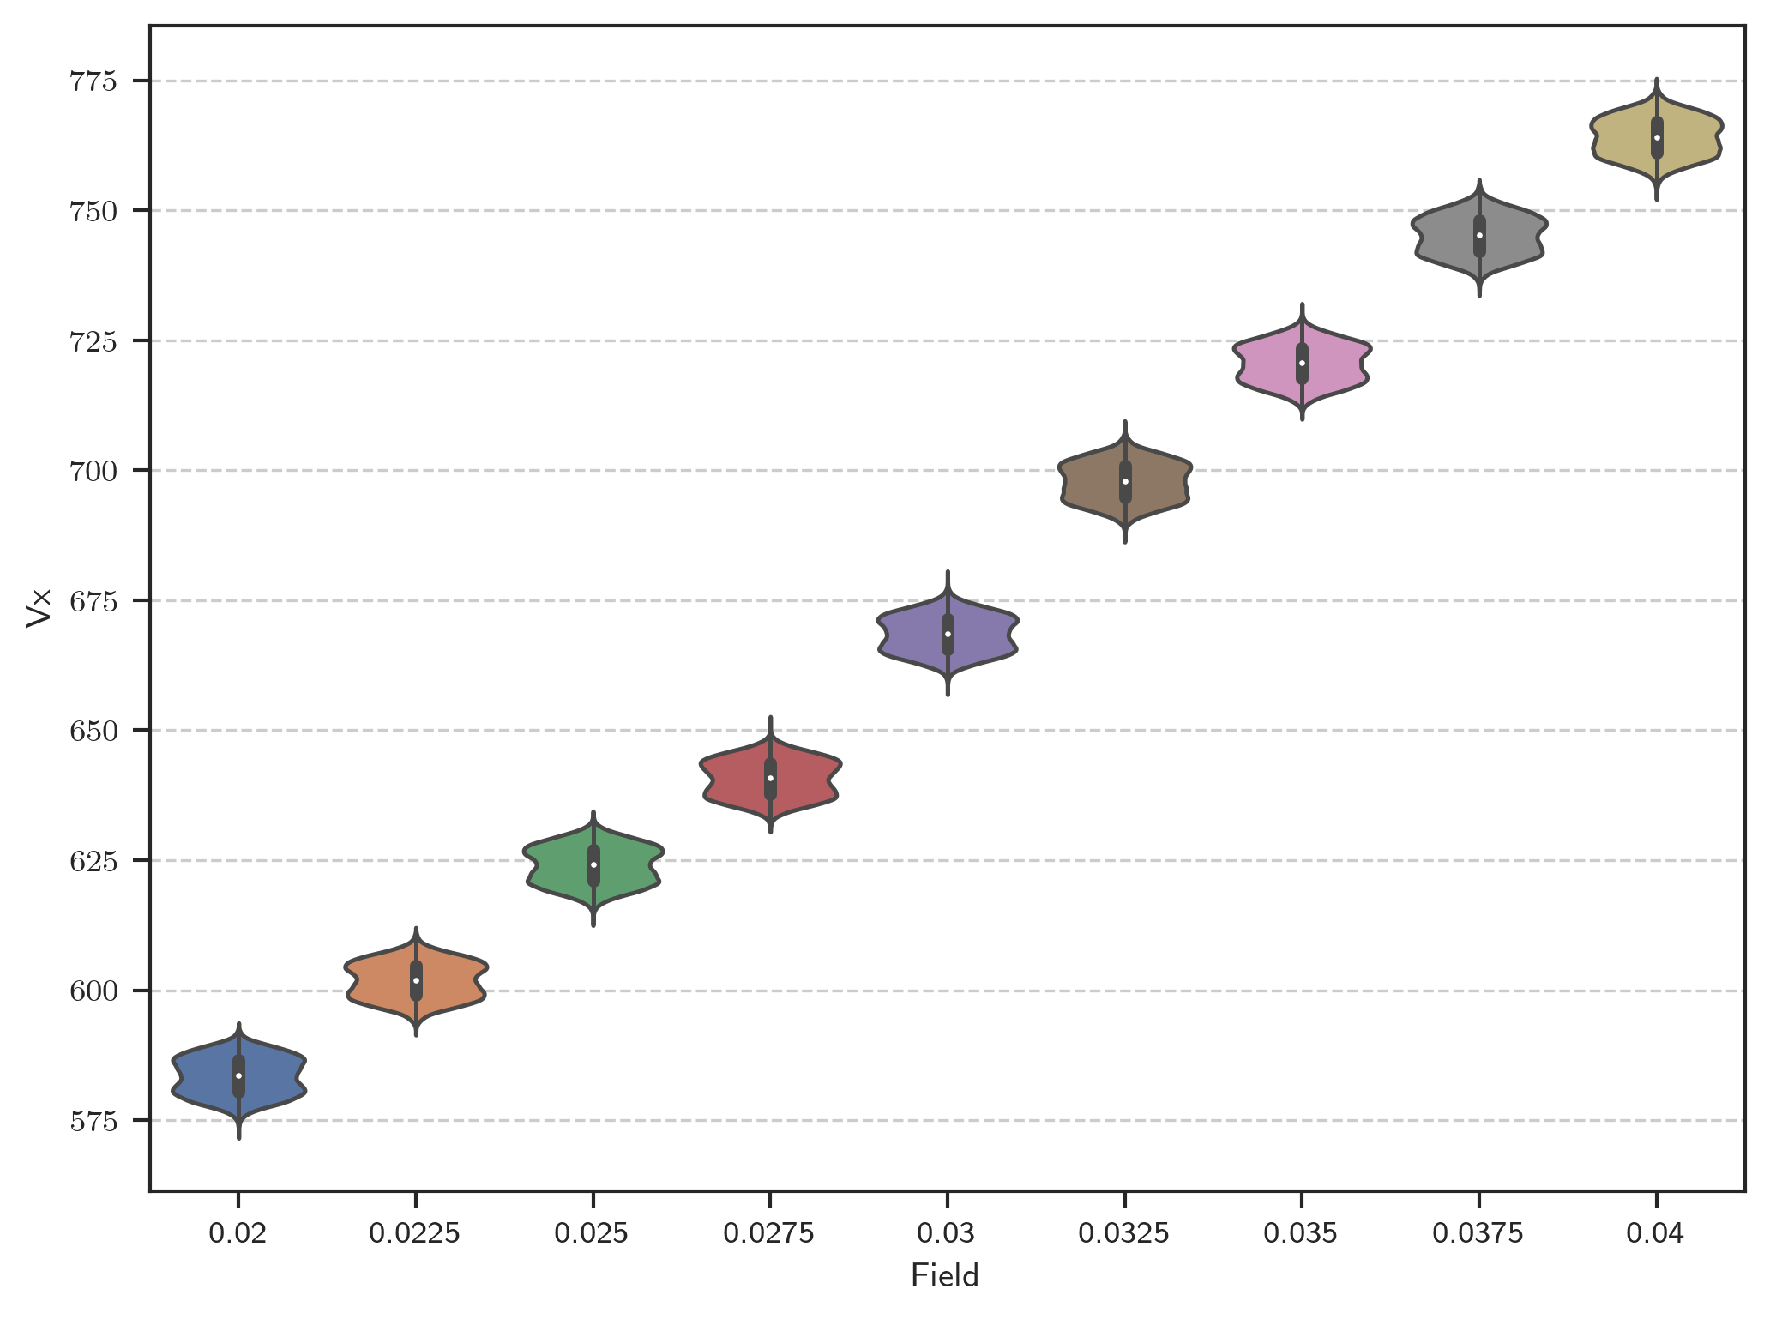

Time signals (Non Gaussian Noise)

Freitag, 13. März 2020

14:36

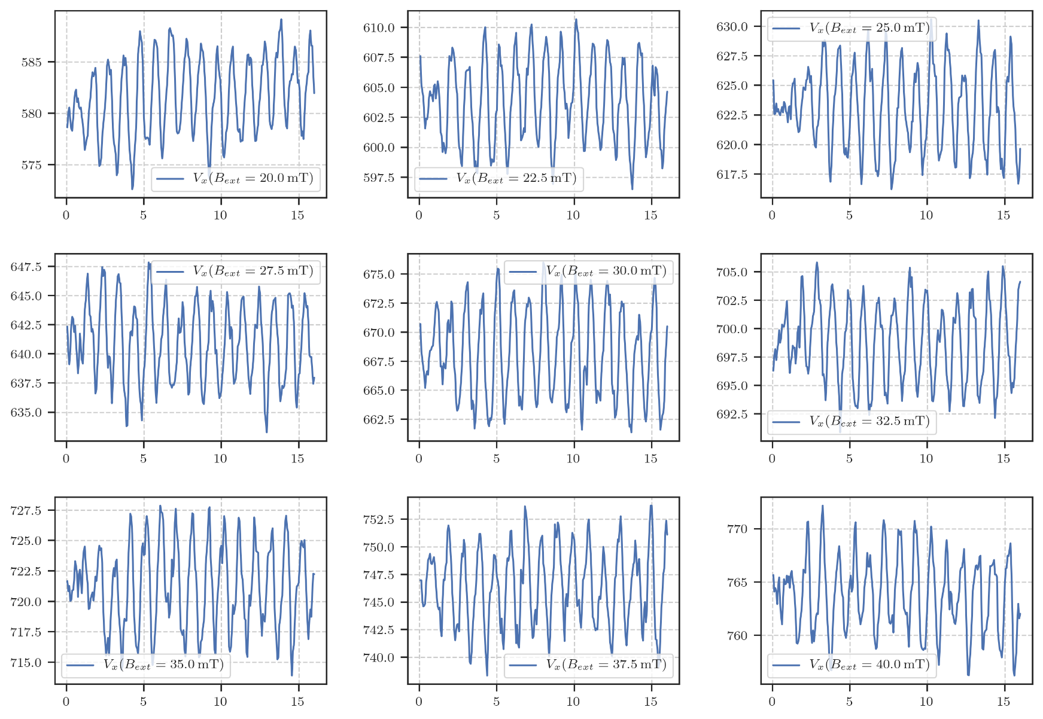

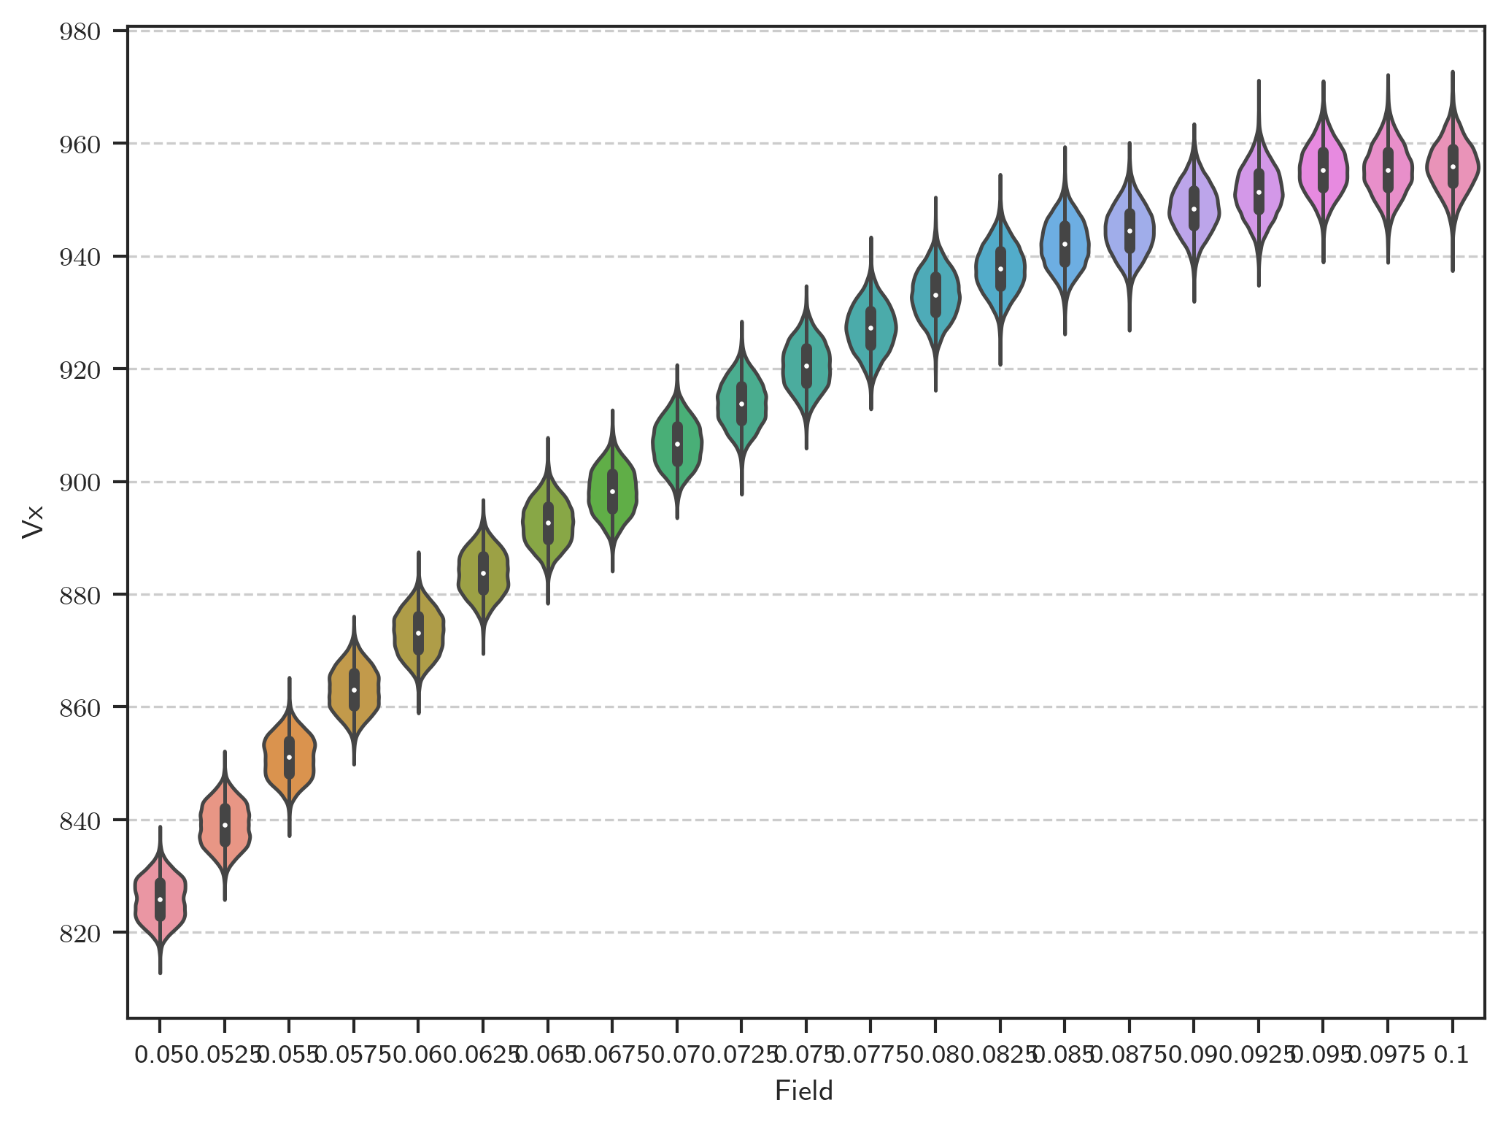

Time signals (Gaussian Noise)

Freitag, 13. März 2020

16:37

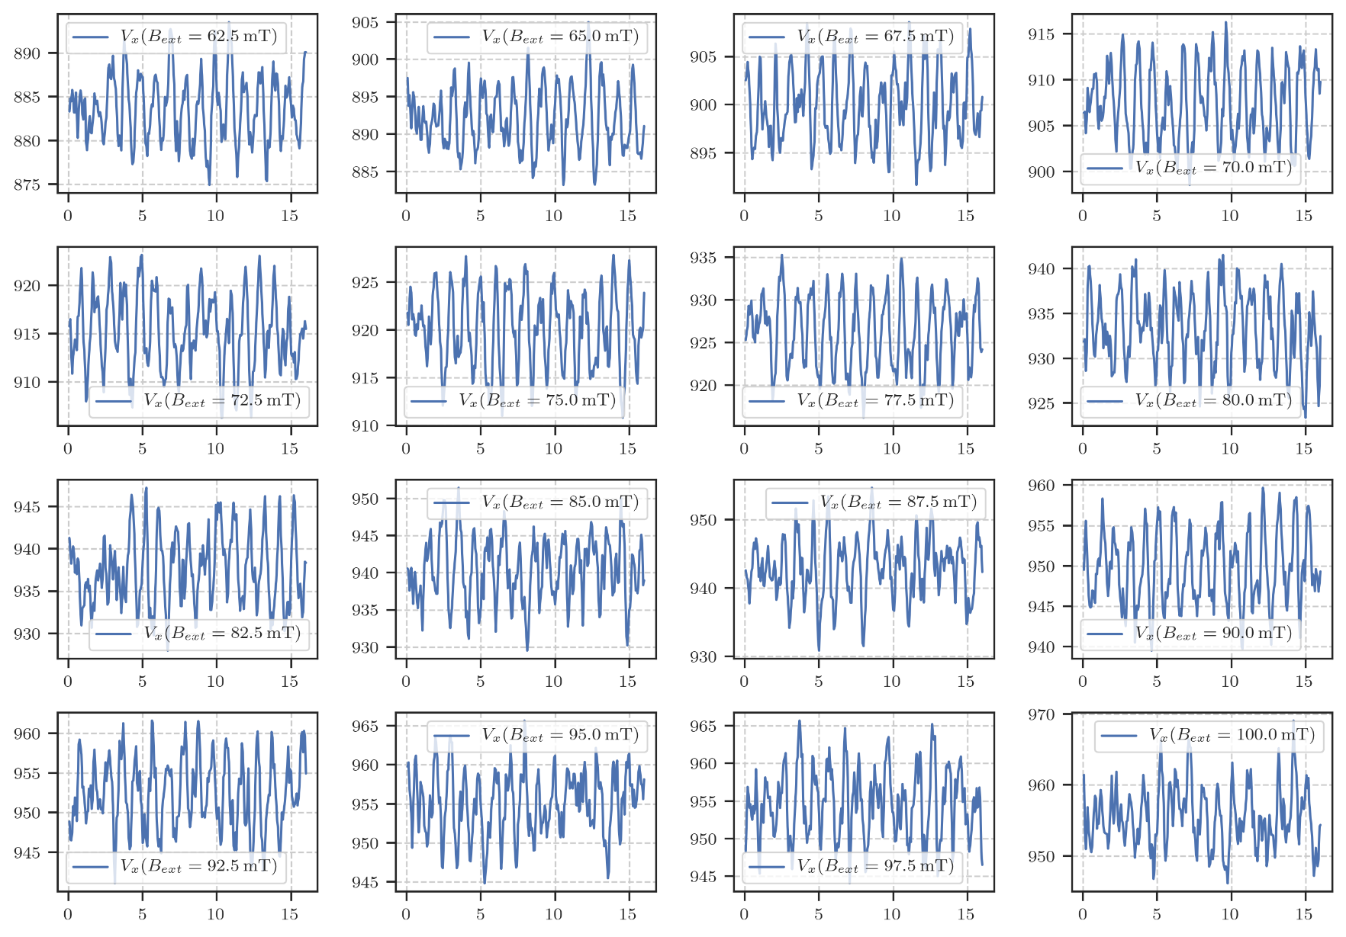

m433: rate:16 Hz length:1024 s with preamp (Up Sweep)

Freitag, 13. März 2020

18:51

|  |  |
| --- | --- |
| Angle of sensor θ | *+45* |
| Temp | 30 K |
|  | **Plusses** |
|  | |  |  |  |  | | --- | --- | --- | --- | |  | ***1-13*** |  | *8-6* | | ***Gate (0V)*** | ***9 - 4*** |  | ***14 - 7 (Preamp)*** | |
|  | *Saturating at -.3T. sweeping from -100mT → +100mT*  *measuring every 2mT steps (101 different steps)* |
| Resistance Box | |  |  |  |  |  |  | | --- | --- | --- | --- | --- | --- | |  | *1 MΩ* |  | 13,5 |  |  | |  | *1 MΩ* |  | *1* |  | *1* | |
| *Pre Amplifier (SR560)* | *Gain Mode: Low | Output: 50O -> Lock In Input A | Gain: 1e2*  Filter Cutoffs:  *Off | Coupling: AC* |
|  | |  |  |  |  |  |  | | --- | --- | --- | --- | --- | --- | | Sens | 20 mV |  | 2,5 V | *f* | *113 Hz* | | *τ* | *30 ms* | *Input A* | *AC* | *Ground* | *Normal Reserve* |   *DAQ settings: Rate: 16 Hz* |
| Period of measurement (min) | *1024 sec for each field* |
| Data files | in Folder NewMeasurements2020\m433\* |

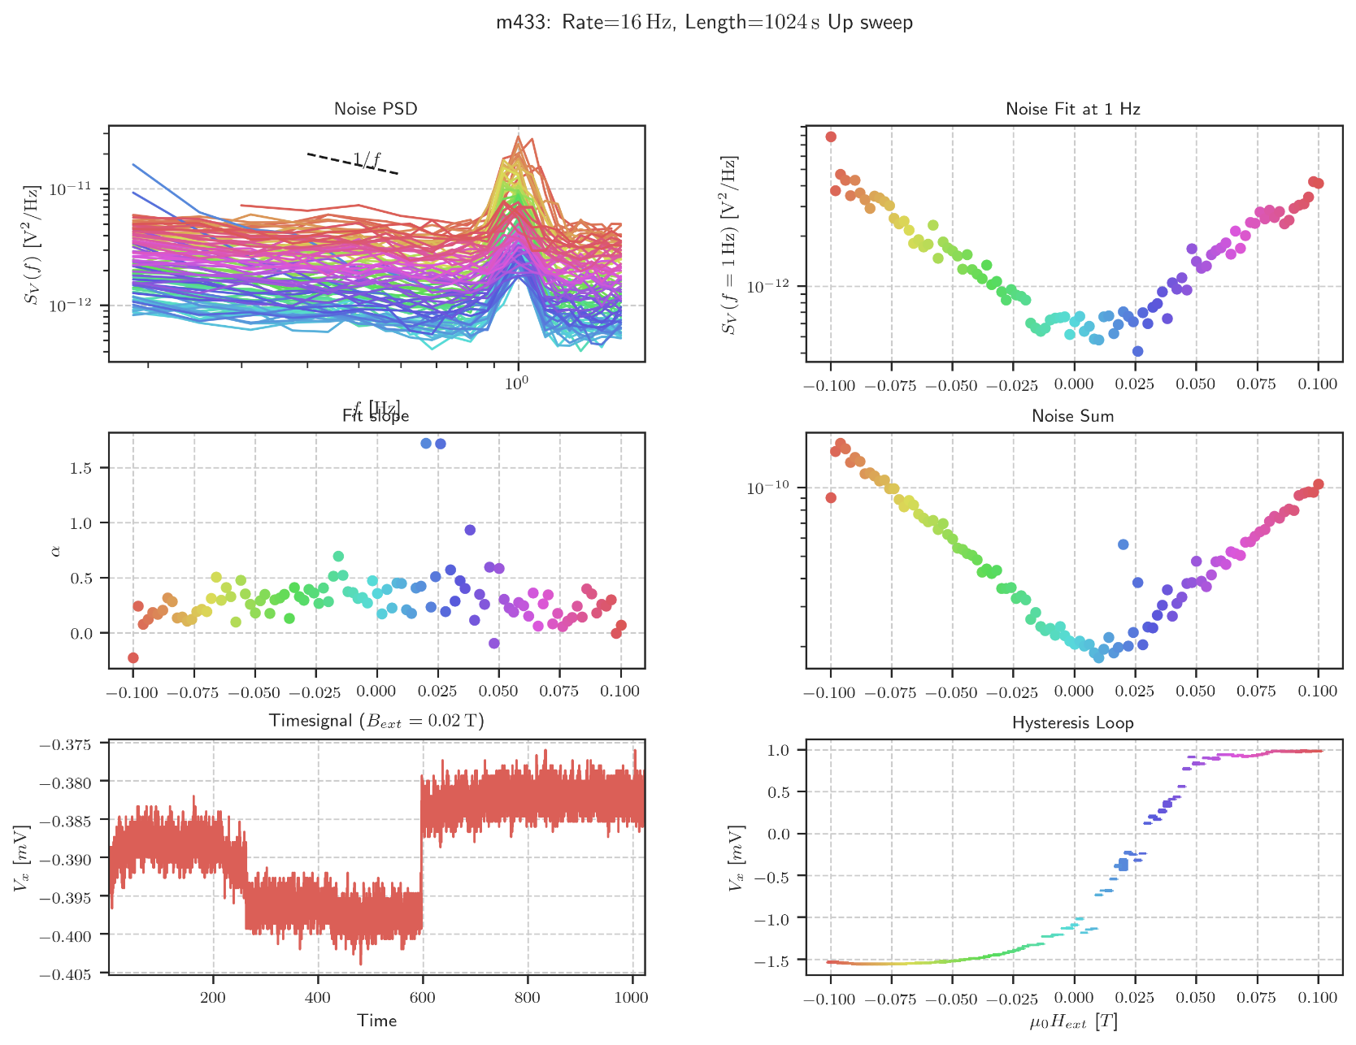

Second Spectrum overview

Mittwoch, 22. April 2020

10:08

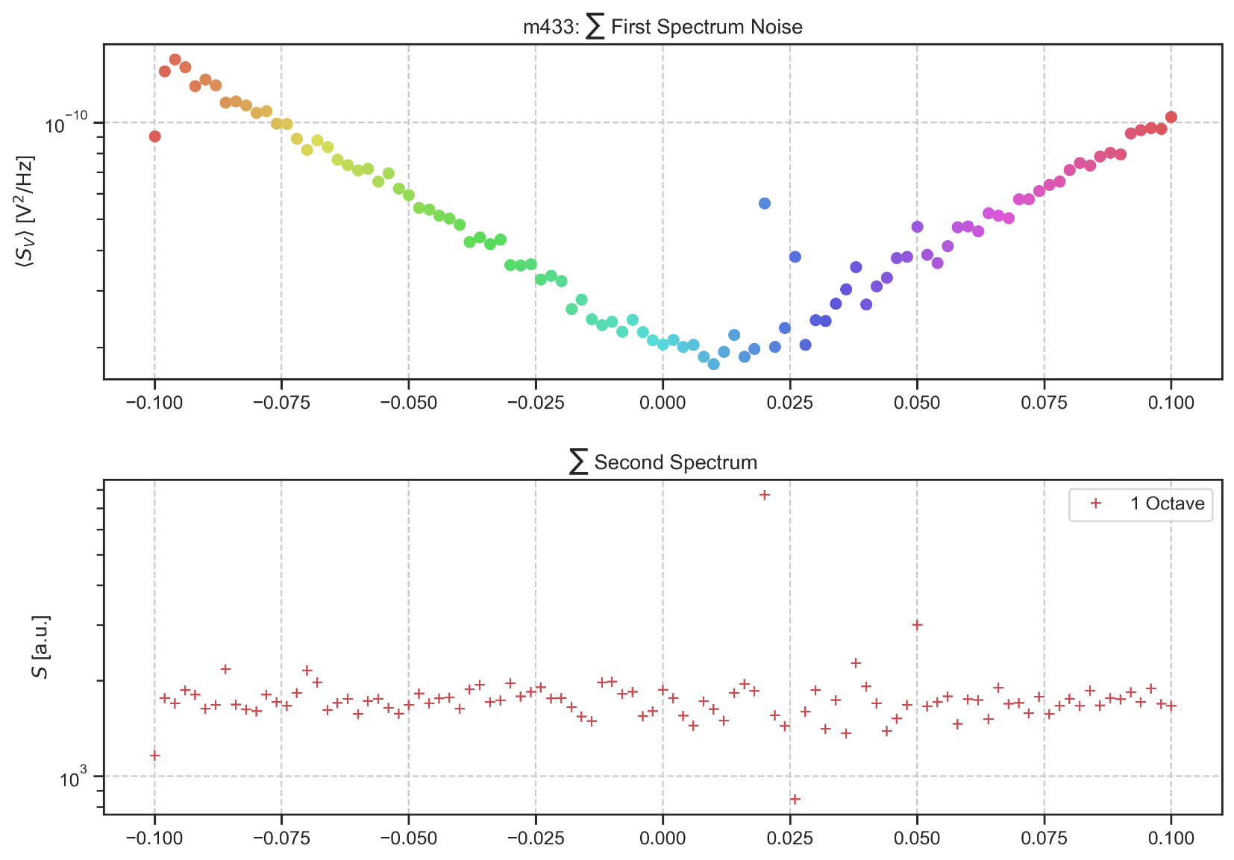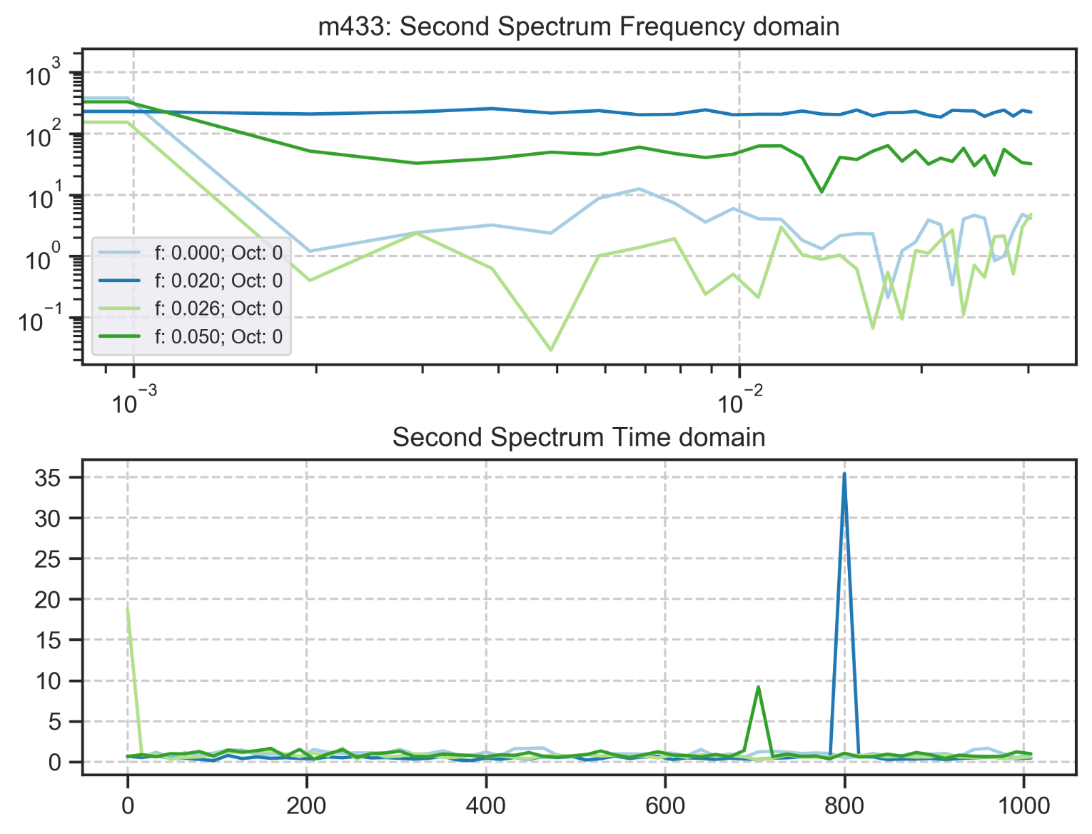

m434: rate:32 Hz length:512 s with preamp (Down Sweep)

Sonntag, 15. März 2020

09:00

|  |  |
| --- | --- |
| Angle of sensor θ | *+45* |
| Temp | 30 K |
|  | **Plusses** |
|  | |  |  |  |  | | --- | --- | --- | --- | |  | ***1-13*** |  | *8-6* | | ***Gate (0V)*** | ***9 - 4*** |  | ***14 - 7 (Preamp)*** | |
|  | *Saturating at .3T. sweeping from +200mT → -200mT*  *measuring every 20mT steps (21 different steps)* |
| Resistance Box | |  |  |  |  |  |  | | --- | --- | --- | --- | --- | --- | |  | *1 MΩ* |  | 13,5 |  |  | |  | *1 MΩ* |  | *1* |  | *1* | |
| *Pre Amplifier (SR560)* | *Gain Mode: Low | Output: 50O -> Lock In Input A | Gain: 1e2*  Filter Cutoffs:  *Off | Coupling: AC* |
|  | |  |  |  |  |  |  | | --- | --- | --- | --- | --- | --- | | Sens | 20 mV |  | 2,5 V | *f* | *113 Hz* | | *τ* | *30 ms* | *Input A* | *AC* | *Ground* | *Normal Reserve* |   *DAQ settings: Rate: 32 Hz* |
| Period of measurement (min) | *512 sec for each field* |
| Data files | in Folder NewMeasurements2020\m434\* |

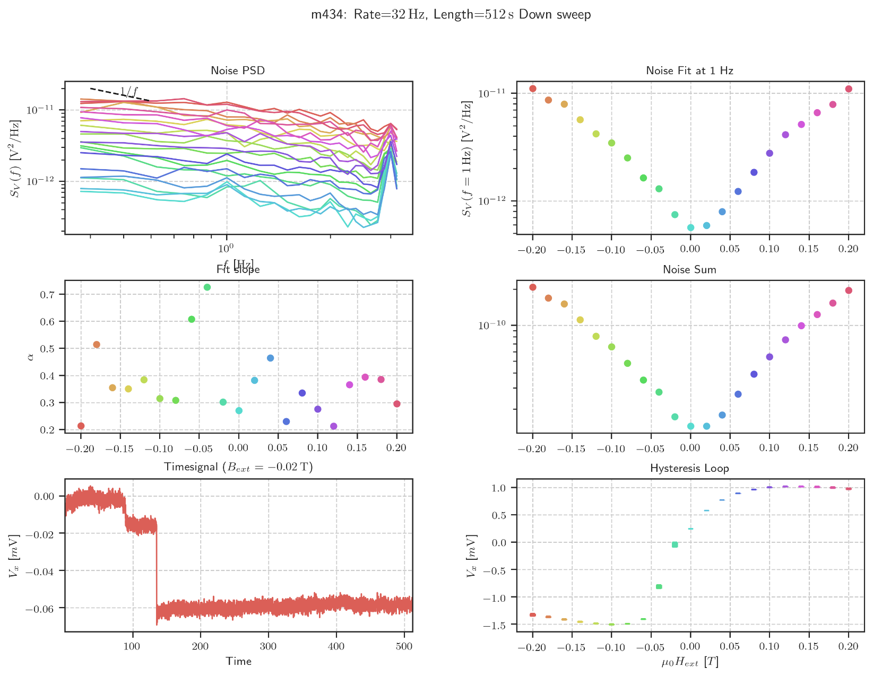

Big Vy signal

Montag, 16. März 2020

12:16

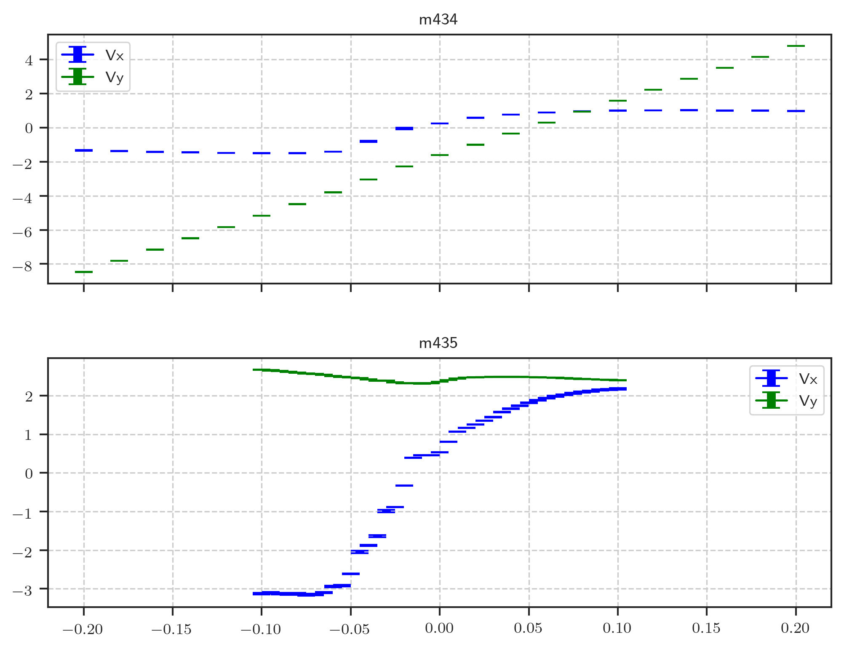

Solution:

Changing + and - connections for next measurement (m435).

Results in a larger Vx signal and lower Vy signal.

m435: rate:16 Hz Switched Polarity (Down Sweep)

Montag, 16. März 2020

18:51

|  |  |
| --- | --- |
| Angle of sensor θ | *+45* |
| Temp | 30 K |
|  | **Plusses** |
|  | |  |  |  |  | | --- | --- | --- | --- | |  | ***13-1*** |  | *6-8* | | ***Gate (0V)*** | ***9 - 4*** |  | ***7 - 14 (Preamp)*** | |
|  | *Saturating at -.3T. sweeping from 100mT → -100mT*  *measuring every 5mT steps (41 different steps)* |
| Resistance Box | |  |  |  |  |  |  | | --- | --- | --- | --- | --- | --- | |  | *1 MΩ* |  | 13,5 |  |  | |  | *1 MΩ* |  | *1* |  | *1* | |
| *Pre Amplifier (SR560)* | *Gain Mode: Low | Output: 50O -> Lock In Input A | Gain: 1e2*  Filter Cutoffs:  *Off | Coupling: AC* |
|  | |  |  |  |  |  |  | | --- | --- | --- | --- | --- | --- | | Sens | 20 mV |  | 5 V | *f* | *113 Hz* | | *τ* | *30 ms* | *Input A* | *AC* | *Ground* | *Normal Reserve* |   *DAQ settings: Rate: 16 Hz* |
| Period of measurement (min) | *1024 sec for each field* |
| Data files | in Folder NewMeasurements2020\m435\* |

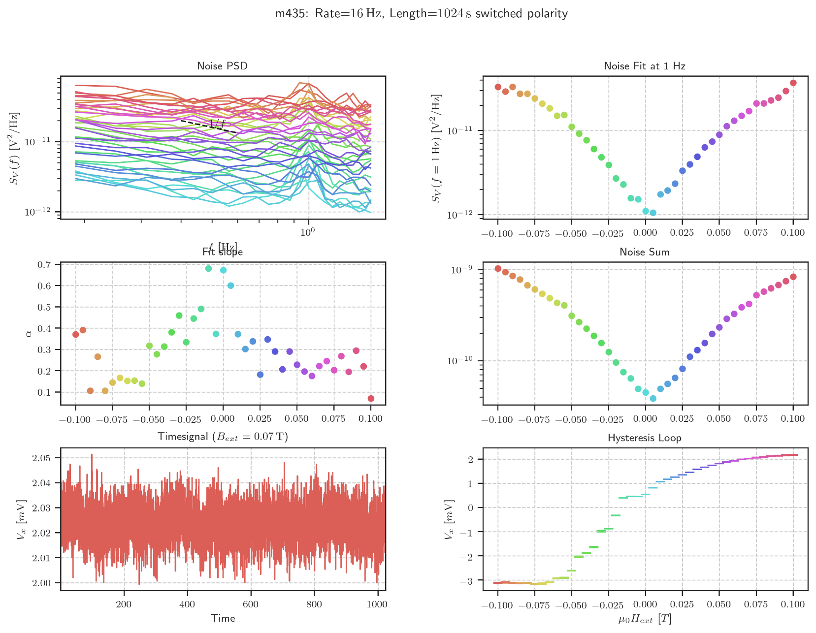

m436: rate:8 Hz Down Sweep

Dienstag, 17. März 2020

15:13

|  |  |
| --- | --- |
| Angle of sensor θ | *+45* |
| Temp | 30 K |
|  | **Plusses** |
|  | |  |  |  |  | | --- | --- | --- | --- | |  | ***13-1*** |  | *6-8* | | ***Gate (0V)*** | ***9 - 4*** |  | ***7 - 14 (Preamp)*** | |
|  | *Saturating at -.3T. sweeping from 200mT → -200mT*  *measuring every 5mT steps (41 different steps)* |
| Resistance Box | |  |  |  |  |  |  | | --- | --- | --- | --- | --- | --- | |  | *1 MΩ* |  | 13,5 |  |  | |  | *1 MΩ* |  | *1* |  | *1* | |
| *Pre Amplifier (SR560)* | *Gain Mode: Low | Output: 50O -> Lock In Input A | Gain: 1e2*  Filter Cutoffs:  *Off | Coupling: AC* |
|  | |  |  |  |  |  |  | | --- | --- | --- | --- | --- | --- | | Sens | 20 mV |  | 5 V | *f* | *113 Hz* | | *τ* | *100 ms* | *Input A* | *AC* | *Ground* | *Normal Reserve* |   *DAQ settings: Rate: 8 Hz* |
| Period of measurement (min) | *1024 sec for each field* |
| Data files | in Folder NewMeasurements2020\m436\* |

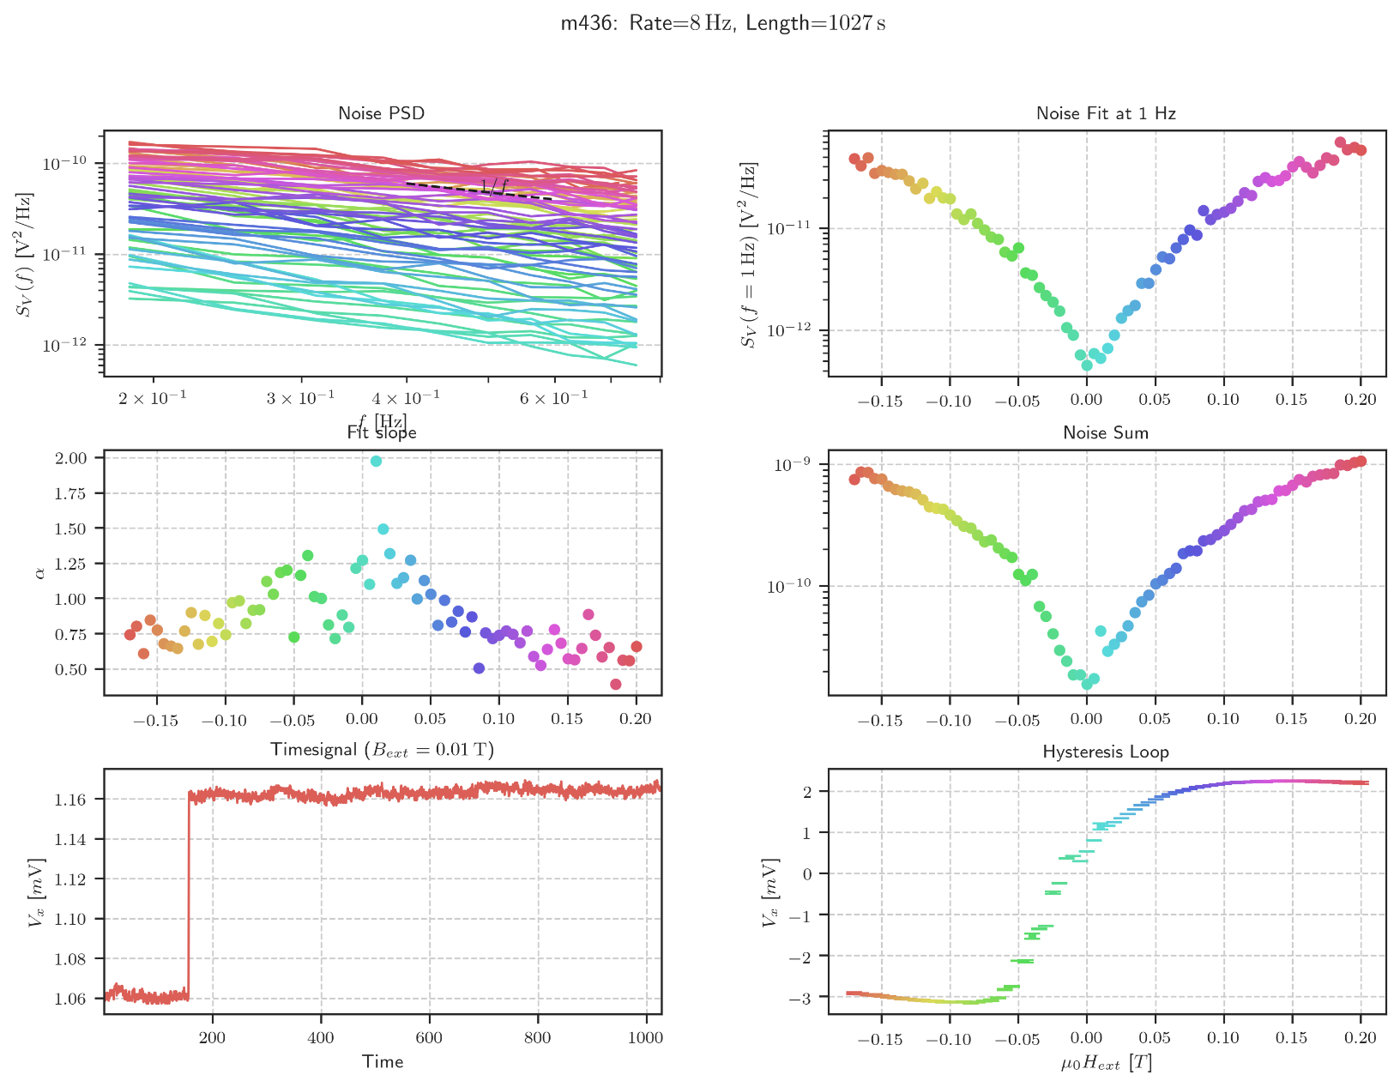

Second Spectrum Overview

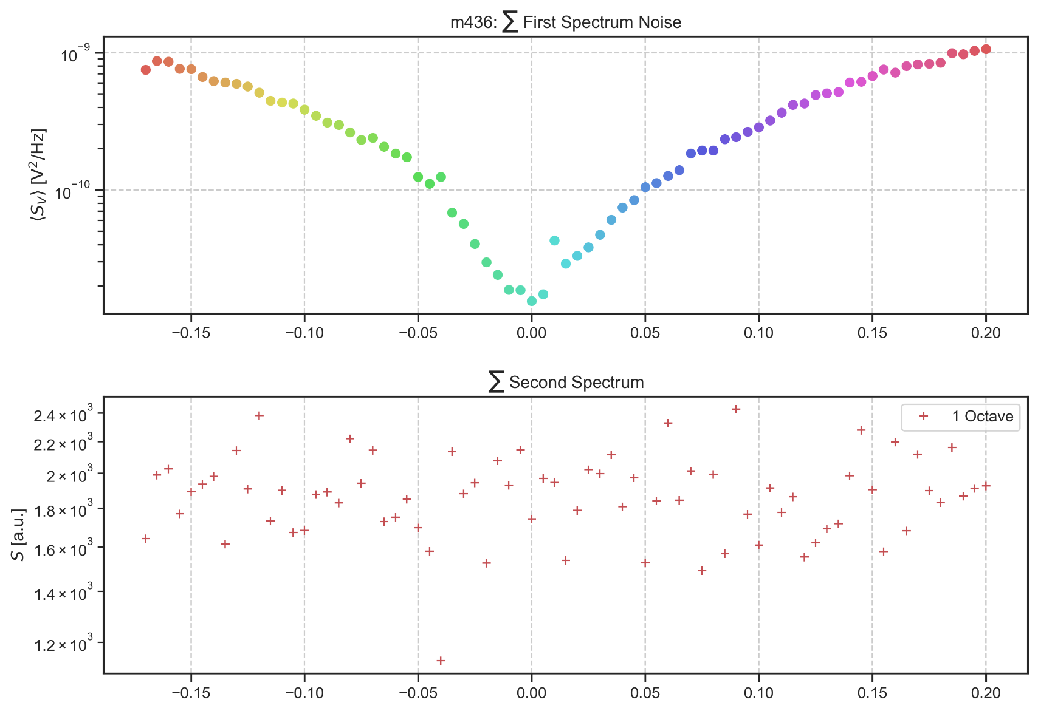

Mittwoch, 22. April 2020

10:32

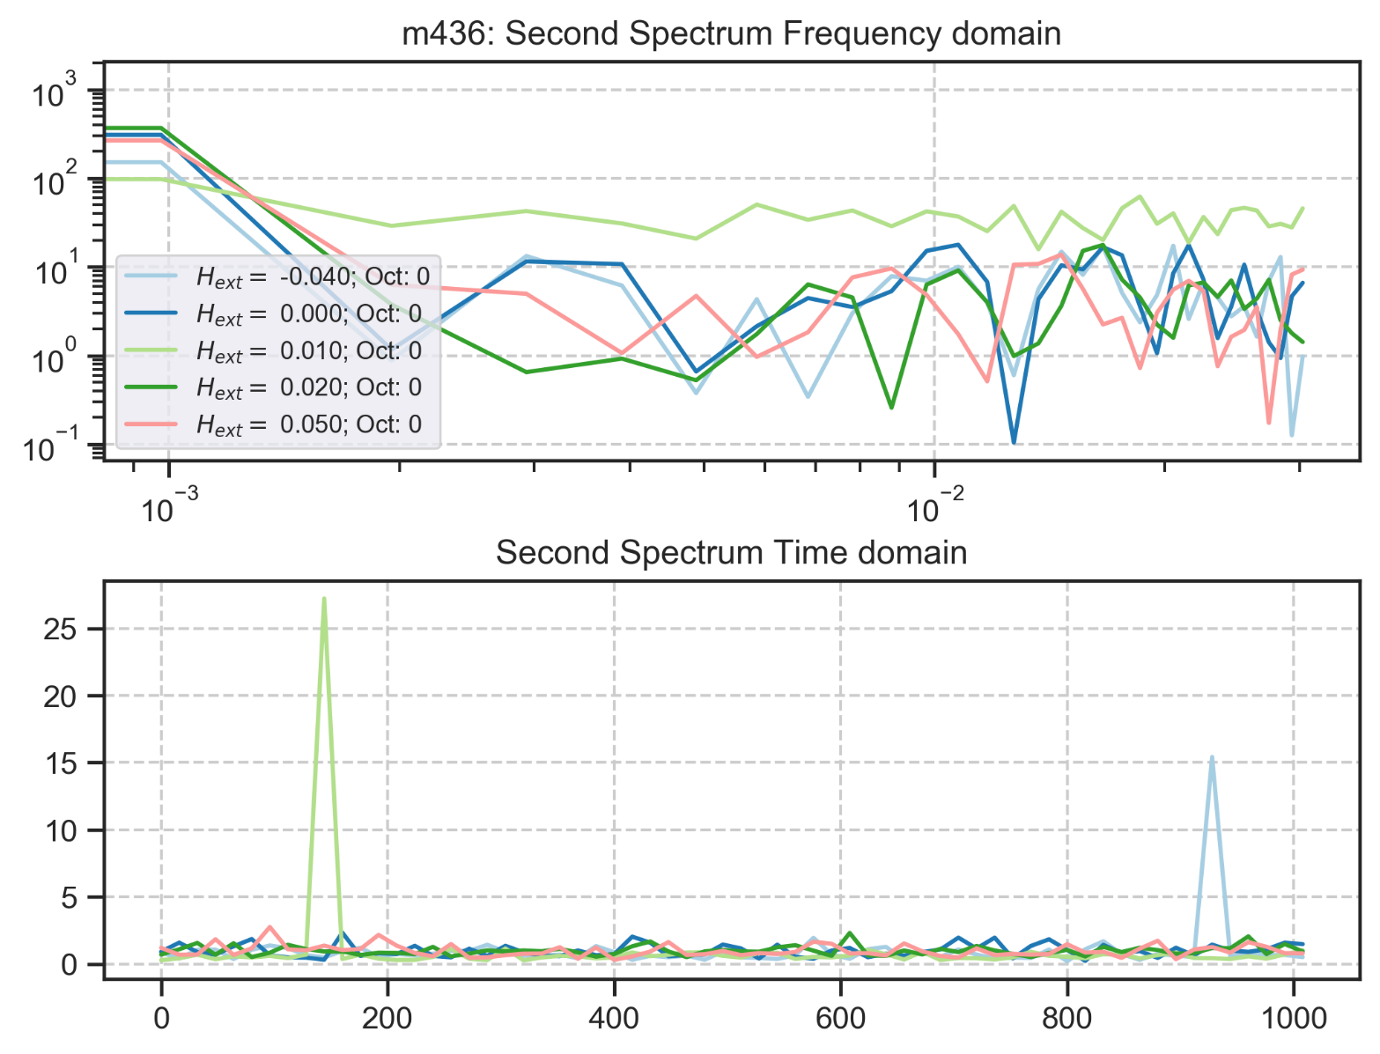

m437: rate:8 Hz Up Sweep

Mittwoch, 18. März 2020

15:13

|  |  |
| --- | --- |
| Angle of sensor θ | *+45* |
| Temp | 30 K |
|  | **Plusses** |
|  | |  |  |  |  | | --- | --- | --- | --- | |  | ***13-1*** |  | *6-8* | | ***Gate (0V)*** | ***9 - 4*** |  | ***7 - 14 (no Preamp.)*** | |
|  | *Saturating at -.3T. sweeping from -150mT → 150mT*  *measuring every 5mT steps (61 different steps)* |
| Resistance Box | |  |  |  |  |  |  | | --- | --- | --- | --- | --- | --- | |  | *1 MΩ* |  | 13,5 kΩ |  |  | |  | *1 MΩ* |  | *1* |  | *1* | |
|  | |  |  |  |  |  |  | | --- | --- | --- | --- | --- | --- | | Sens | 50 μV |  | 5 V | *f* | *113 Hz* | | *τ* | *100 ms* | *Input A* | *AC* | *Ground* | *Normal Reserve* |   *DAQ settings: Rate: 8 Hz* |
| Period of measurement (min) | *768 sec for each field* |
| Data files | in Folder NewMeasurements2020\m437\* |

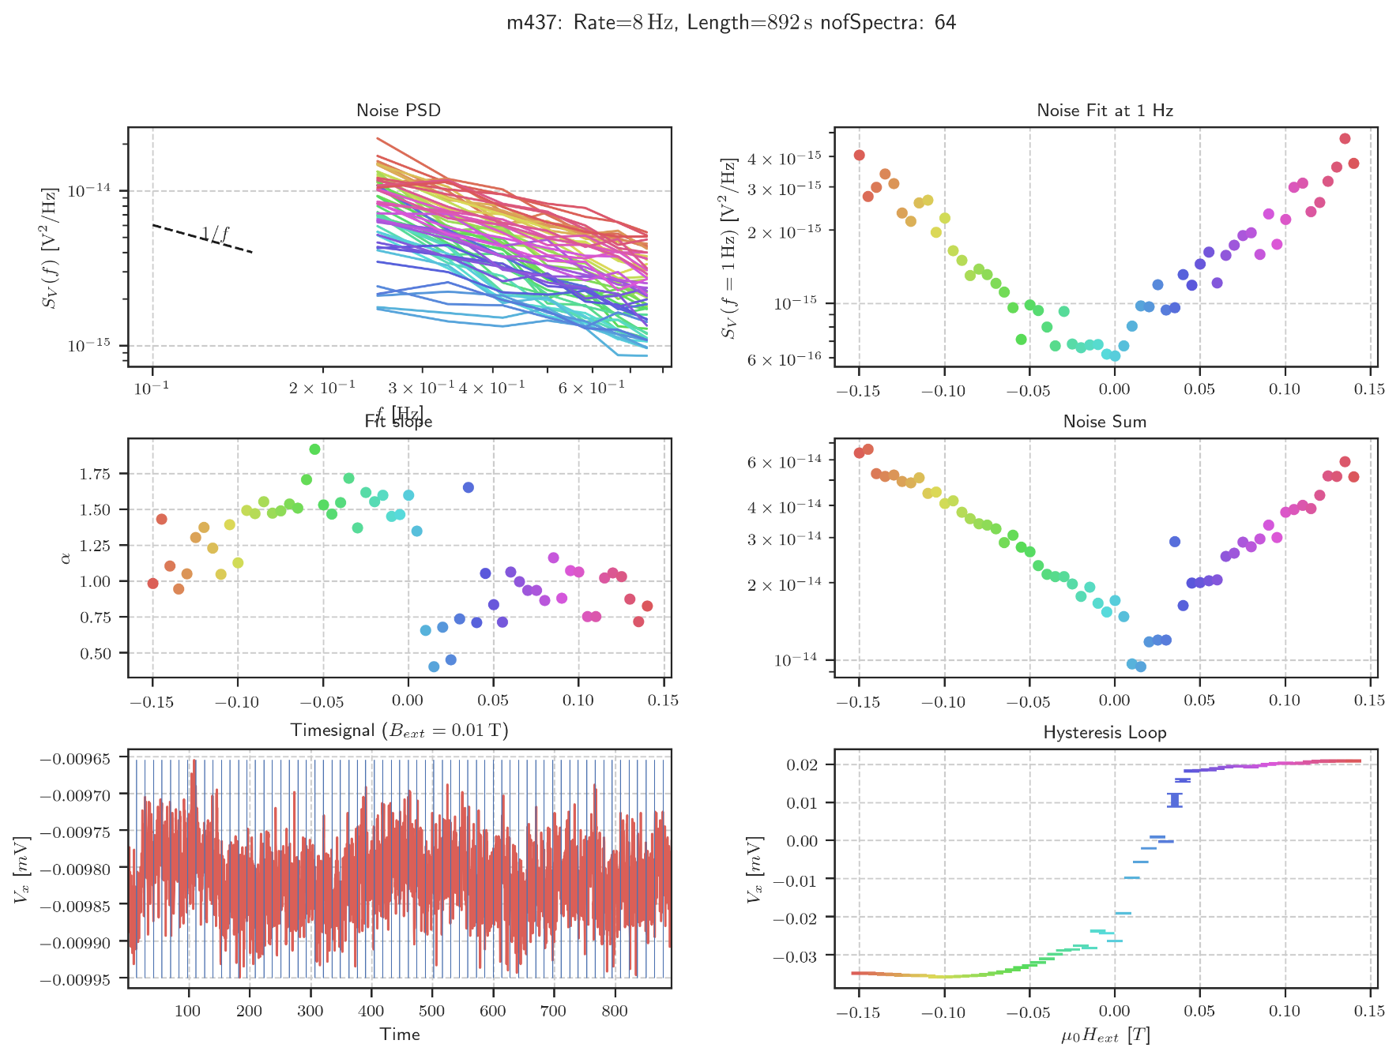

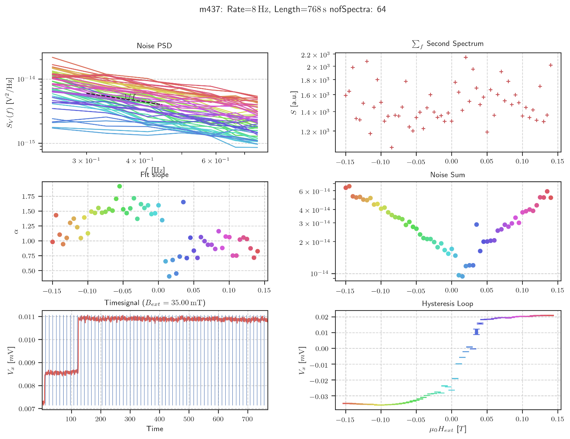

Info2 (64 vs 32 Averages)

Mittwoch, 22. April 2020

10:50

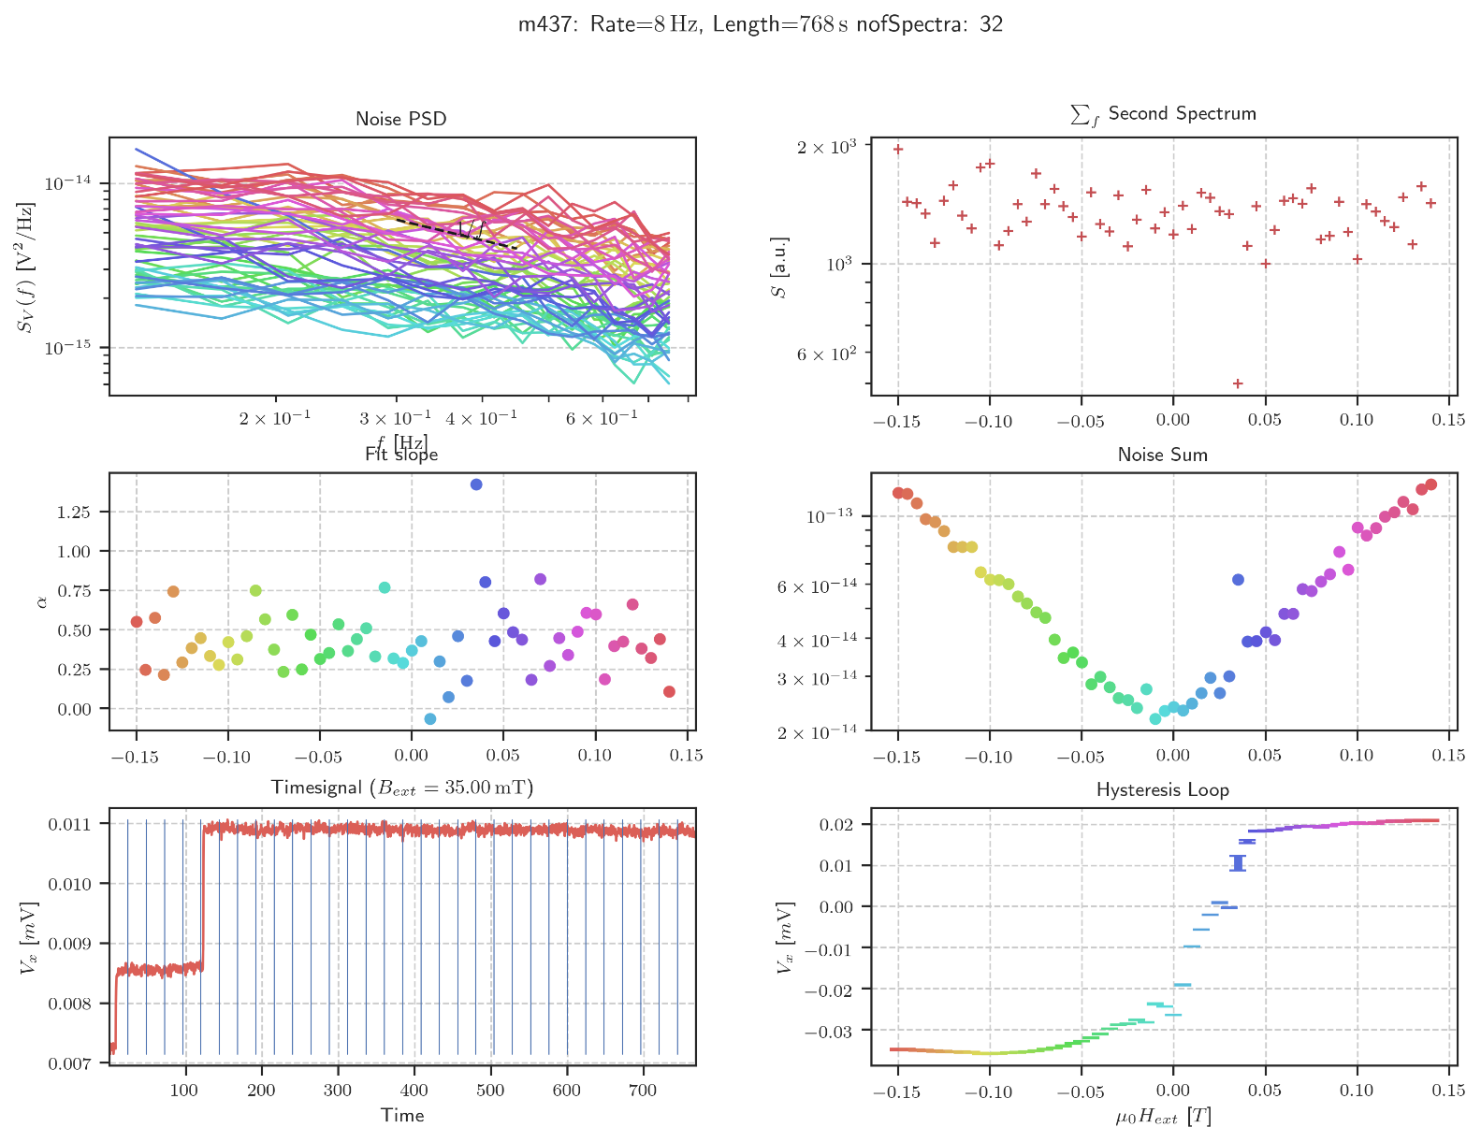

Second Spectrum Overview

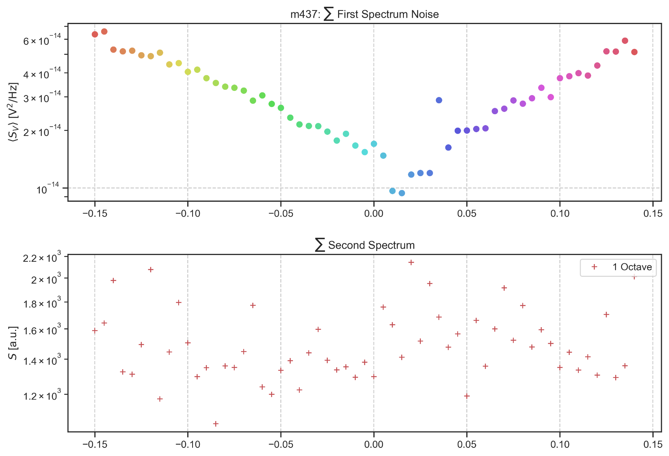

Mittwoch, 22. April 2020

10:45

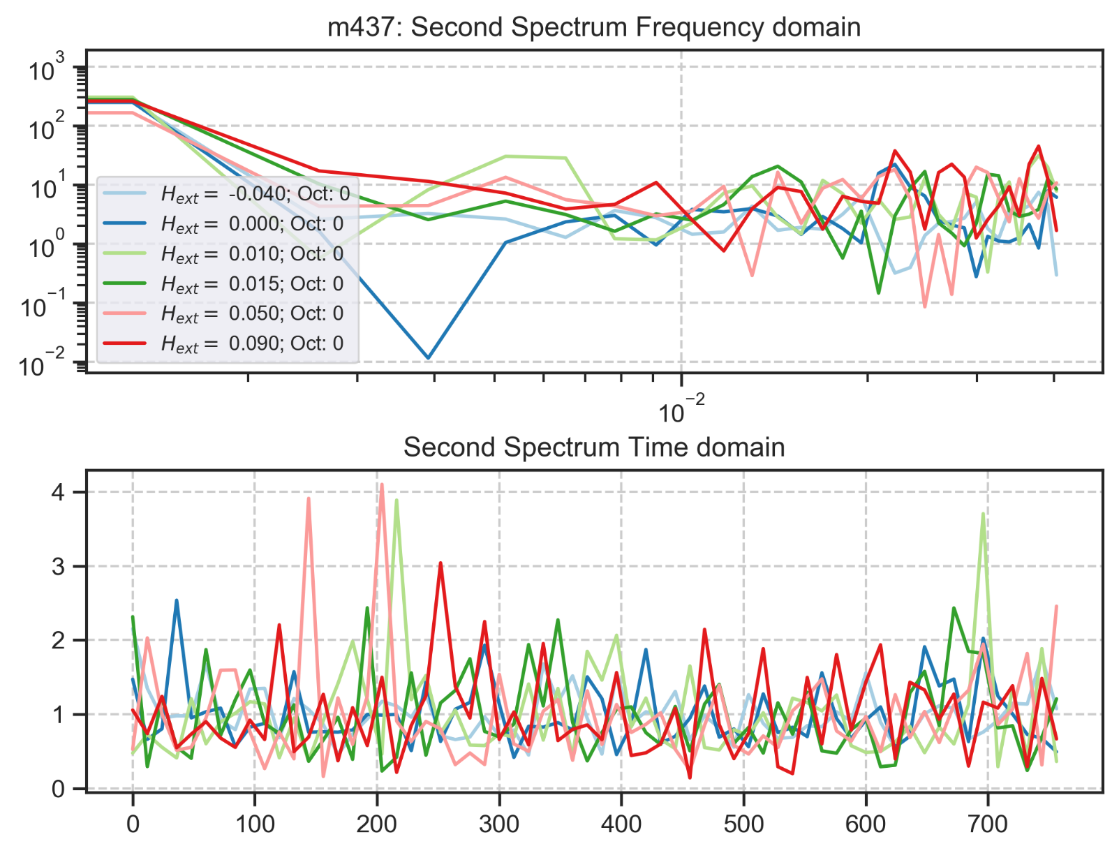

m438: rate:4 Hz 2048 s No Preamp Down Sweep

Donnerstag, 19. März 2020

14:06

|  |  |
| --- | --- |
| Angle of sensor θ | *+45* |
| Temp | 30 K |
|  | **Plusses** |
|  | |  |  |  |  | | --- | --- | --- | --- | |  | ***13-1*** |  | *6-8* | | ***Gate (0V)*** | ***9 - 4*** |  | ***7 - 14 (no Preamp)*** | |
|  | *Saturating at -.3T. sweeping from 100mT → -100mT*  *measuring every 10mT steps (21 different steps)* |
| Resistance Box | |  |  |  |  |  |  | | --- | --- | --- | --- | --- | --- | |  | *1 MΩ* |  | 13,5 kΩ |  |  | |  | *1 MΩ* |  | *1* |  | *1* | |
|  | |  |  |  |  |  |  | | --- | --- | --- | --- | --- | --- | | Sens | 50 μV |  | 5 V | *f* | *113 Hz* | | *τ* | *100 ms* | *Input A* | *AC* | *Ground* | *Normal Reserve* |   *DAQ settings: Rate: 4 Hz* |
| Period of measurement (min) | *2048 sec for each field* |
| Data files | in Folder NewMeasurements2020\m438\* |

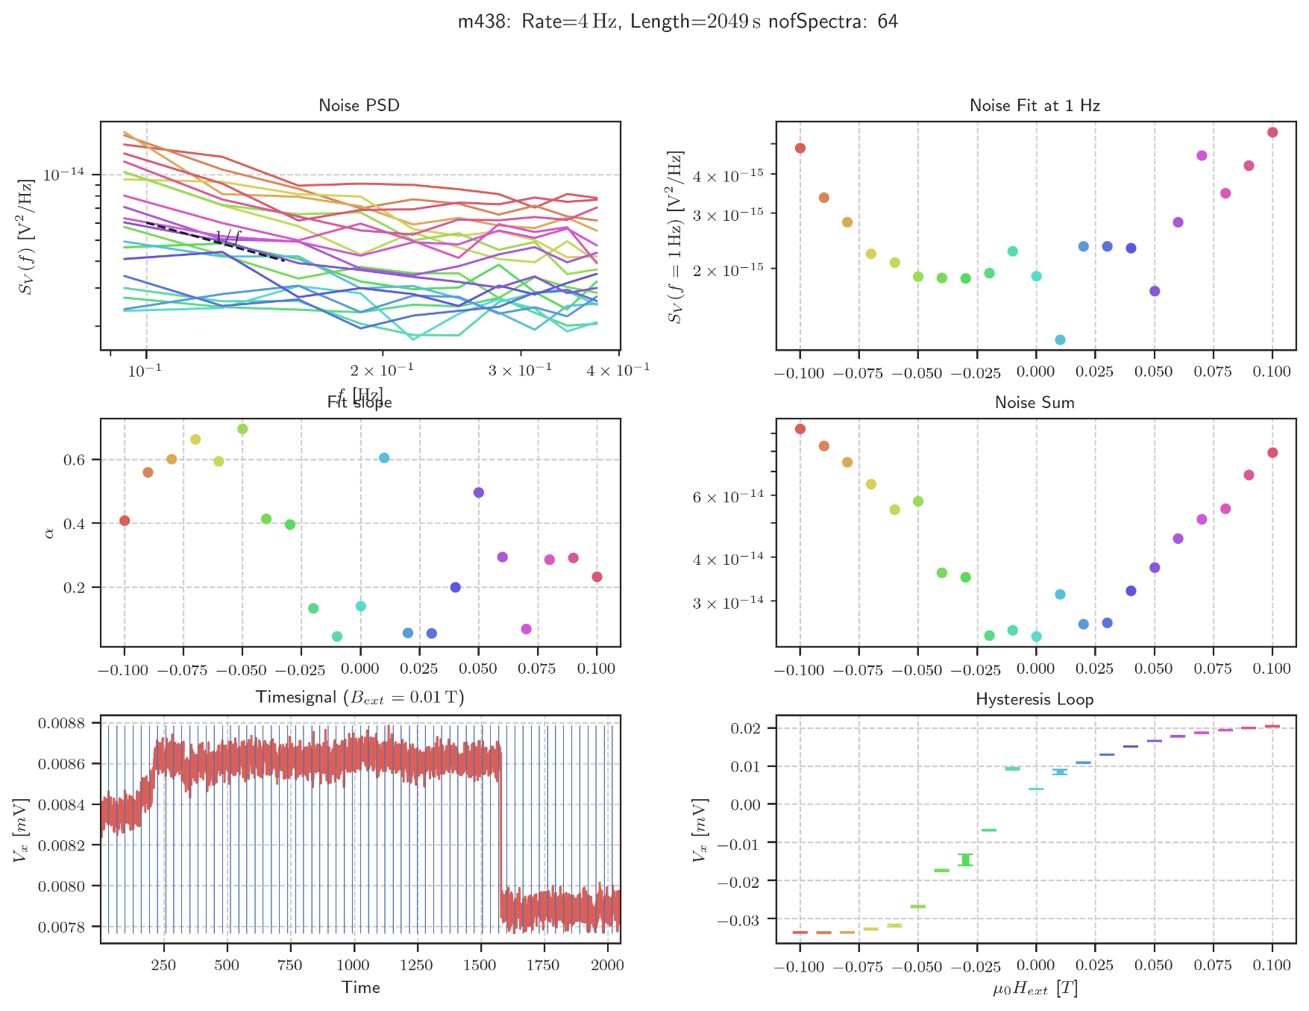

m439: rate:16 Hz 1024s Up Sweep

Freitag, 20. März 2020

02:09

|  |  |
| --- | --- |
| Angle of sensor θ | *+45* |
| Temp | 30 K |
|  | **Plusses** |
|  | |  |  |  |  | | --- | --- | --- | --- | |  | ***13-1*** |  | *6-8* | | ***Gate (0V)*** | ***9 - 4*** |  | ***7 - 14 (No Preamp)*** | |
|  | *Saturating at -.3T. sweeping from -100mT → 100mT*  *measuring every 5mT steps (21 different steps)* |
| Resistance Box | |  |  |  |  |  |  | | --- | --- | --- | --- | --- | --- | |  | *1 MΩ* |  | 13,5 |  |  | |  | *1 MΩ* |  | *1* |  | *1* | |
|  | |  |  |  |  |  |  | | --- | --- | --- | --- | --- | --- | | Sens | 50 μV |  | 5 V | *f* | *113 Hz* | | *τ* | *100 ms* | *Input A* | *AC* | *Ground* | *Normal Reserve* |   *DAQ settings: Rate: 16 Hz* |
| Period of measurement (min) | *1024 sec for each field* |
| Data files | in Folder NewMeasurements2020\m437\* |

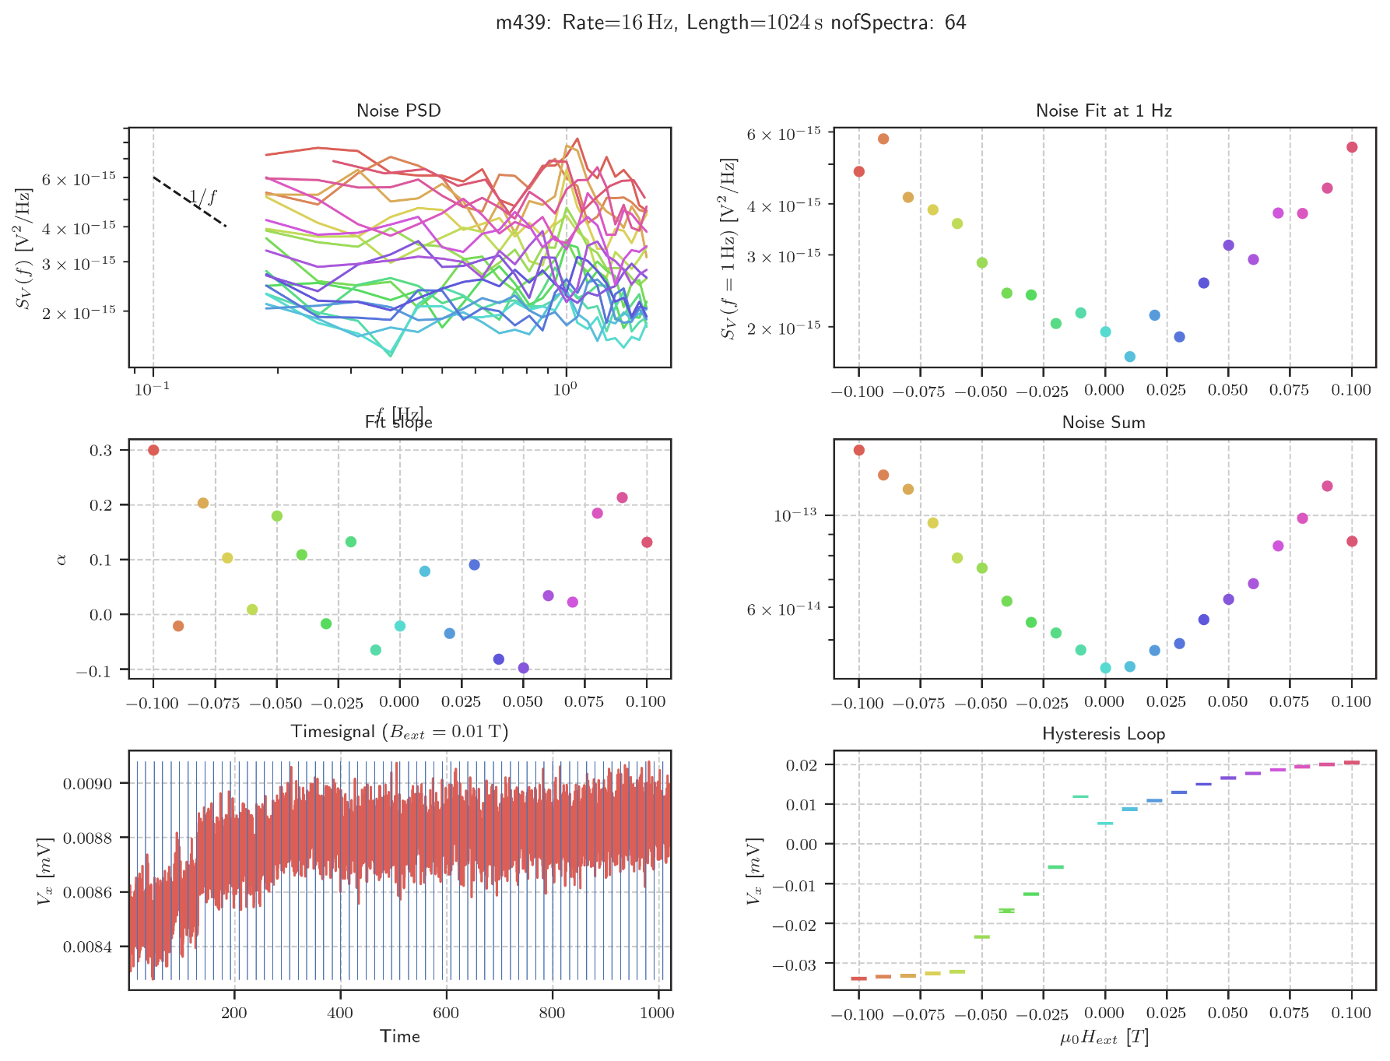

m440: rate:32 Hz 512s

Samstag, 21. März 2020

10:02

|  |  |
| --- | --- |
| Angle of sensor θ | *+45* |
| Temp | 30 K |
|  | **Plusses** |
|  | |  |  |  |  | | --- | --- | --- | --- | |  | ***13-1*** |  | *6-8* | | ***Gate (0V)*** | ***9 - 4*** |  | ***7 - 14 (No Preamp)*** | |
|  | *Saturating at -.3T. sweeping from 100mT → -100mT*  *measuring every 5mT steps (41 different steps)* |
| Resistance Box | |  |  |  |  |  |  | | --- | --- | --- | --- | --- | --- | |  | *1 MΩ* |  | 13,5 |  |  | |  | *1 MΩ* |  | *1* |  | *1* | |
|  | |  |  |  |  |  |  | | --- | --- | --- | --- | --- | --- | | Sens | 20 mV |  | 5 V | *f* | *113 Hz* | | *τ* | *30 ms* | *Input A* | *AC* | *Ground* | *Normal Reserve* |   *DAQ settings: Rate: 32 Hz* |
| Period of measurement (min) | *512 sec for each field* |
| Data files | in Folder NewMeasurements2020\m440\* |

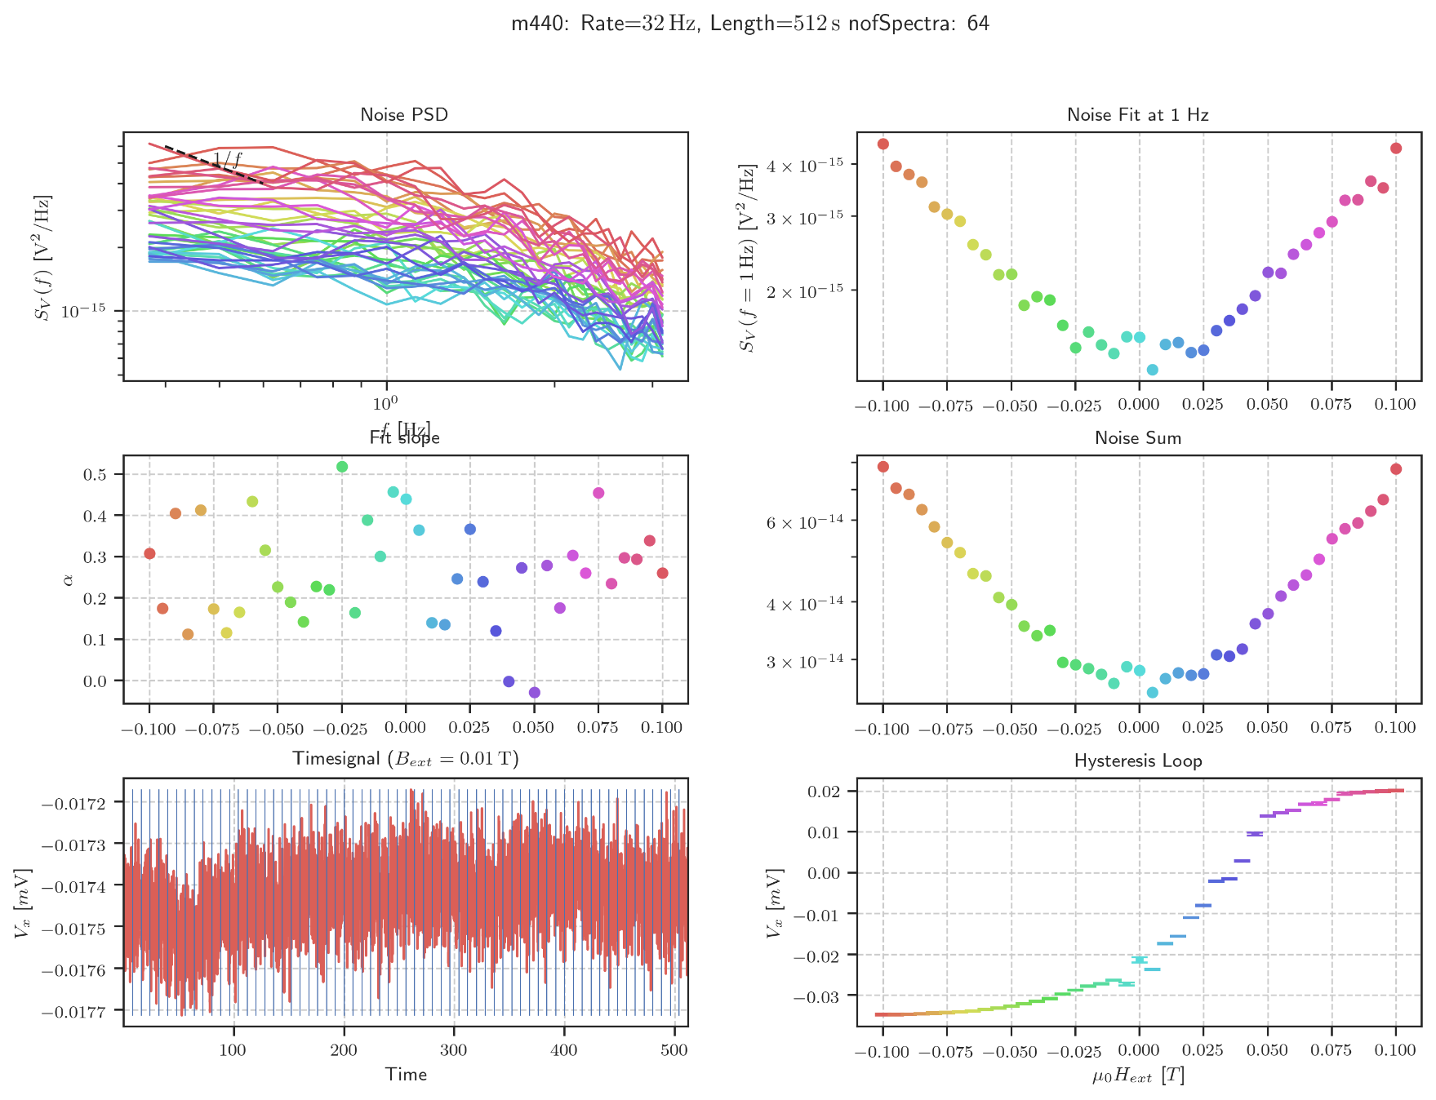

m441: rate:32 Hz 512s

Montag, 23. März 2020

16:46

|  |  |
| --- | --- |
| Angle of sensor θ | *+45* |
| Temp | 30 K |
|  | **Plusses** |
|  | |  |  |  |  | | --- | --- | --- | --- | |  | ***13-1*** |  | *6-8* | | ***Gate (0V)*** | ***9 - 4*** |  | ***7 - 14 (No Preamp)*** | |
|  | *Saturating at -.3T. sweeping from 200mT → -200mT*  *measuring every 5mT steps (41 different steps)* |
| Resistance Box | |  |  |  |  |  |  | | --- | --- | --- | --- | --- | --- | |  | *1 MΩ* |  | 13,5 |  |  | |  | *1 MΩ* |  | *1* |  | *1* | |
|  | |  |  |  |  |  |  | | --- | --- | --- | --- | --- | --- | | Sens | 20 mV |  | 5 V | *f* | *113 Hz* | | *τ* | *30 ms* | *Input A* | *AC* | *Ground* | *Normal Reserve* |   *DAQ settings: Rate: 8 Hz* |
| Period of measurement (min) | *1024 sec for each field* |
| Data files | in Folder NewMeasurements2020\m440\* |

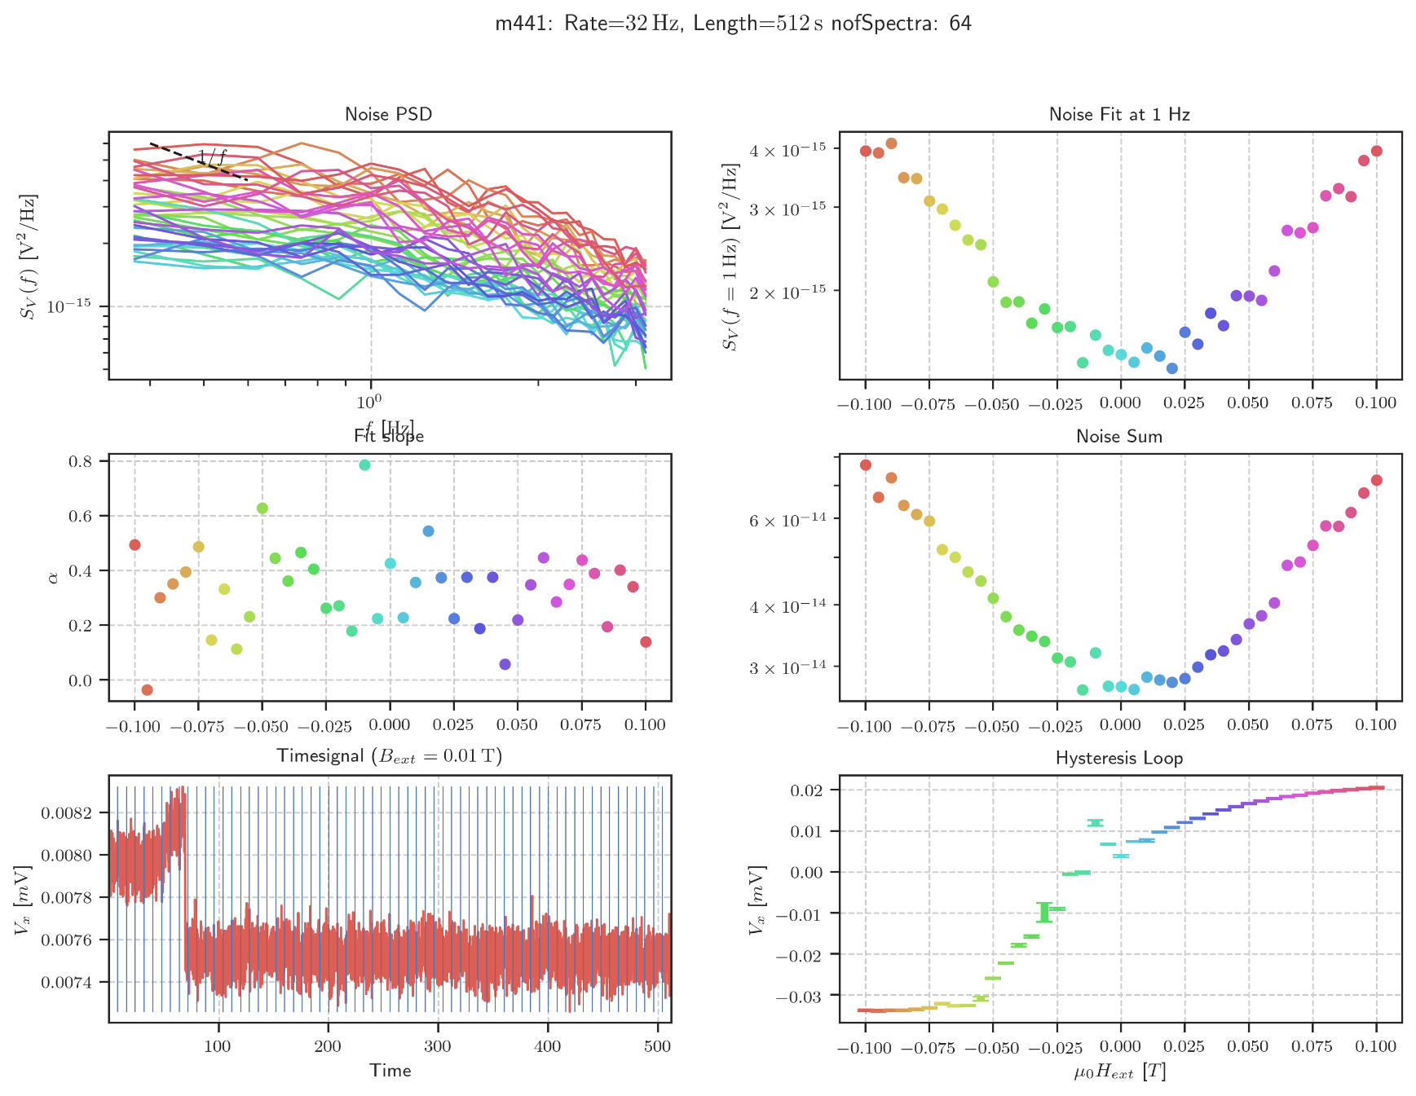

m442: rate:4 Hz 2048s

Montag, 23. März 2020

16:46

|  |  |
| --- | --- |
| Angle of sensor θ | *+45* |
| Temp | 30 K |
|  | **Plusses** |
|  | |  |  |  |  | | --- | --- | --- | --- | |  | ***13-1*** |  | *6-8* | | ***Gate (0V)*** | ***9 - 4*** |  | ***7 - 14 (No Preamp)*** | |
|  | *Saturating at -.3T. sweeping from 200mT → -200mT*  *measuring every 5mT steps (41 different steps)* |
| Resistance Box | |  |  |  |  |  |  | | --- | --- | --- | --- | --- | --- | |  | *1 MΩ* |  | 13,5 |  |  | |  | *1 MΩ* |  | *1* |  | *1* | |
|  | |  |  |  |  |  |  | | --- | --- | --- | --- | --- | --- | | Sens | 20 mV |  | 5 V | *f* | *113 Hz* | | *τ* | *30 ms* | *Input A* | *AC* | *Ground* | *Normal Reserve* |   *DAQ settings: Rate: 8 Hz* |
| Period of measurement (min) | *1024 sec for each field* |
| Data files | in Folder NewMeasurements2020\m440\* |

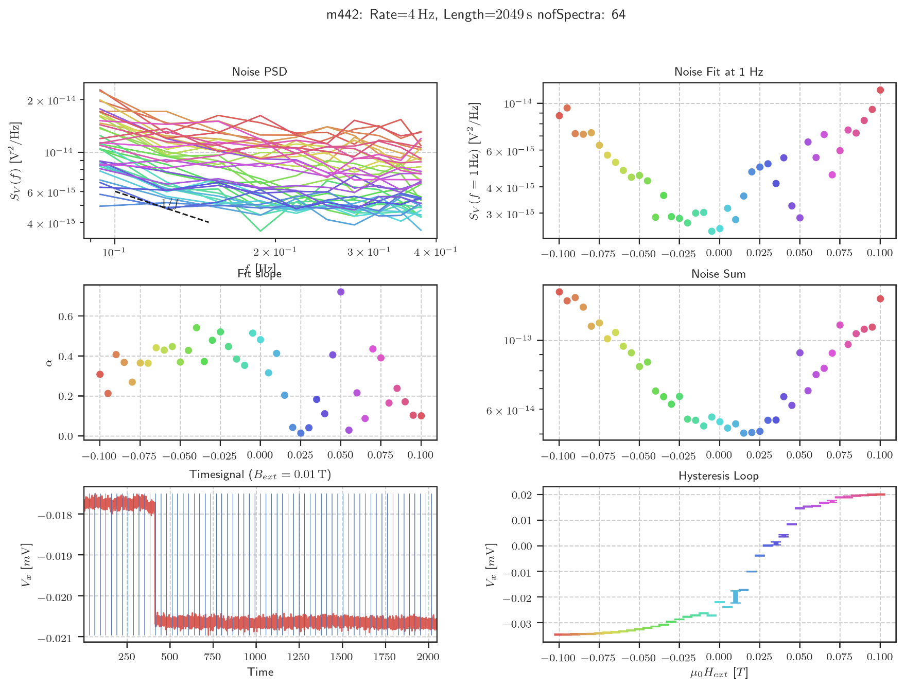

m443: rate:8 Hz 2048s Down

Montag, 23. März 2020

16:46

|  |  |
| --- | --- |
| Angle of sensor θ | *+45* |
| Temp | 30 - 5 K (slow cooldown due to missing exchange gas)  *Starting @ 17:30 with 28K (INSTABLE)* |
|  | **Plusses** |
|  | |  |  |  |  | | --- | --- | --- | --- | |  | ***13-1*** |  | *6-8* | | ***Gate (0V)*** | ***9 - 4*** |  | ***7 - 14 (No Preamp)*** | |
|  | *Saturating at -.3T. sweeping from 100mT → -100mT*  *measuring every 5mT steps (41 different steps)* |
| Resistance Box | |  |  |  |  |  |  | | --- | --- | --- | --- | --- | --- | |  | *1 MΩ* |  | 13,5 |  |  | |  | *1 MΩ* |  | *1* |  | *1* | |
|  | |  |  |  |  |  |  | | --- | --- | --- | --- | --- | --- | | Sens | 20 μV |  | 5 V | *f* | *113 Hz* | | *τ* | *100 ms* | *Input A* | *AC* | *Ground* | *Normal Reserve* |   *DAQ settings: Rate: 8 Hz* |
| Period of measurement (min) | *2048 sec for each field* |
| Data files | in Folder NewMeasurements2020\m443\* |

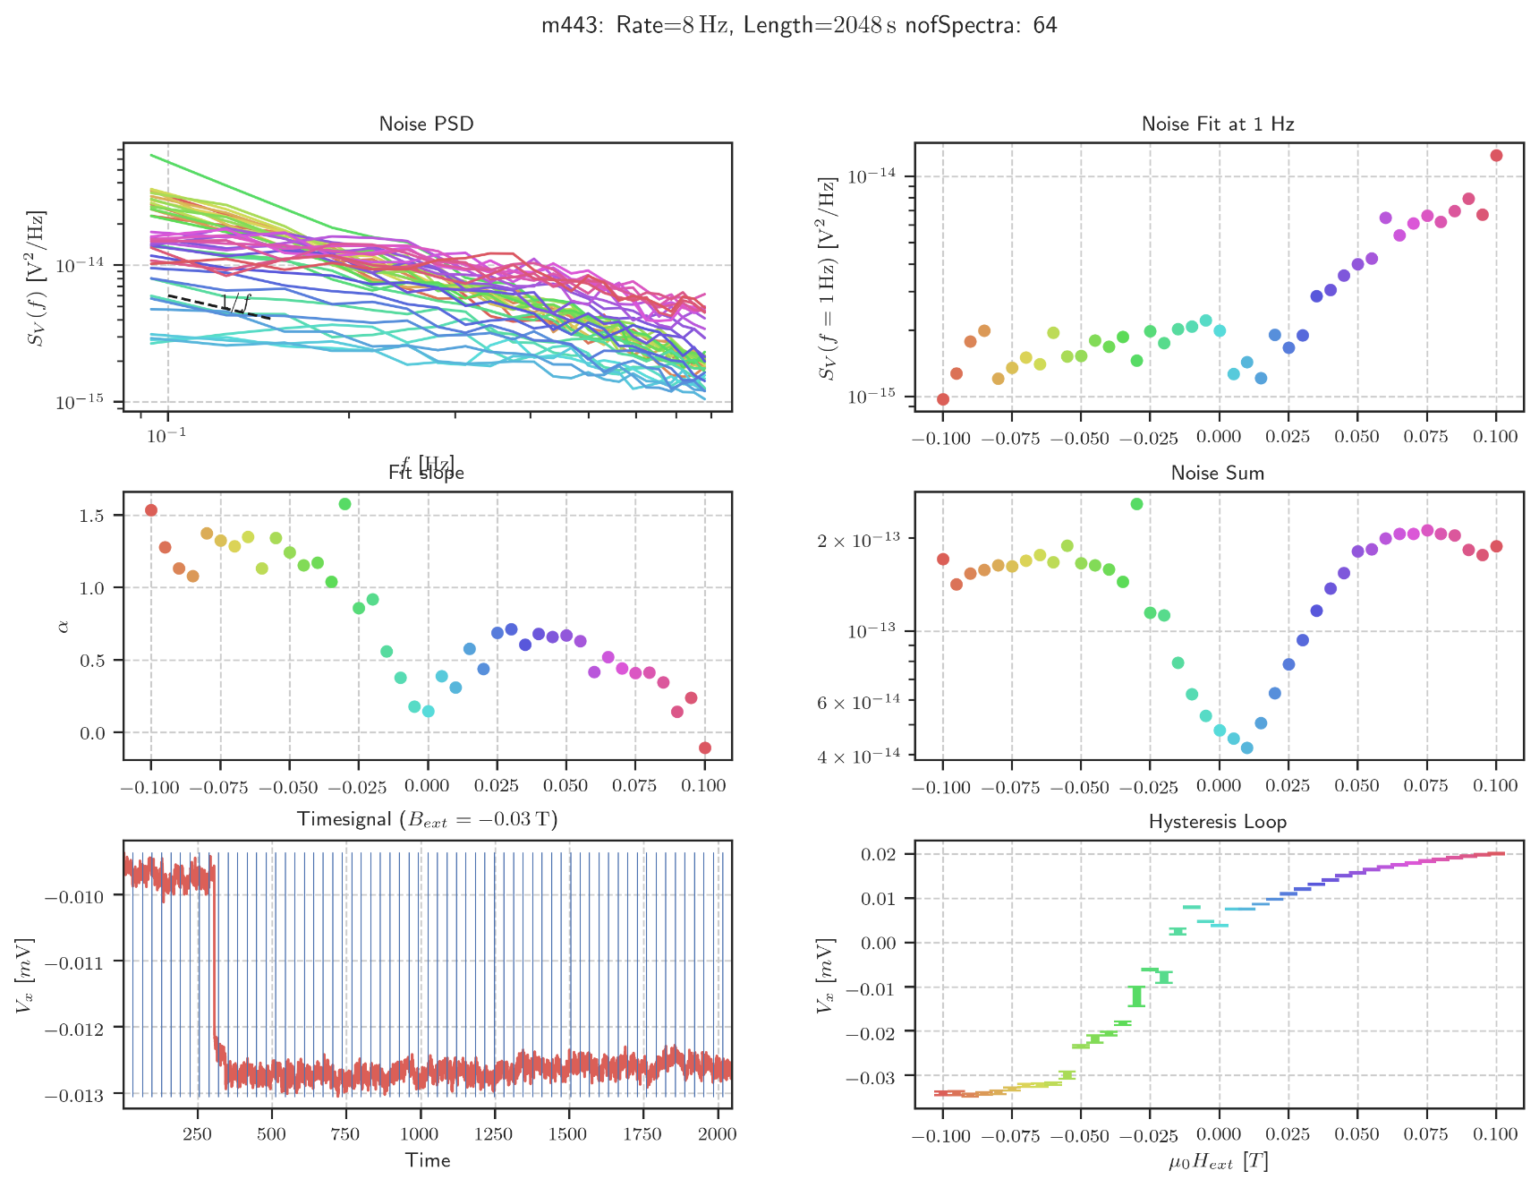

Violin Plot (-.05 -> -.01)

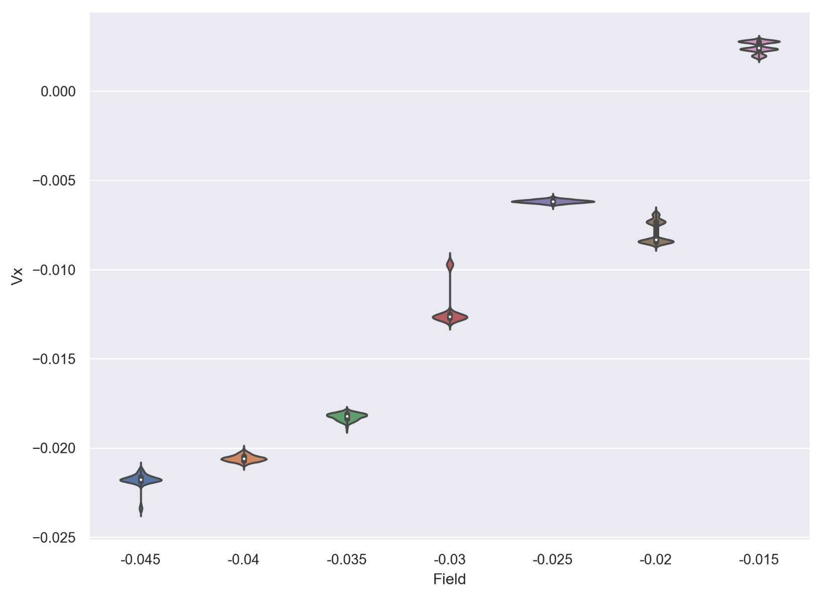

Mittwoch, 22. April 2020

11:47

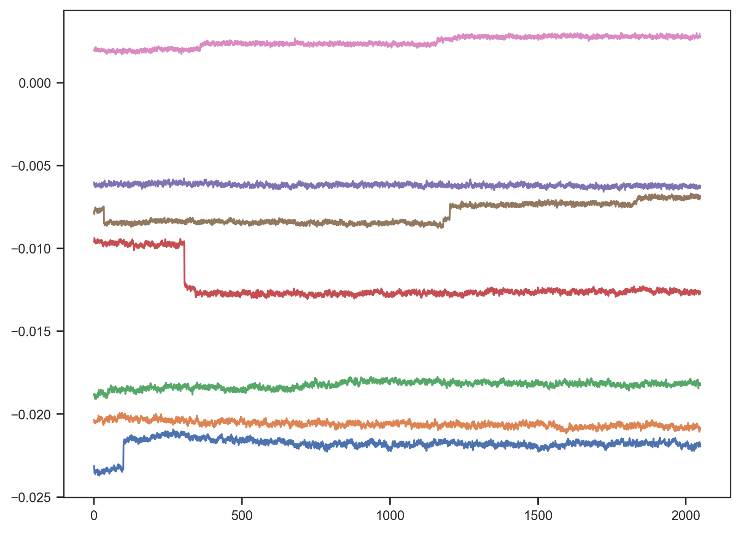

Second Spectrum Info32

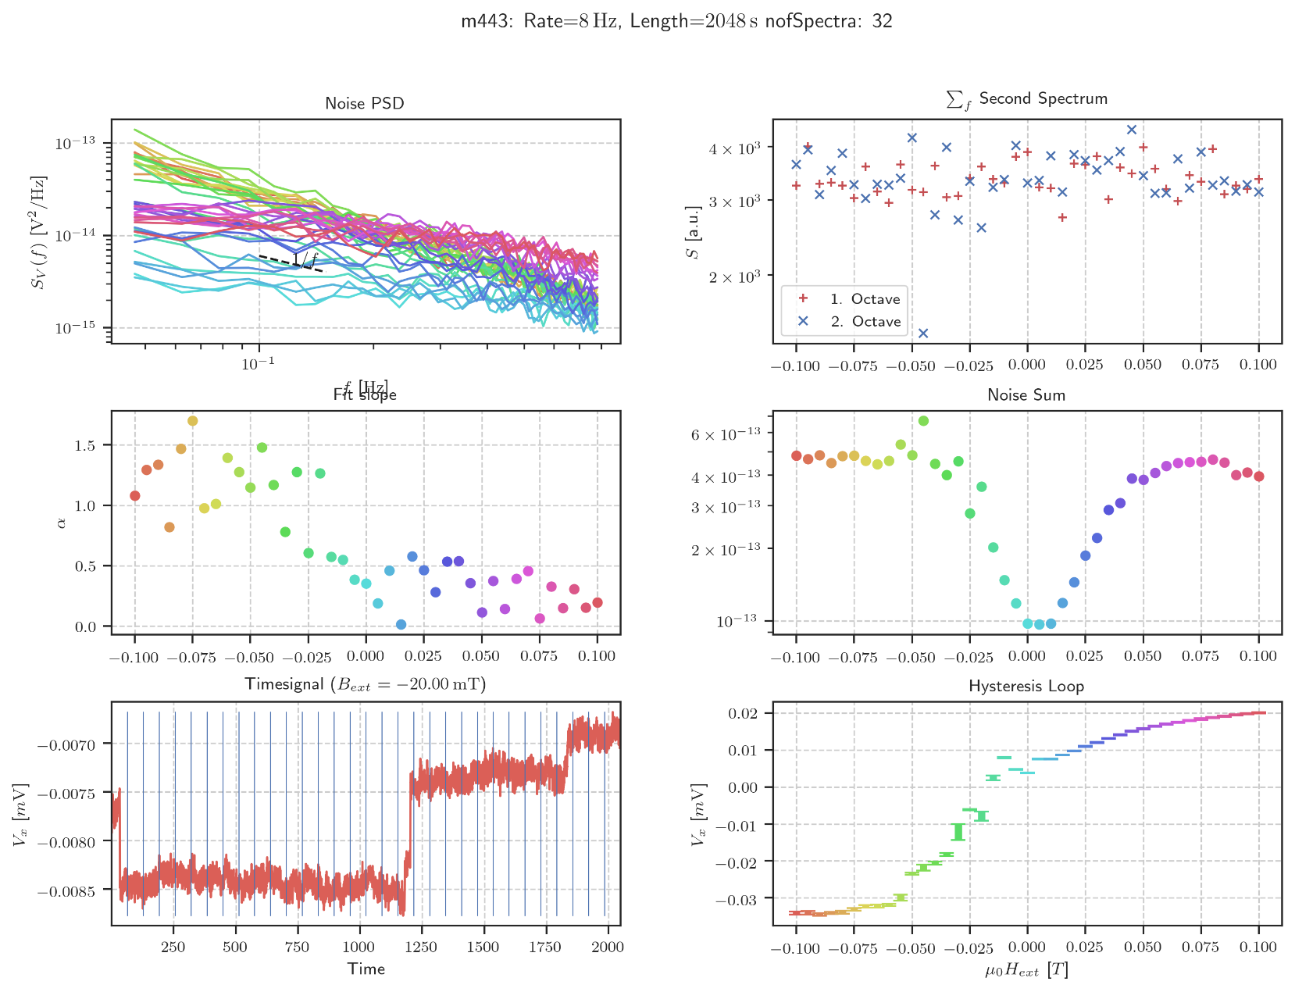

Mittwoch, 22. April 2020

11:13

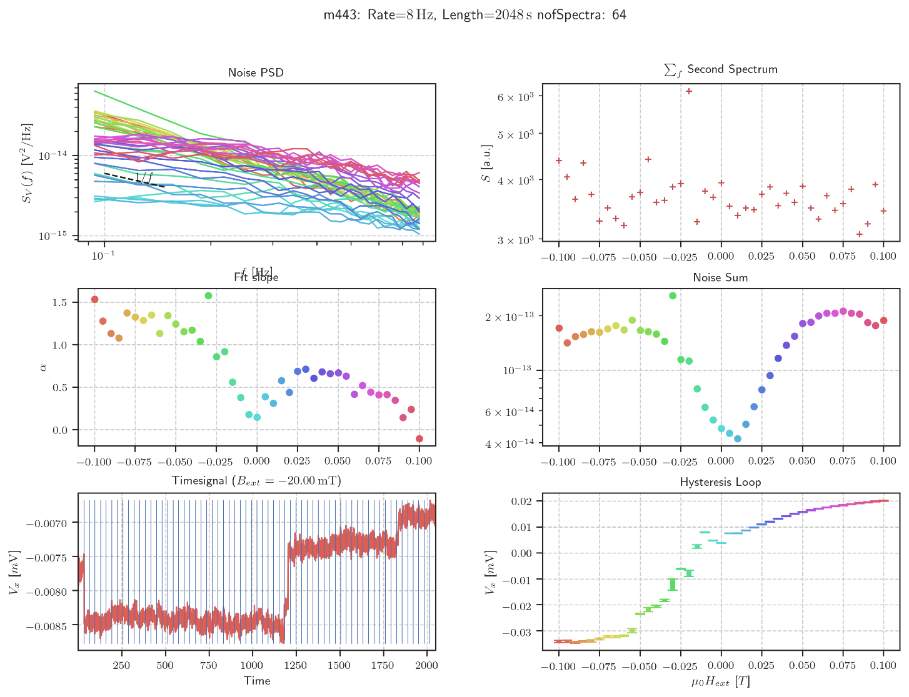

Second Spectrum

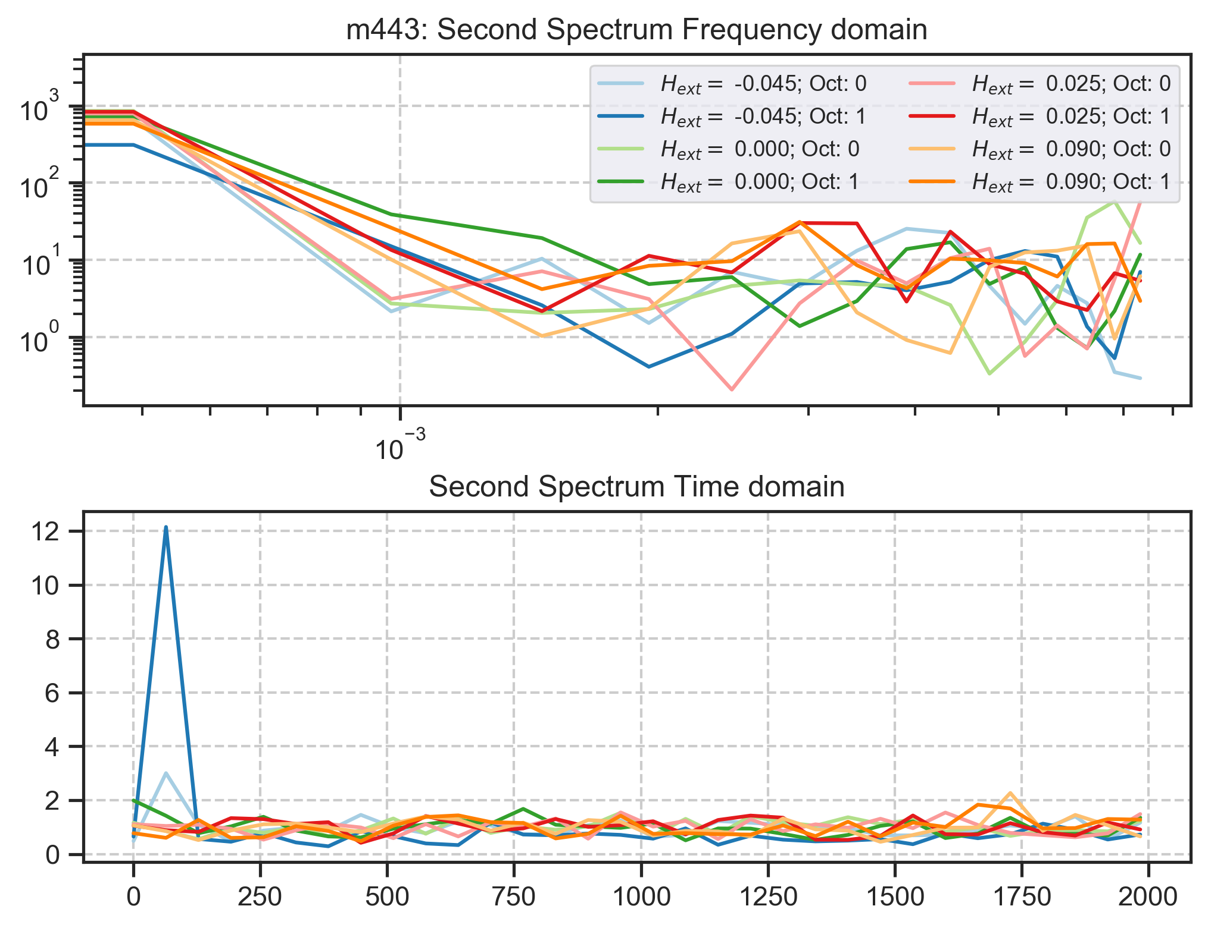

Mittwoch, 22. April 2020

11:19

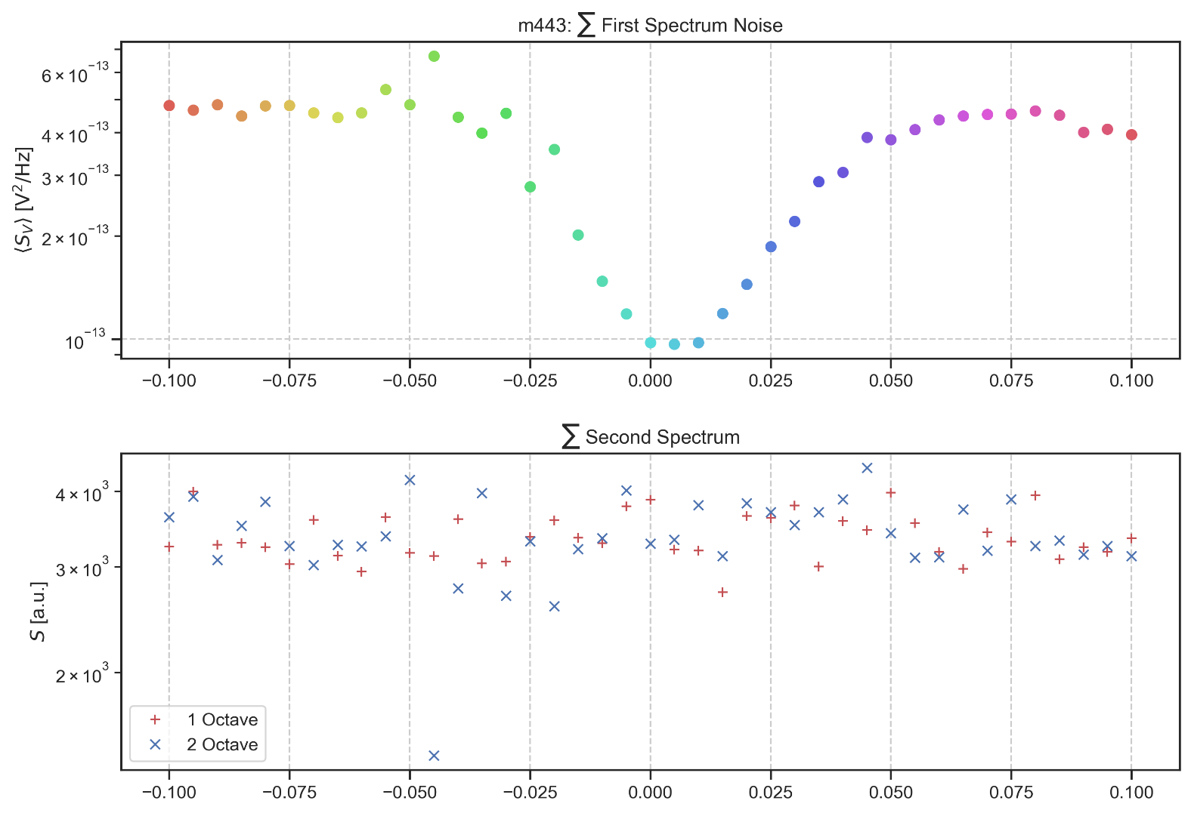

Time Signal vs Second Spectrum

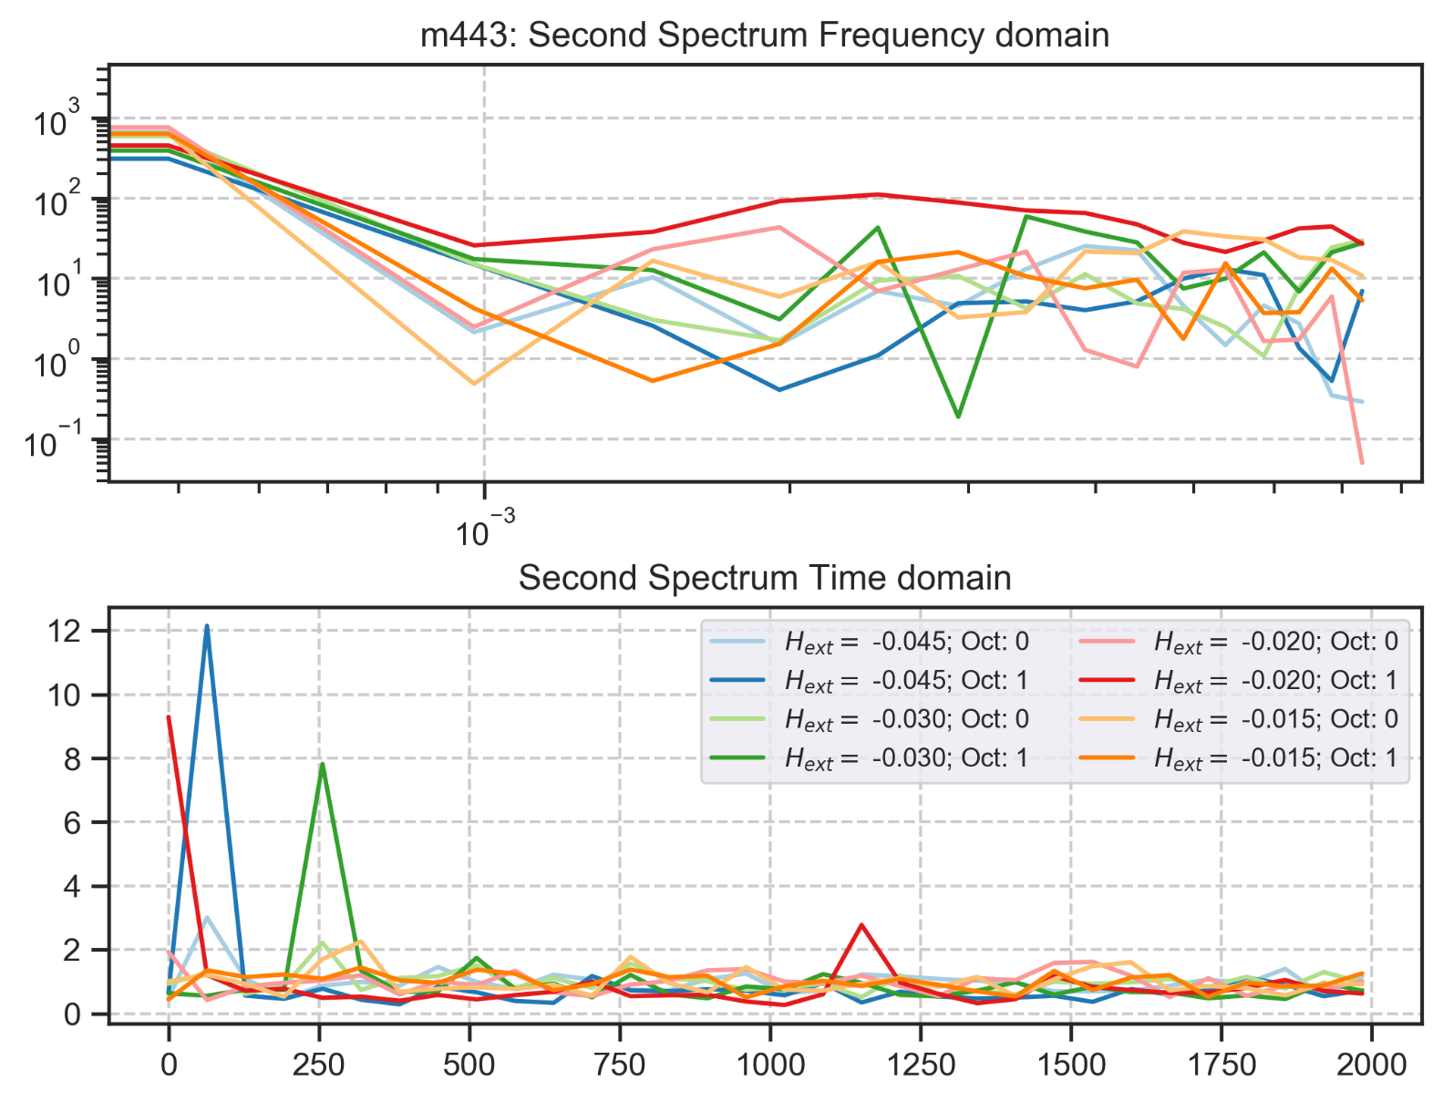

Mittwoch, 22. April 2020

11:39

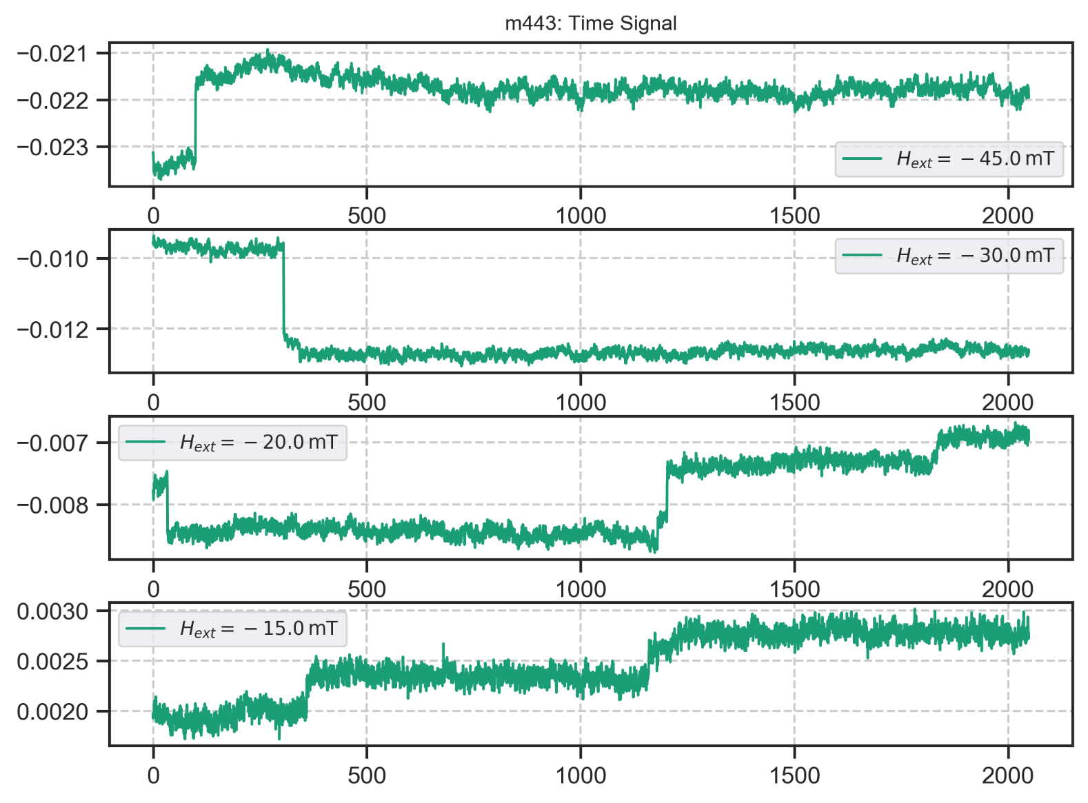

Second Spectrum 64 Averages

Mittwoch, 22. April 2020

12:45

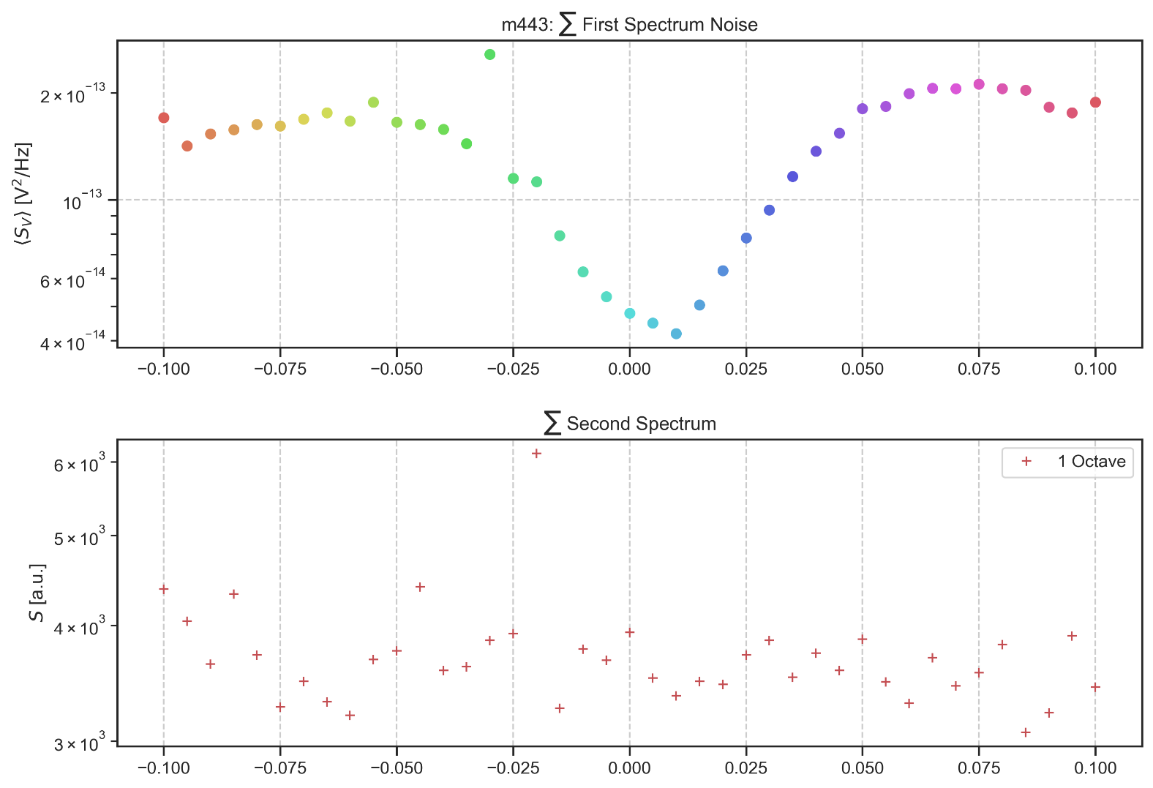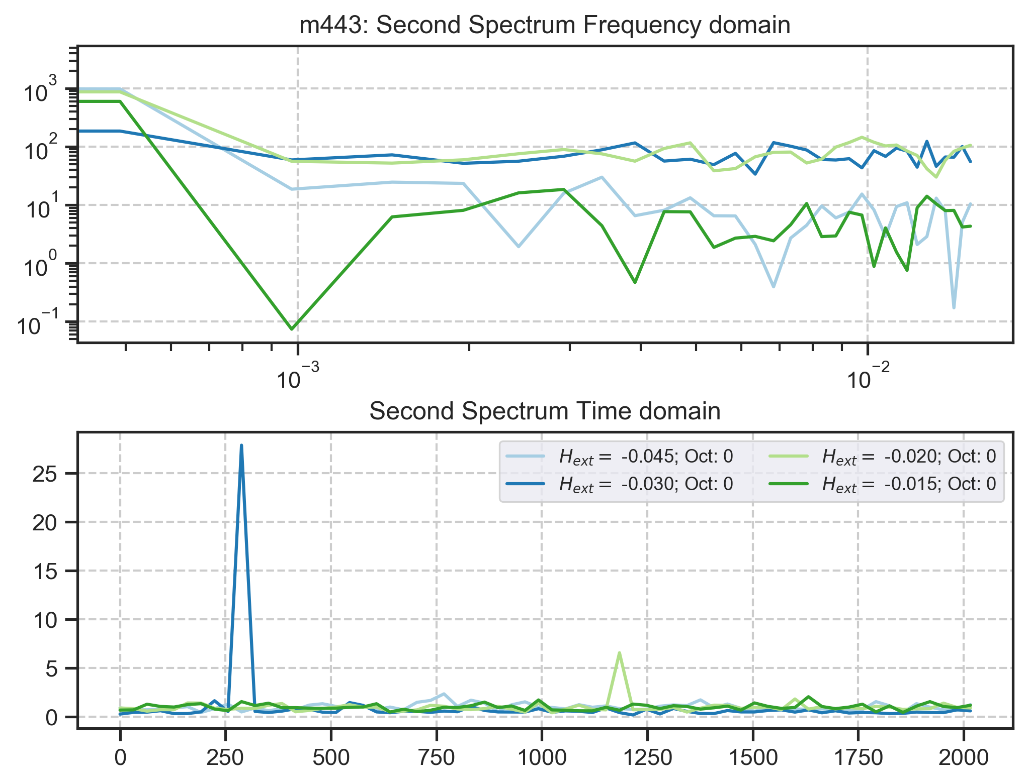

m444: rate:8 Hz 2048s Up

Montag, 23. März 2020

17:29

|  |  |
| --- | --- |
| Angle of sensor θ | *+45* |
| Temp | Ended @ 11 K (INSTABLE) |
|  | **Plusses** |
|  | |  |  |  |  | | --- | --- | --- | --- | |  | ***13-1*** |  | *6-8* | | ***Gate (0V)*** | ***9 - 4*** |  | ***7 - 14 (No Preamp)*** | |
|  | *Saturating at -.3T. sweeping from 100mT → -100mT*  *measuring every 5mT steps (41 different steps)* |
| Resistance Box | |  |  |  |  |  |  | | --- | --- | --- | --- | --- | --- | |  | *1 MΩ* |  | 13,5 |  |  | |  | *1 MΩ* |  | *1* |  | *1* | |
|  | |  |  |  |  |  |  | | --- | --- | --- | --- | --- | --- | | Sens | 50 μV |  | 5 V | *f* | *113 Hz* | | *τ* | *30 ms* | *Input A* | *AC* | *Ground* | *Normal Reserve* |   *DAQ settings: Rate: 8 Hz* |
| Period of measurement (min) | *2048 sec for each field* |
| Data files | in Folder NewMeasurements2020\m444\* |

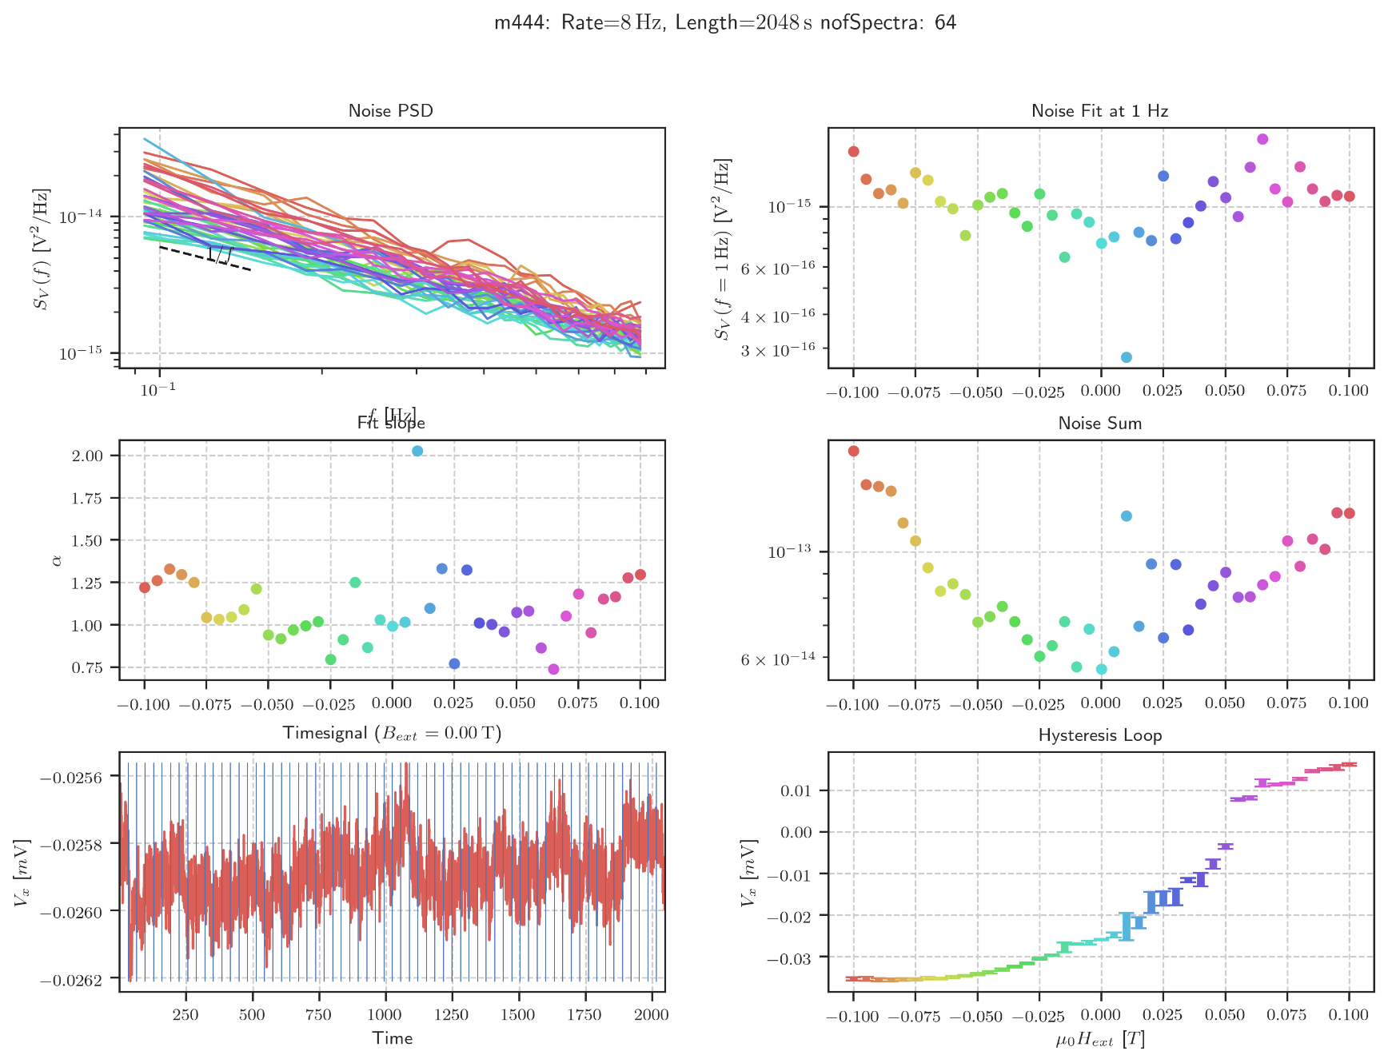

Noise Hysteresis (443/444)

Temperature Sweep from 30K -> 10K (to save Helium)

Mittwoch, 22. April 2020

11:26

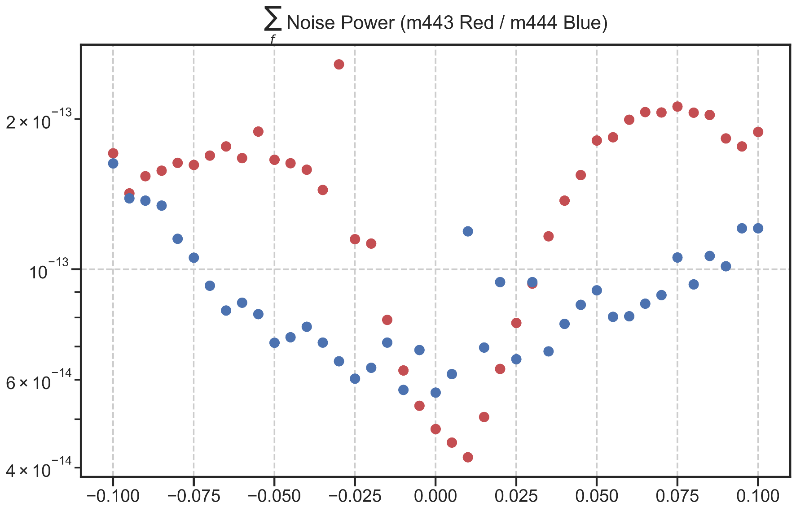

Violin Plot (0.01 -> 0.05)

Mittwoch, 22. April 2020

15:07

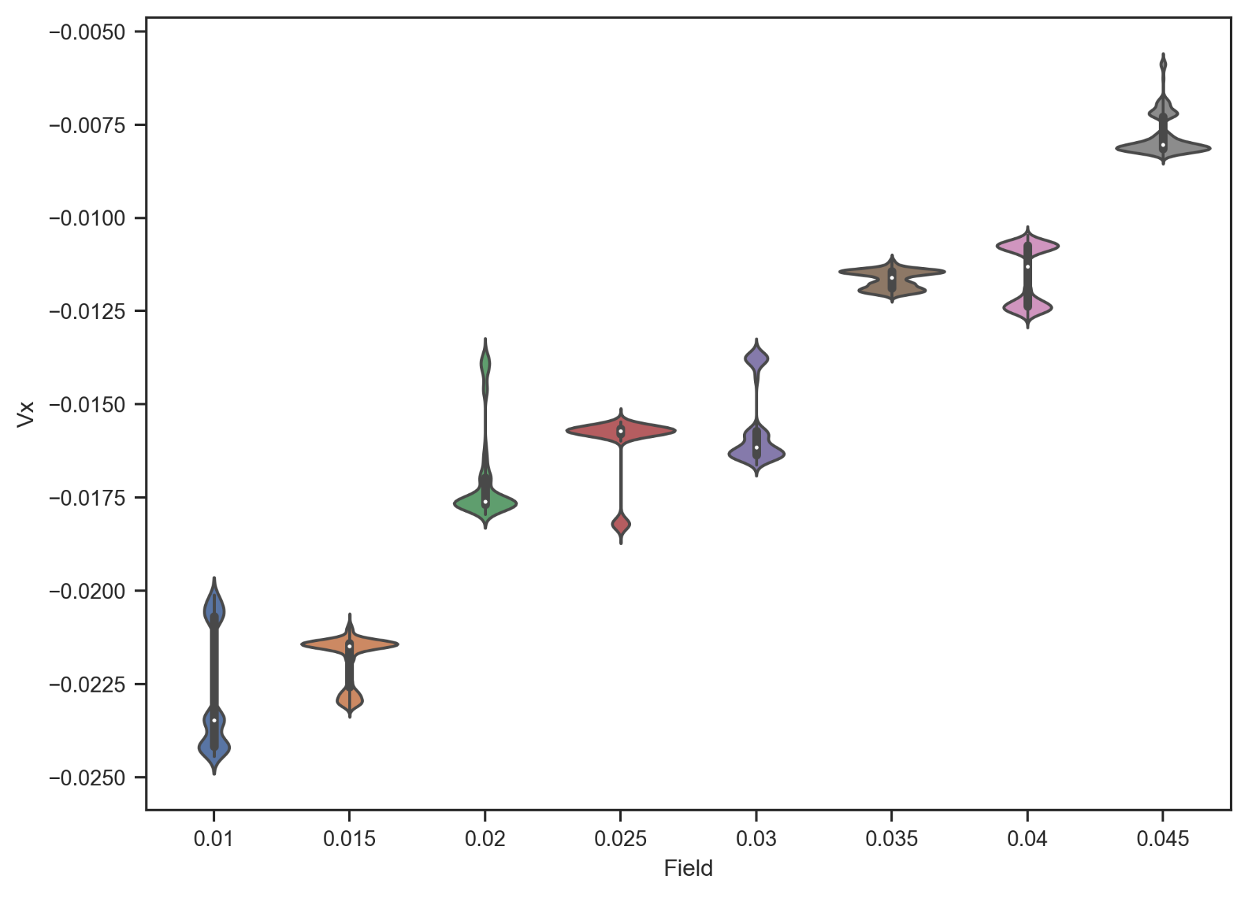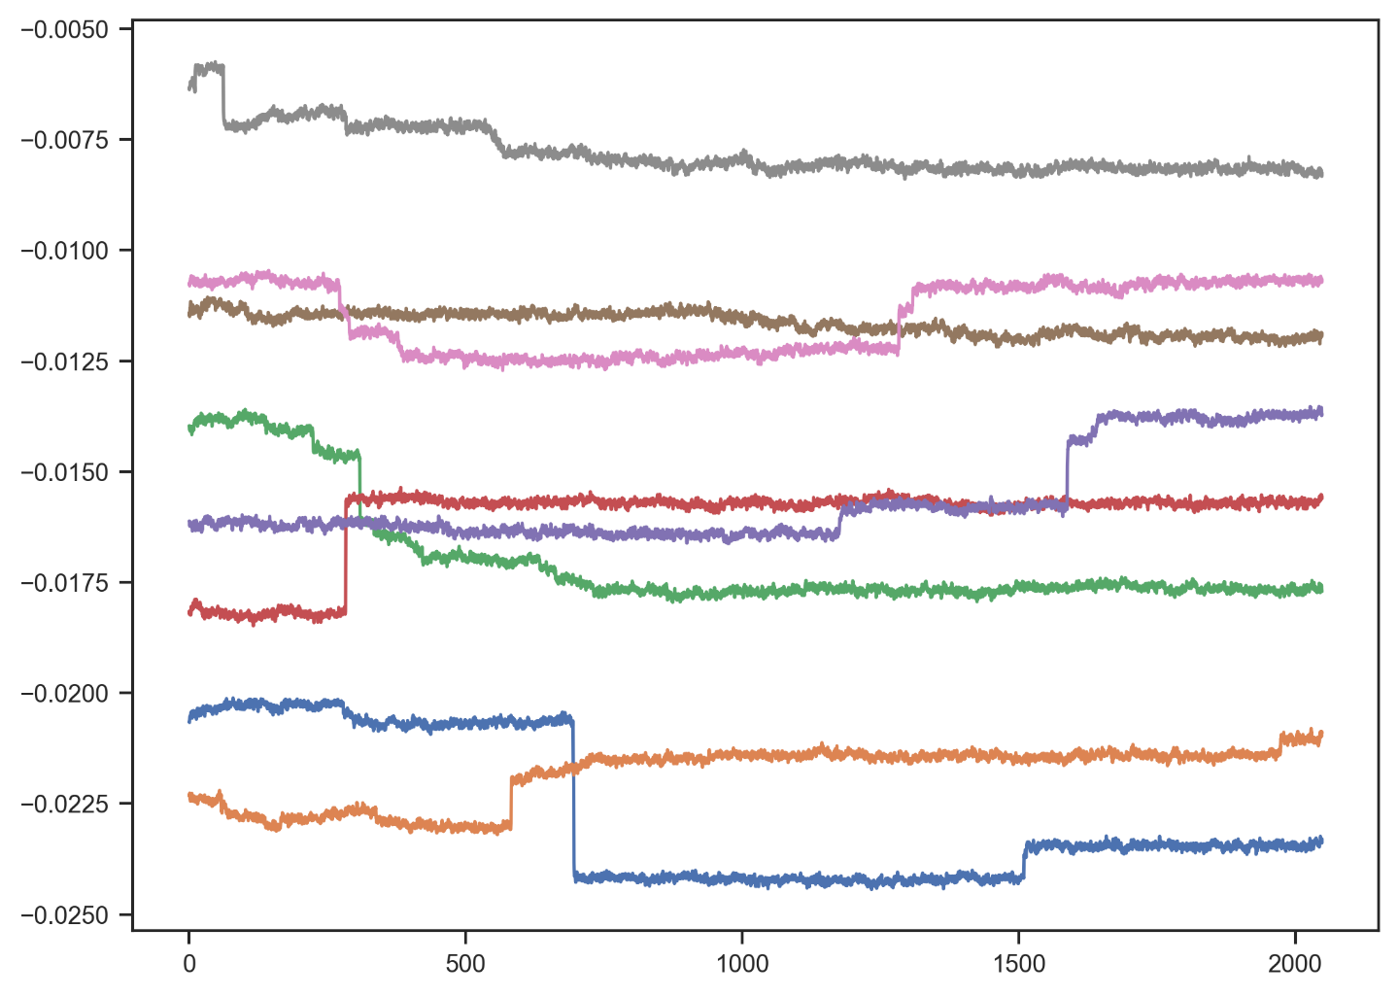

Info 2

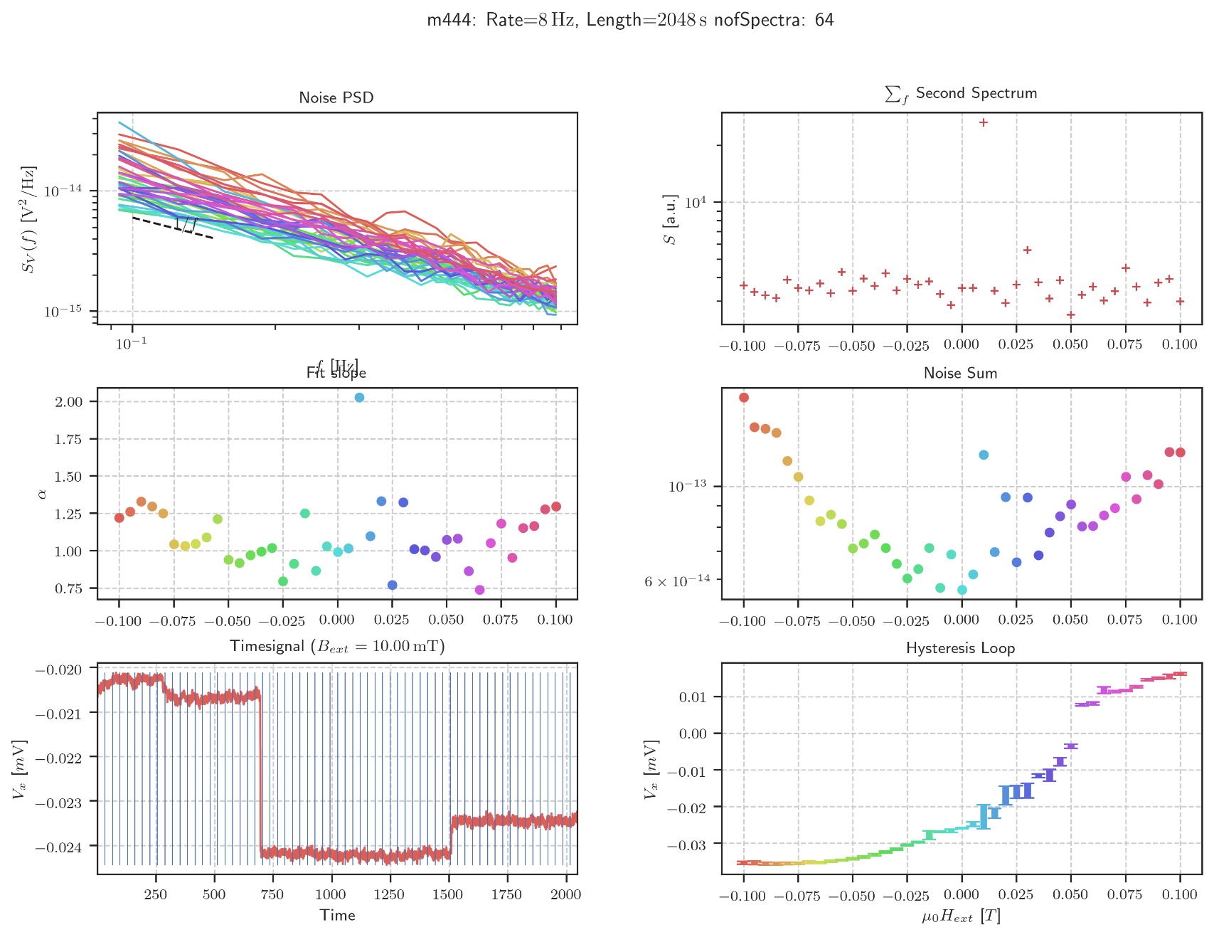

Mittwoch, 22. April 2020

14:33

Second Spectrum

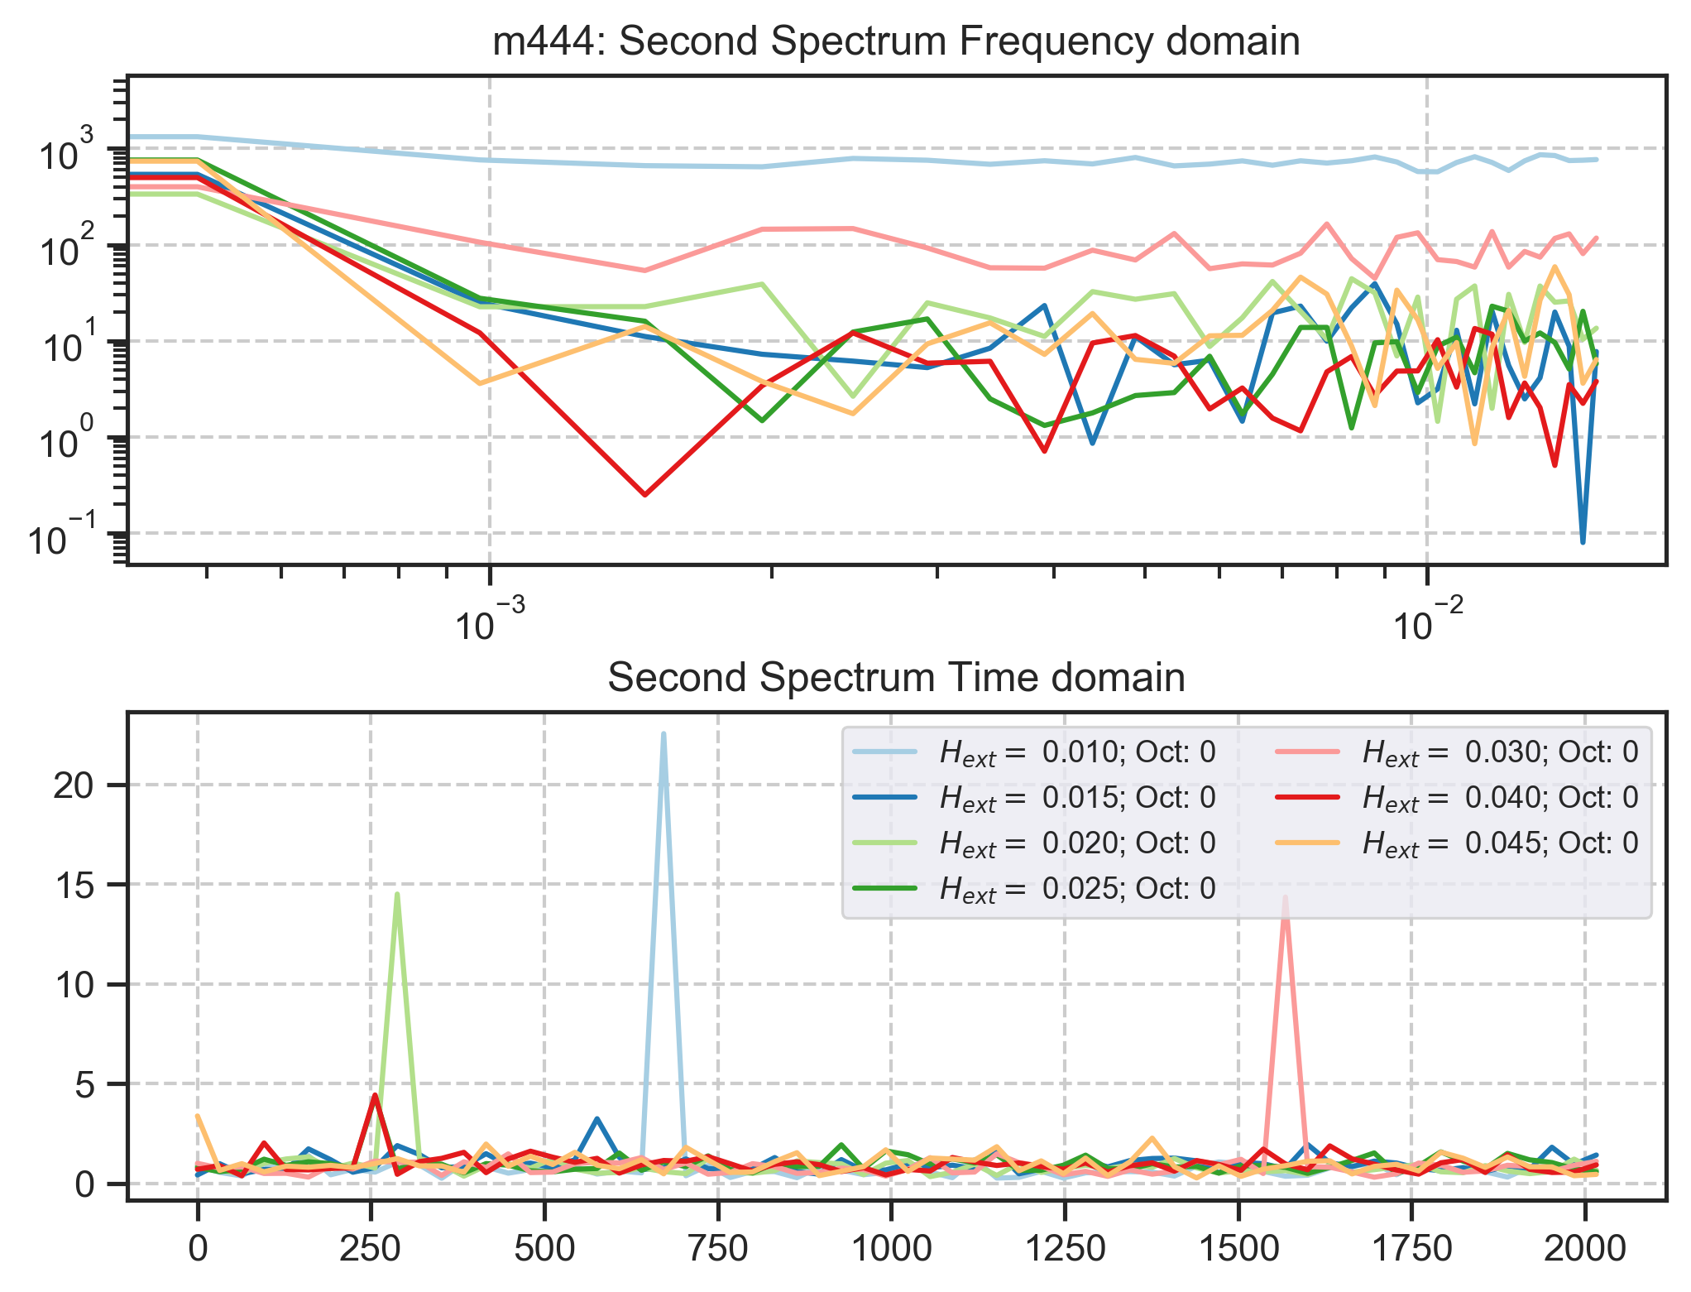

Mittwoch, 22. April 2020

14:34

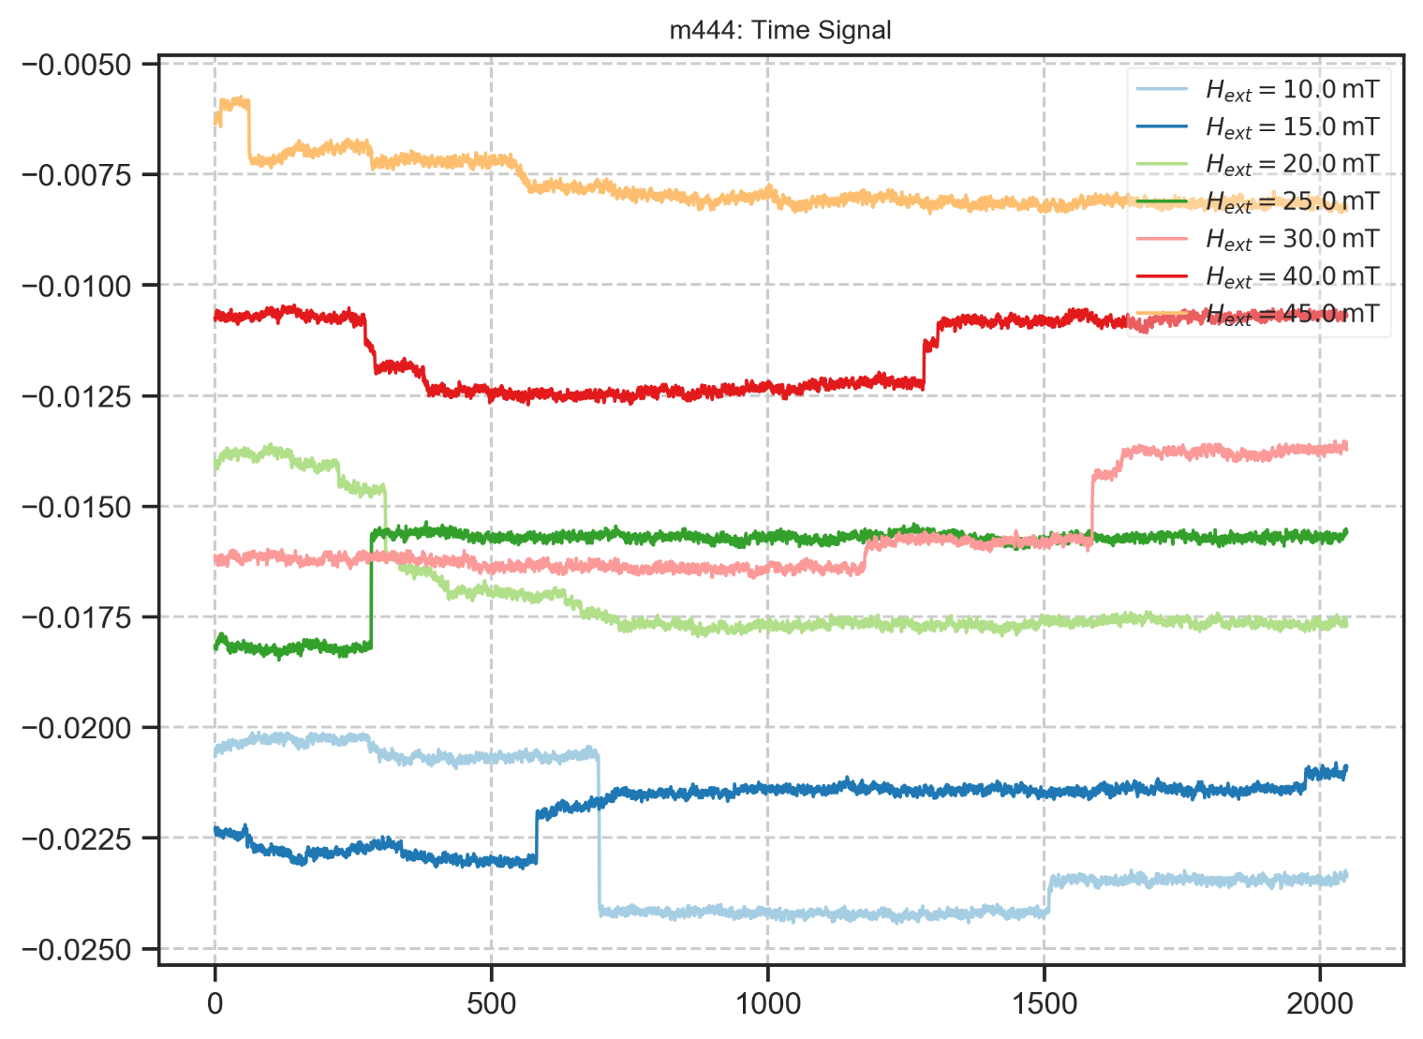

m445: rate:2 Hz ERROR

Freitag, 27. März 2020

13:58

|  |  |
| --- | --- |
| Angle of sensor θ | *+45* |
| Temp | 10 K |
|  | **Plusses** |
|  | |  |  |  |  | | --- | --- | --- | --- | |  | ***13-1*** |  | *6-8* | | ***Gate (0V)*** | ***9 - 4*** |  | ***7 - 14 (No Preamp)*** | |
|  | *Saturating at -.3T. sweeping from 100mT → -100mT*  *measuring every 5mT steps (21 different steps)* |
| Resistance Box | |  |  |  |  |  |  | | --- | --- | --- | --- | --- | --- | |  | *1 MΩ* |  | 13,5 |  |  | |  | *1 MΩ* |  | *1* |  | *1* | |
|  | |  |  |  |  |  |  | | --- | --- | --- | --- | --- | --- | | Sens | 50 μV |  | 5 V | *f* | *113 Hz* | | *τ* | *100 ms* | *Input A* | *AC* | *Ground* | *Normal Reserve* |   *DAQ settings: Rate: 2 Hz* |
| Period of measurement (min) | *2048 sec for each field* |
| Data files | in Folder NewMeasurements2020\m445\* |
|  | Program did not measure the full time! It crashed always too early! |
|  | Unable to evaluate data! |

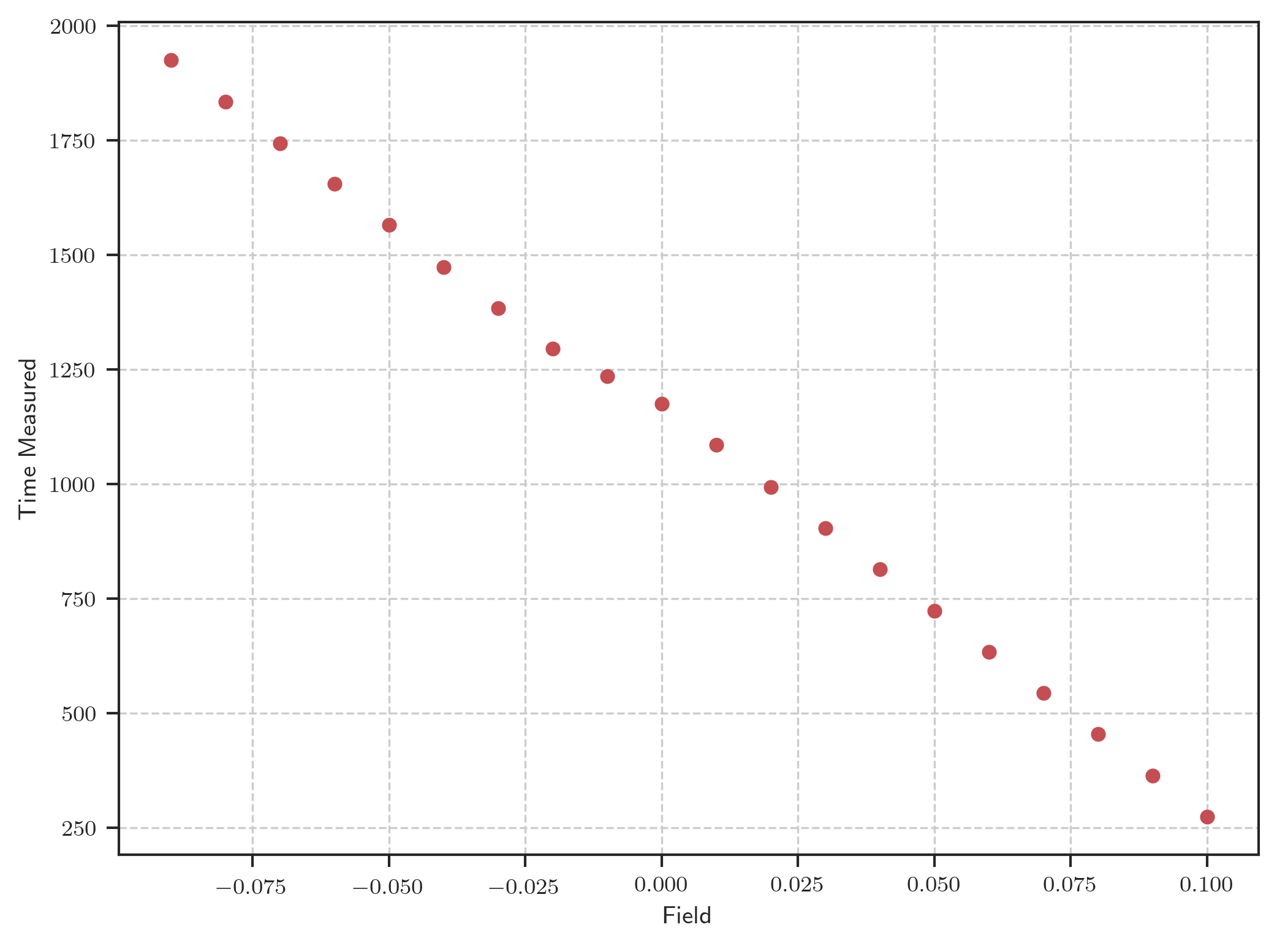

m446: rate:8 Hz 2048s Down (15K)

Freitag, 27. März 2020

13:59

|  |  |
| --- | --- |
| Angle of sensor θ | *+45* |
| Temp | 15 K |
|  | **Plusses** |
|  | |  |  |  |  | | --- | --- | --- | --- | |  | ***13-1*** |  | *6-8* | | ***Gate (0V)*** | ***9 - 4*** |  | ***7 - 14 (No Preamp)*** | |
|  | *Saturating at 0.3T sweeping from 100mT → -100mT*  *measuring every 5mT steps (41 different steps)* |
| Resistance Box | |  |  |  |  |  |  | | --- | --- | --- | --- | --- | --- | |  | *1 MΩ* |  | 13,5 |  |  | |  | *1 MΩ* |  | *1* |  | *1* | |
|  | |  |  |  |  |  |  | | --- | --- | --- | --- | --- | --- | | Sens | 50 μV |  | 5 V | *f* | *113 Hz* | | *τ* | *100 ms* | *Input A* | *AC* | *Ground* | *Normal Reserve* |   *DAQ settings: Rate: 8 Hz* |
| Period of measurement (min) | *2048 sec for each field* |
| Data files | in Folder NewMeasurements2020\m446\* |

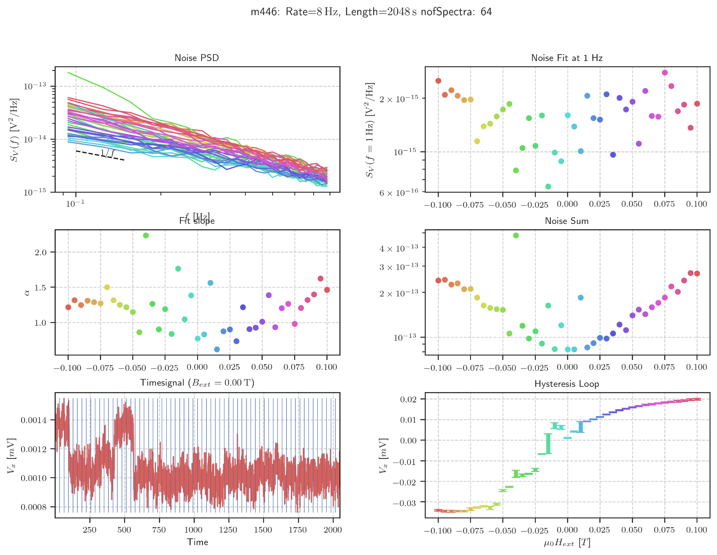

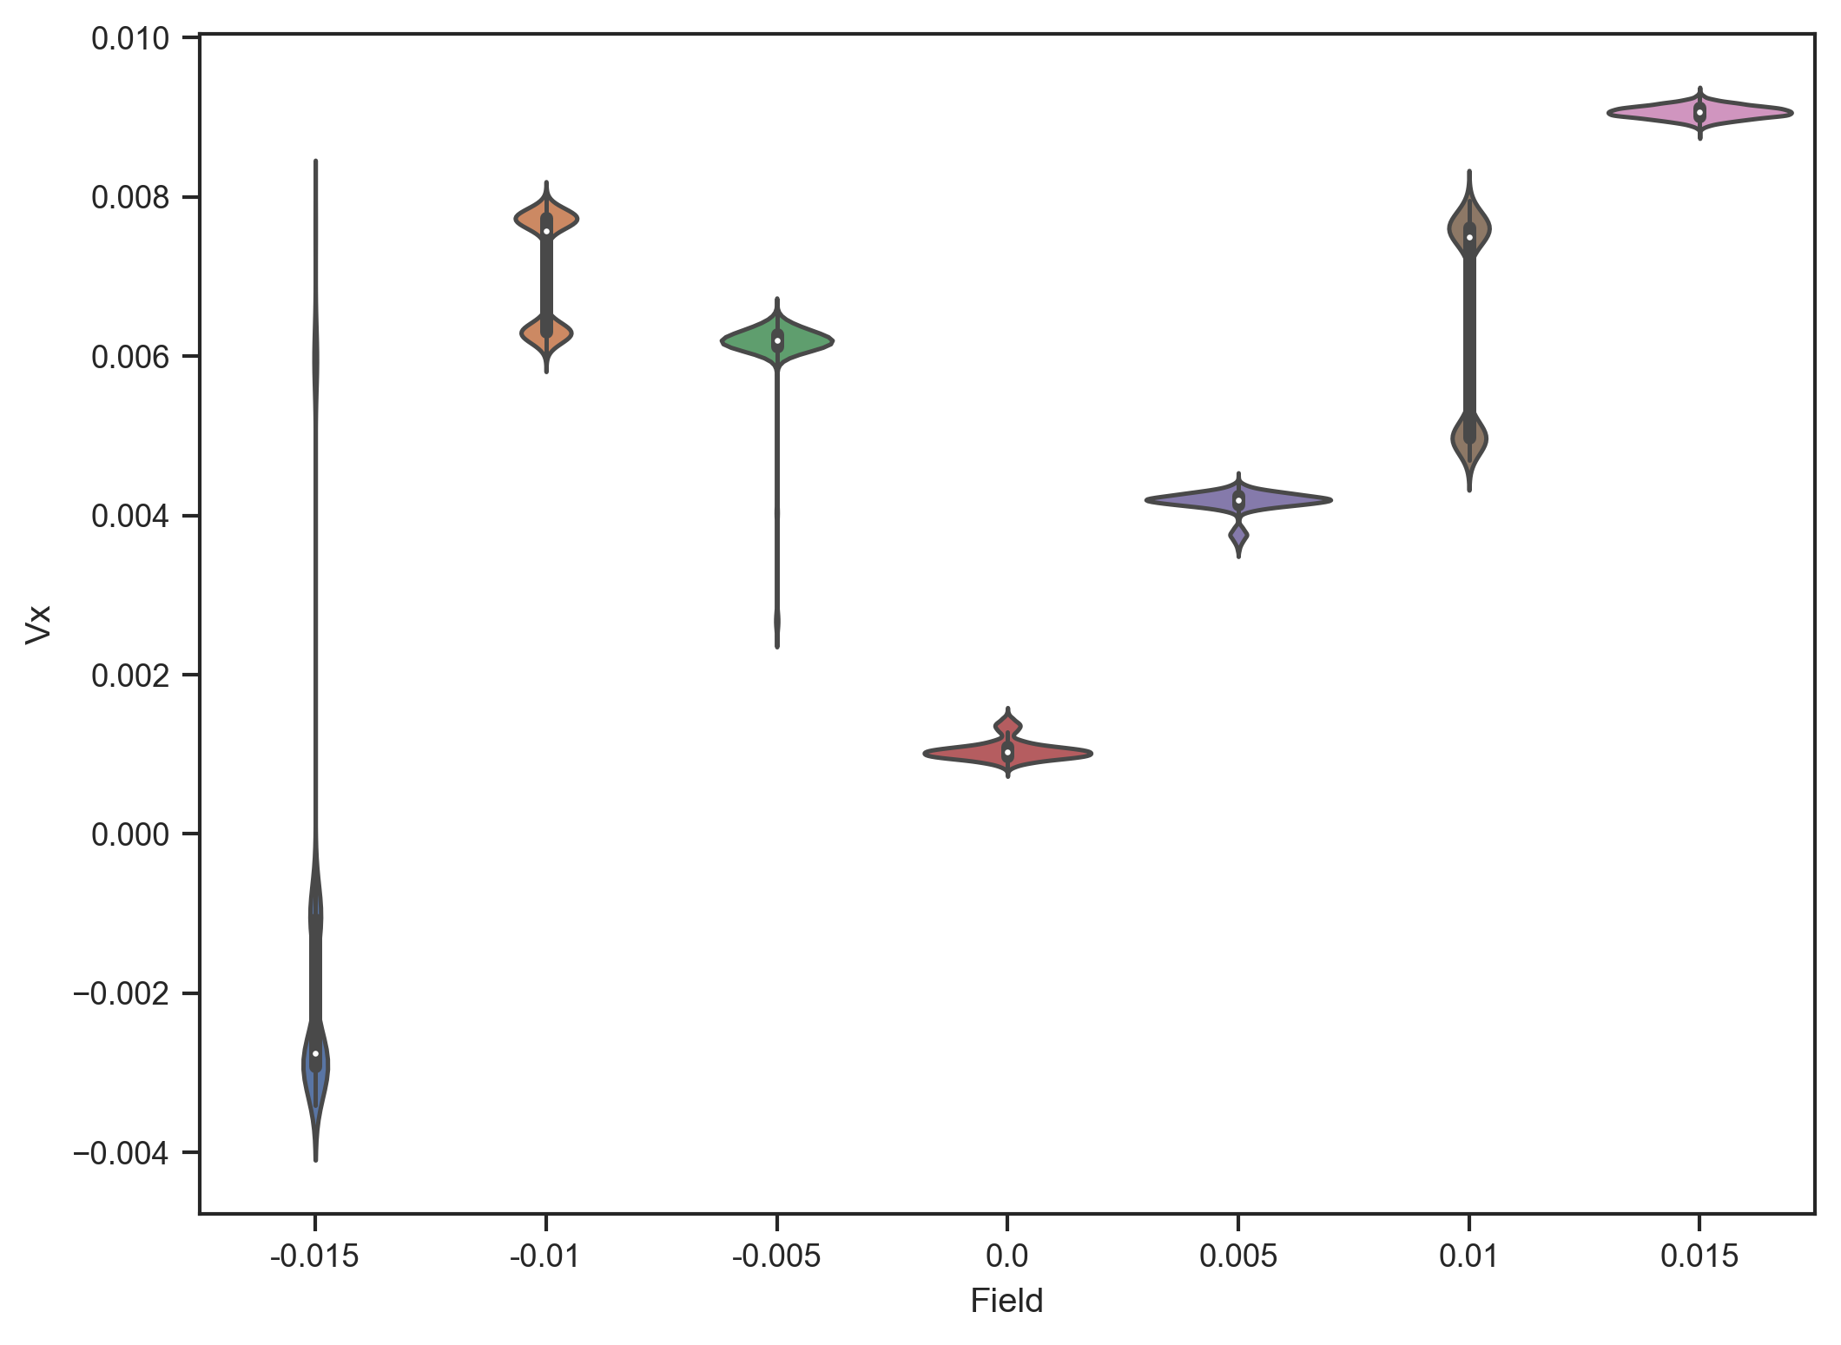

Violin Plot (-.015 -> .015)

Donnerstag, 16. April 2020

17:48

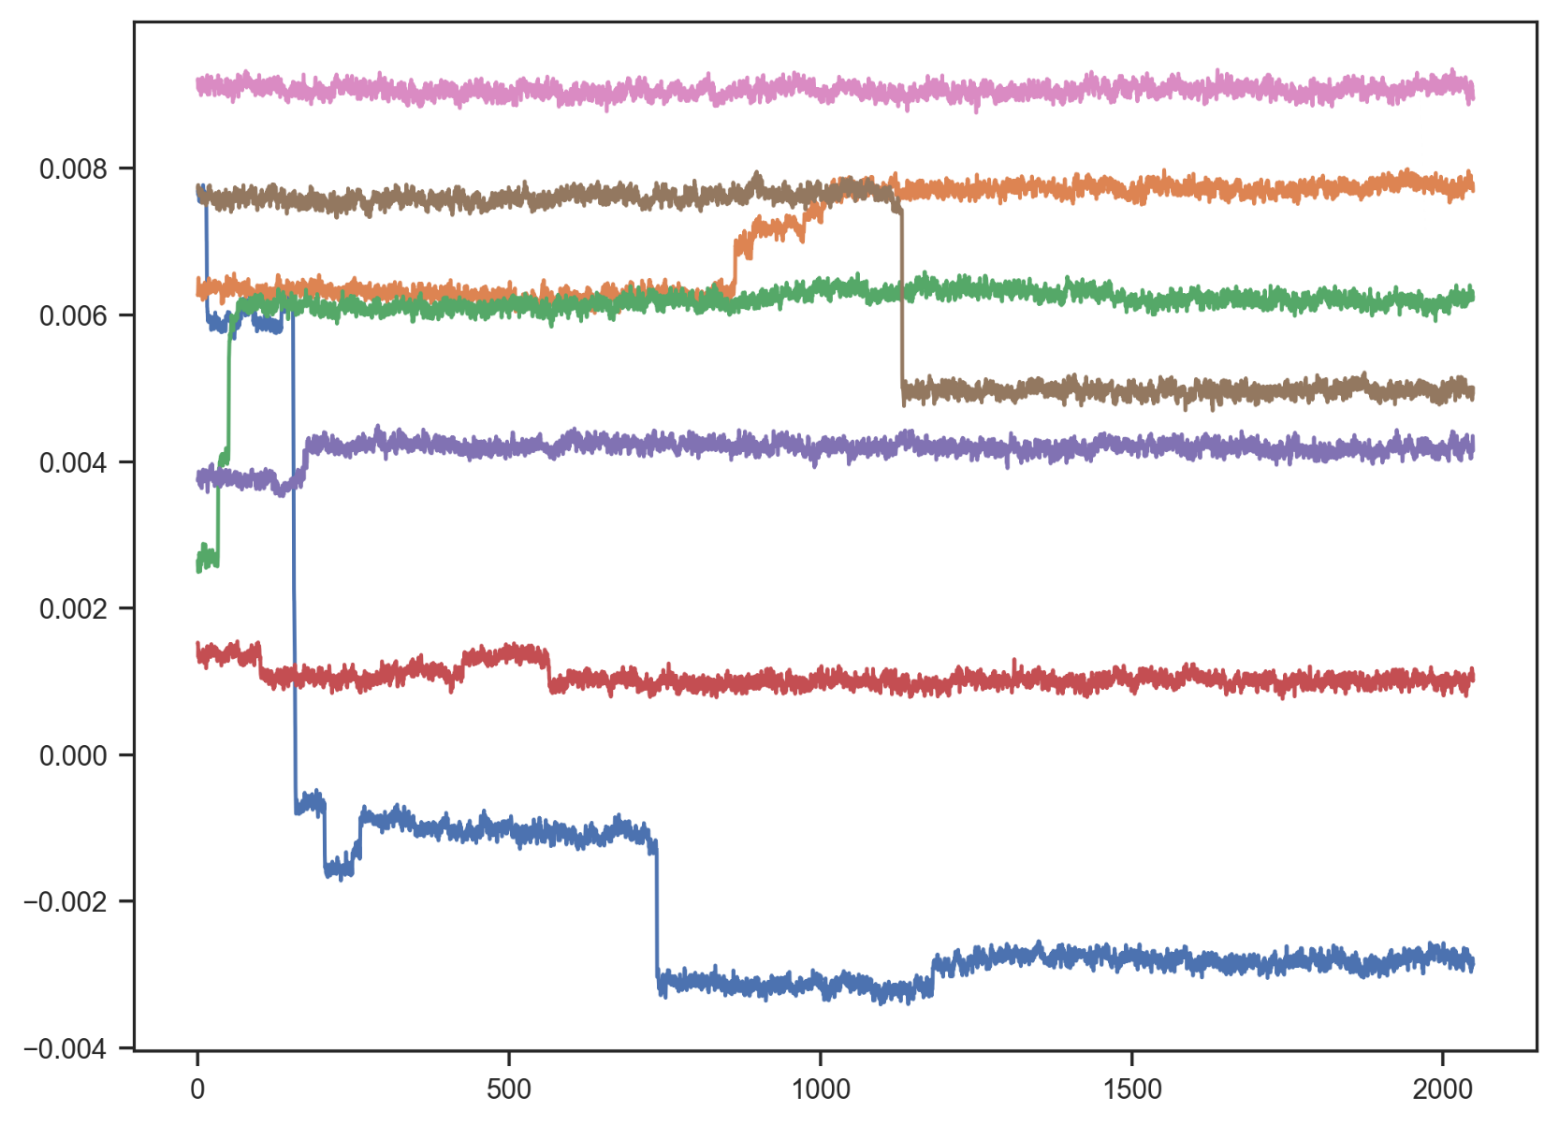

Second Spectrum

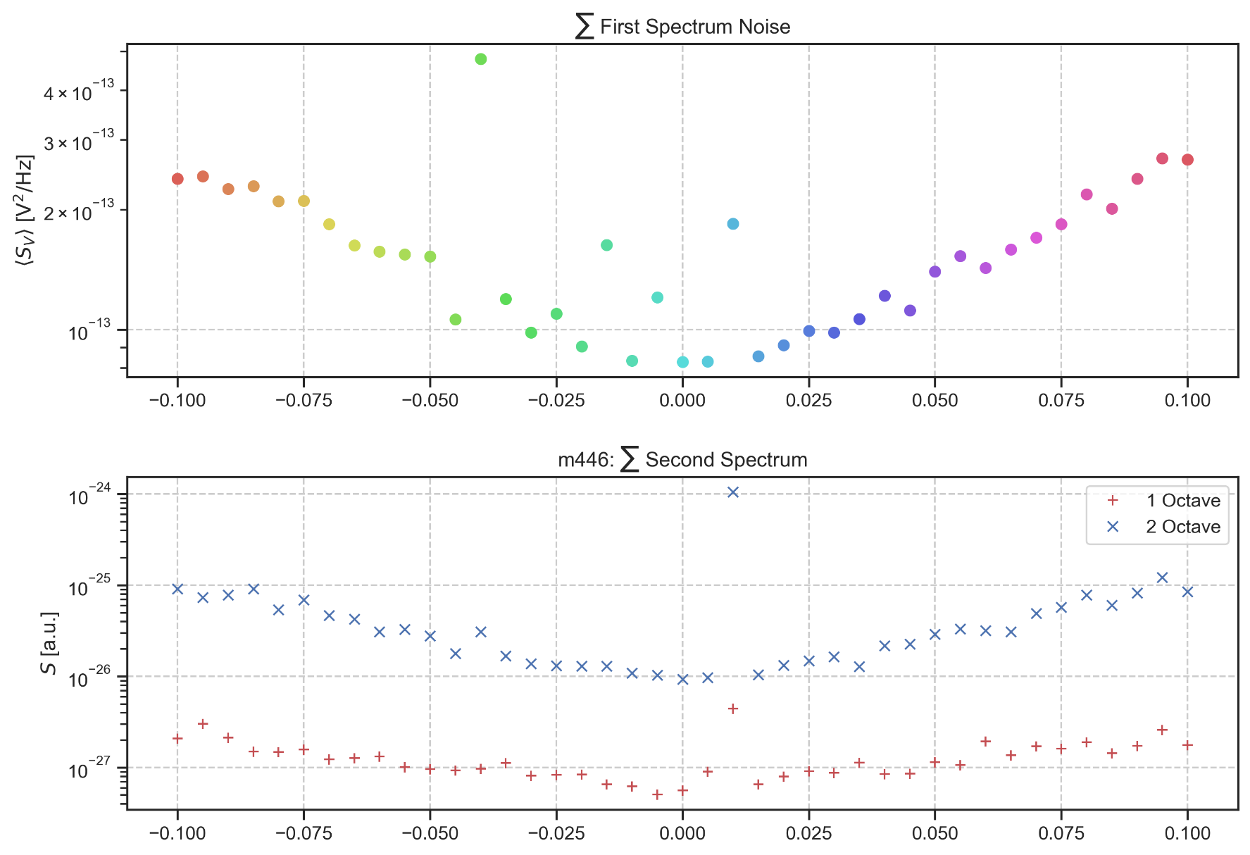

Dienstag, 21. April 2020

18:03

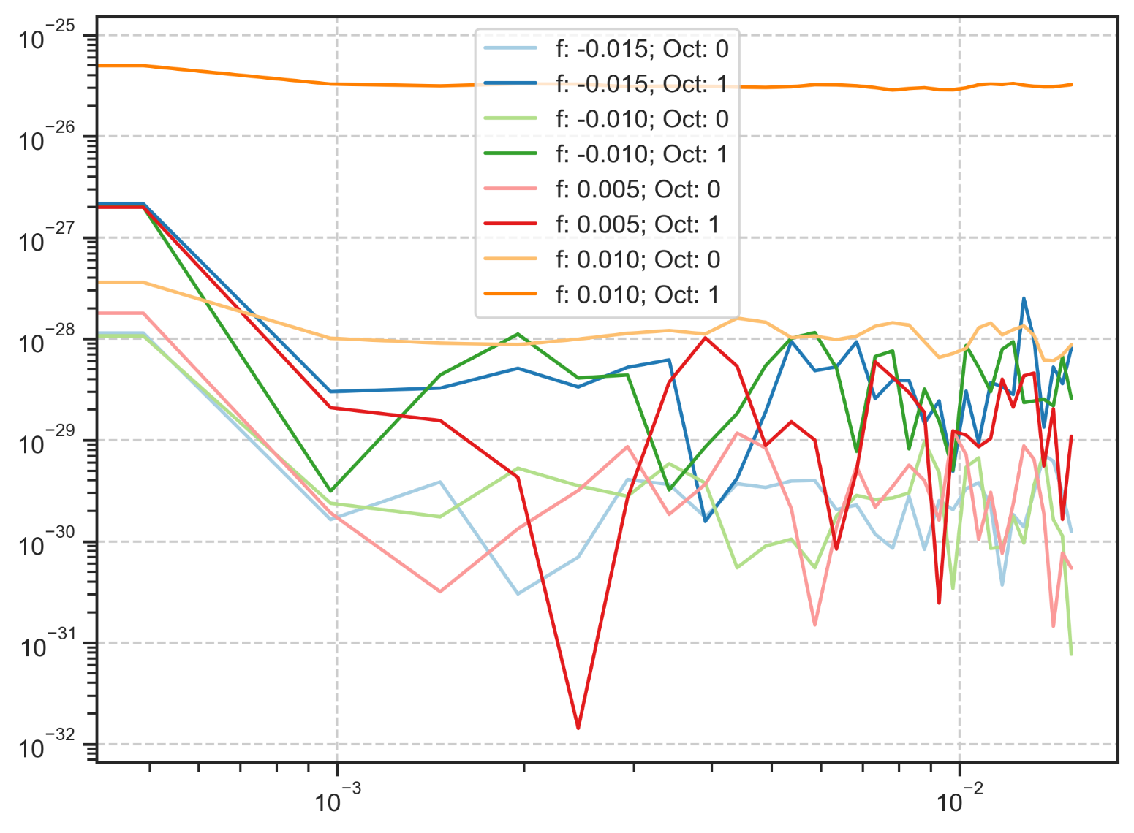

m447: rate:8 Hz 2048s Up (15K)

Freitag, 27. März 2020

14:01

|  |  |
| --- | --- |
| Angle of sensor θ | *+45* |
| Temp | 15 K |
|  | **Plusses** |
|  | |  |  |  |  | | --- | --- | --- | --- | |  | ***13-1*** |  | *6-8* | | ***Gate (0V)*** | ***9 - 4*** |  | ***7 - 14 (No Preamp)*** | |
|  | *Saturating at 0.3T sweeping from 100mT → -100mT*  *measuring every 5mT steps (41 different steps)* |
| Resistance Box | |  |  |  |  |  |  | | --- | --- | --- | --- | --- | --- | |  | *1 MΩ* |  | 13,5 |  |  | |  | *1 MΩ* |  | *1* |  | *1* | |
|  | |  |  |  |  |  |  | | --- | --- | --- | --- | --- | --- | | Sens | 50 μV |  | 5 V | *f* | *113 Hz* | | *τ* | *100 ms* | *Input A* | *AC* | *Ground* | *Normal Reserve* |   *DAQ settings: Rate: 8 Hz* |
| Period of measurement (min) | *2048 sec for each field* |
| Data files | in Folder NewMeasurements2020\m447\* |

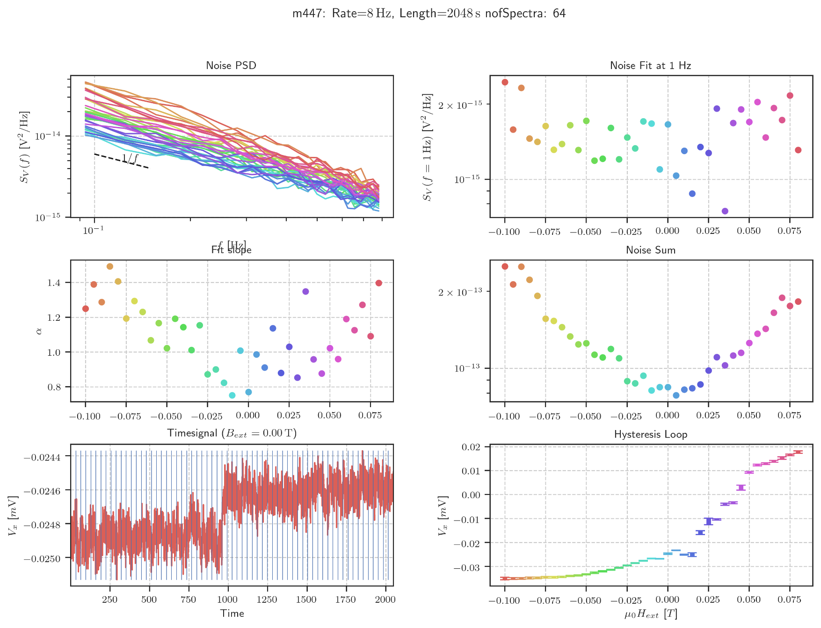

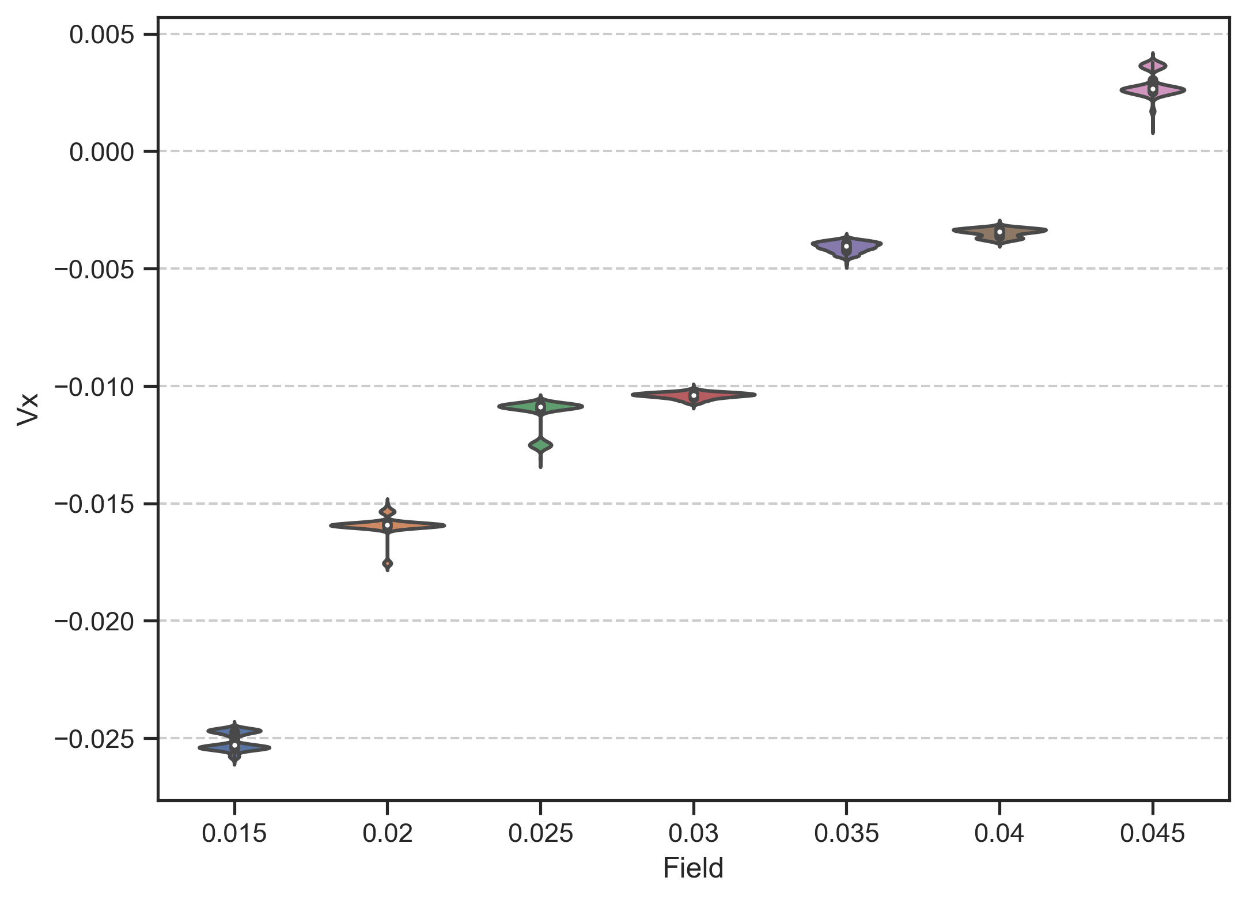

Violin Plot (.015 -> .045)

Mittwoch, 22. April 2020

15:23

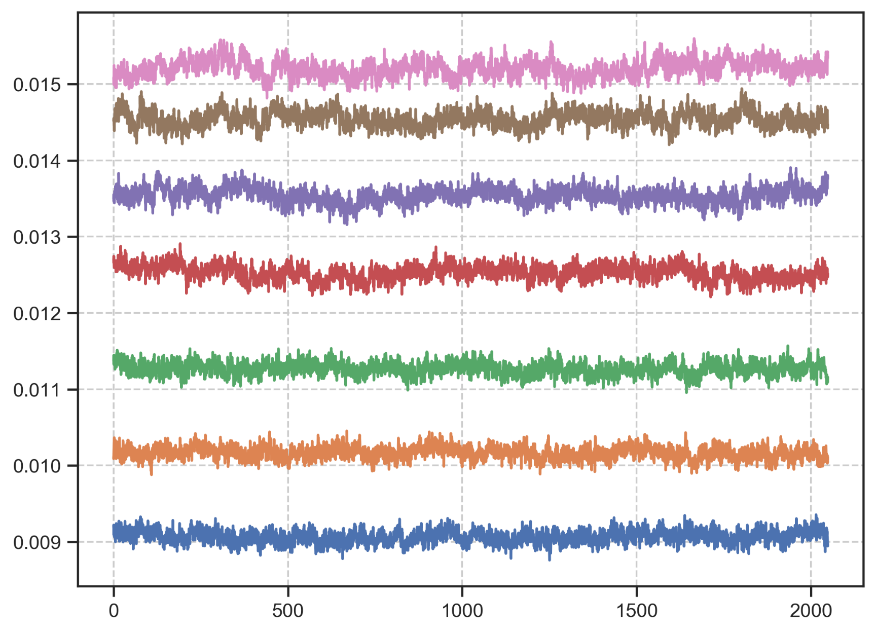

Noise Hysteresis (446/447)

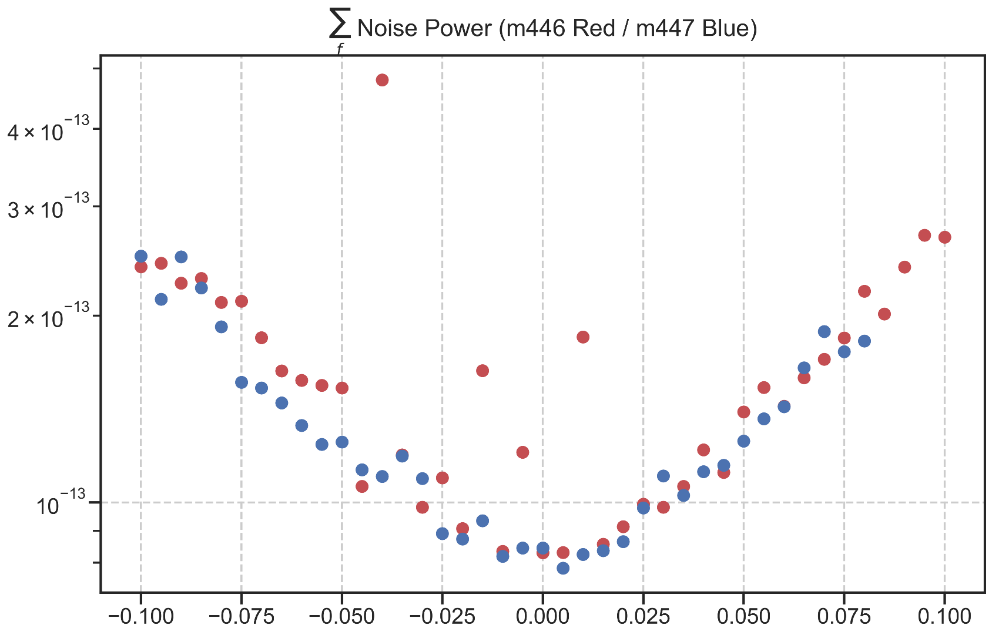

Mittwoch, 22. April 2020

15:22

Second Spectrum

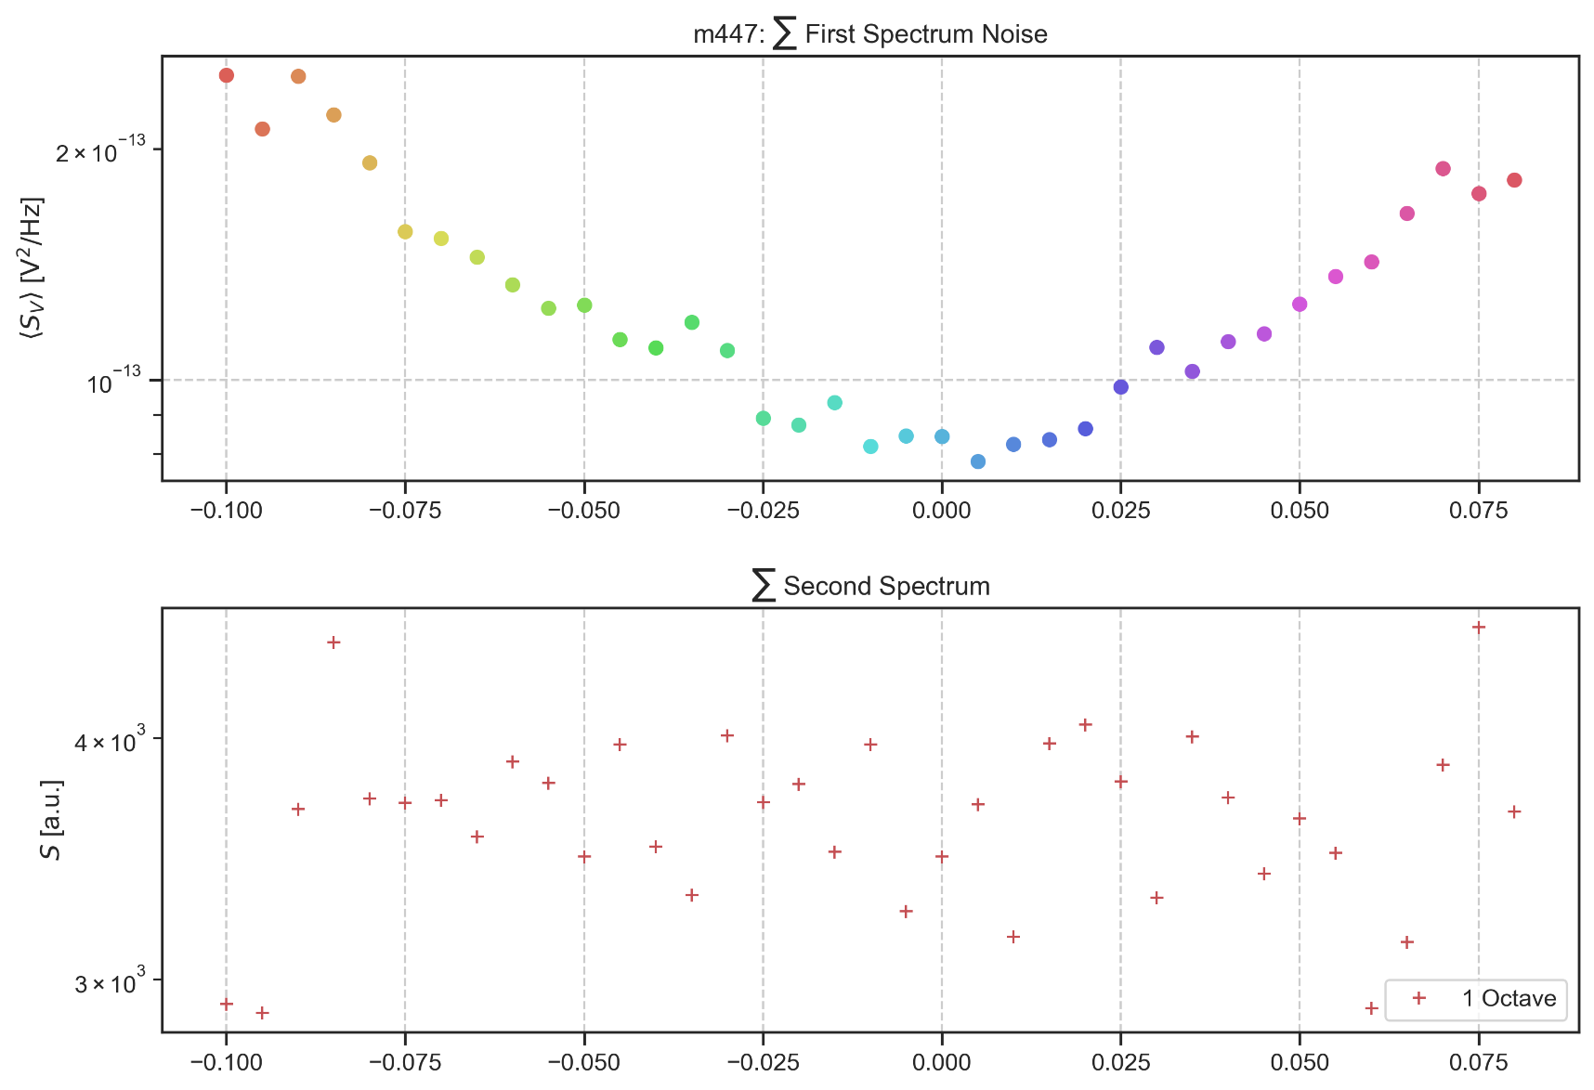

Mittwoch, 22. April 2020

15:26

m448: rate:4 Hz 2048s Down (15K)

Dienstag, 31. März 2020

15:30

|  |  |
| --- | --- |
| Angle of sensor θ | *+45* |
| Temp | 15 K |
|  | **Plusses** |
|  | |  |  |  |  | | --- | --- | --- | --- | |  | ***13-1*** |  | *6-8* | | ***Gate (0V)*** | ***9 - 4*** |  | ***7 - 14 (No Preamp)*** | |
|  | *Saturating at 0.3T sweeping from 100mT → -100mT*  *measuring every 5mT steps (41 different steps)* |
| Resistance Box | |  |  |  |  |  |  | | --- | --- | --- | --- | --- | --- | |  | *1 MΩ* |  | 13,5 |  |  | |  | *1 MΩ* |  | *1* |  | *1* | |
|  | |  |  |  |  |  |  | | --- | --- | --- | --- | --- | --- | | Sens | 50 μV |  | 5 V | *f* | *113 Hz* | | *τ* | *100 ms* | *Input A* | *AC* | *Ground* | *Normal Reserve* |   *DAQ settings: Rate: 4 Hz* |
| Period of measurement (min) | *2048 sec for each field* |
| Data files | in Folder NewMeasurements2020\m448\* |

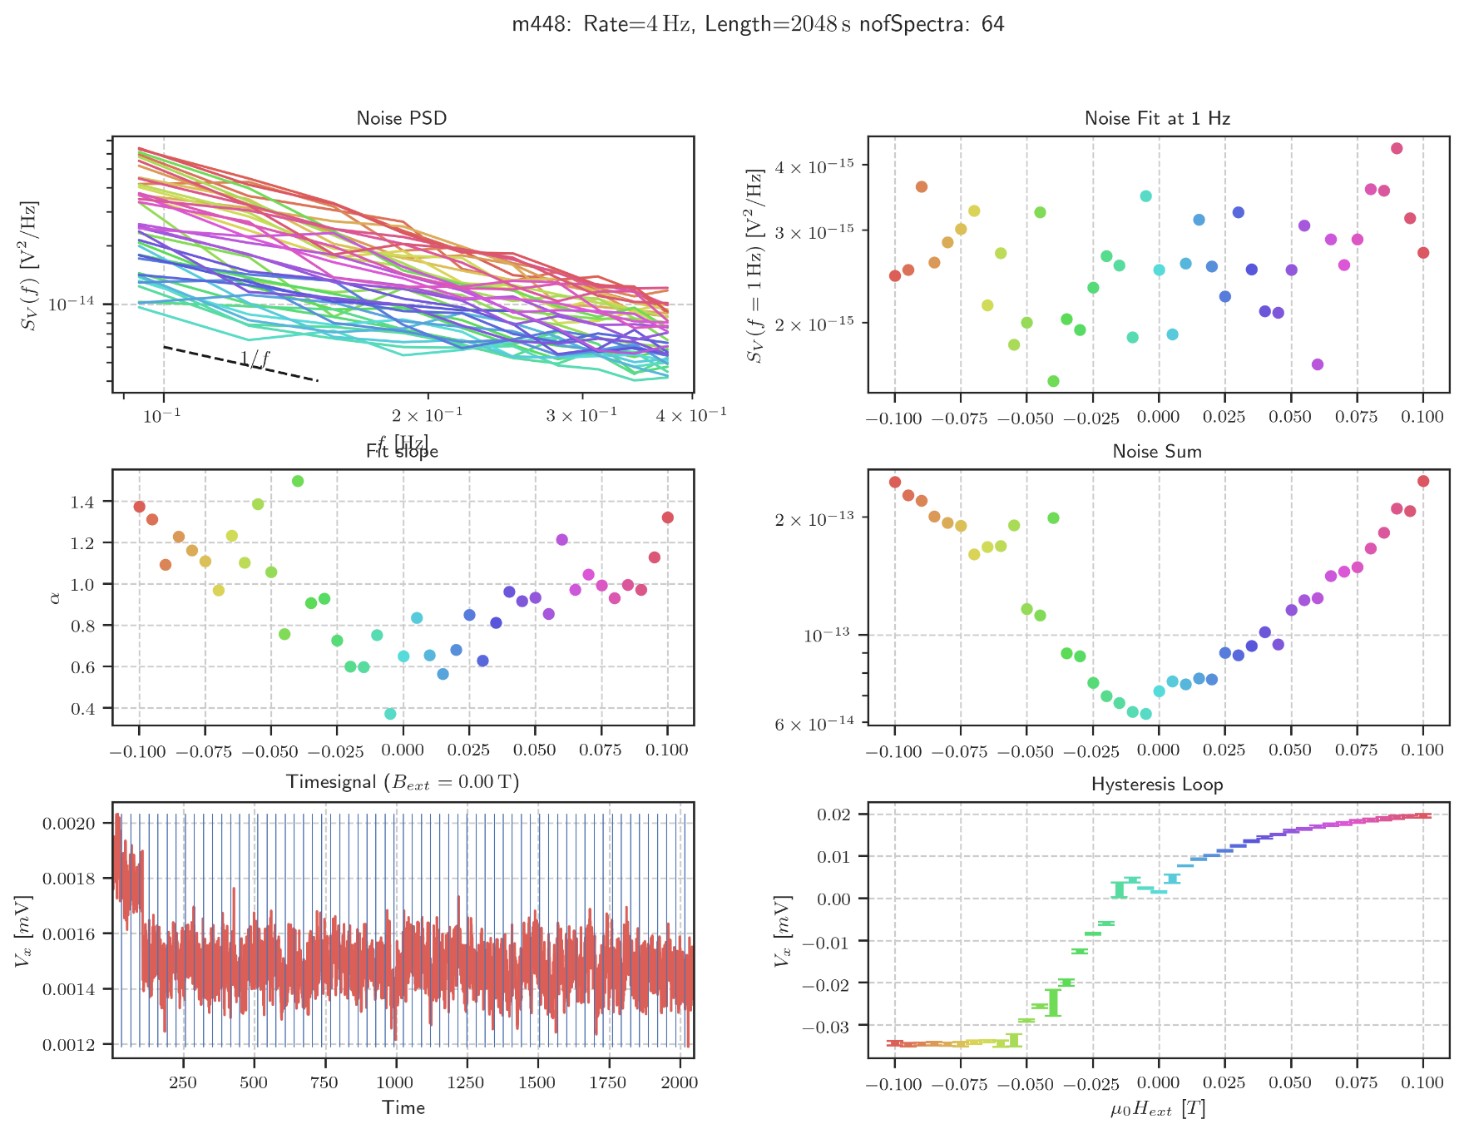

m449: rate:4 Hz 2048s Up (15K)

Dienstag, 31. März 2020

15:30

|  |  |
| --- | --- |
| Angle of sensor θ | *+45* |
| Temp | 15 K |
|  | **Plusses** |
|  | |  |  |  |  | | --- | --- | --- | --- | |  | ***13-1*** |  | *6-8* | | ***Gate (0V)*** | ***9 - 4*** |  | ***7 - 14 (No Preamp)*** | |
|  | *Saturating at 0.3T sweeping from -100mT → 100mT*  *measuring every 5mT steps (41 different steps)* |
| Resistance Box | |  |  |  |  |  |  | | --- | --- | --- | --- | --- | --- | |  | *1 MΩ* |  | 13,5 |  |  | |  | *1 MΩ* |  | *1* |  | *1* | |
|  | |  |  |  |  |  |  | | --- | --- | --- | --- | --- | --- | | Sens | 50 μV |  | 5 V | *f* | *113 Hz* | | *τ* | *100 ms* | *Input A* | *AC* | *Ground* | *Normal Reserve* |   *DAQ settings: Rate: 4 Hz* |
| Period of measurement (min) | *2048 sec for each field* |
| Data files | in Folder NewMeasurements2020\m446\* |

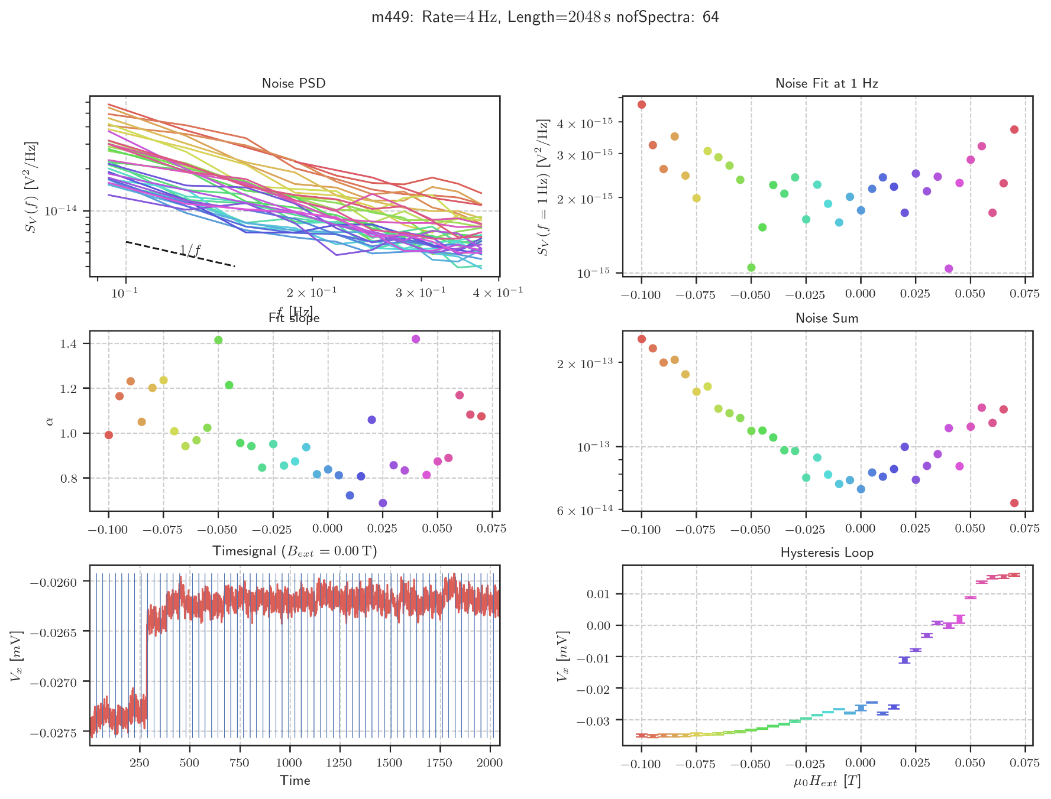

Noise Hysteresis (448/449)

Mittwoch, 22. April 2020

15:43

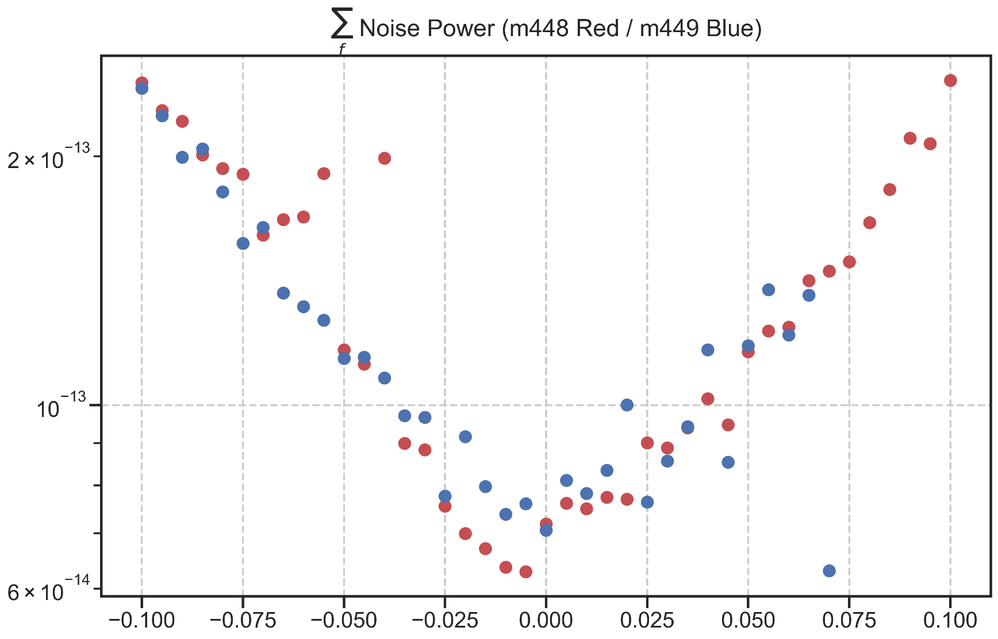

m450: EMPTY rate:8 Hz 1024s Down (15K)

Dienstag, 31. März 2020

15:30

|  |  |
| --- | --- |
| Angle of sensor θ | *+45* |
| Temp | 15 K |
|  | **Empty Cross #2** |
|  | |  |  |  |  | | --- | --- | --- | --- | |  | ***10-5*** |  | *6-8* | | ***Gate (0V)*** | ***9 - 4*** |  | ***7 - 14 (No Preamp)*** | |
|  | *Saturating at 0.3T sweeping from 100mT → -100mT*  *measuring every 5mT steps (41 different steps)* |
| Resistance Box | |  |  |  |  |  |  | | --- | --- | --- | --- | --- | --- | |  | *1 MΩ* |  | 13,5 |  |  | |  | *1 MΩ* |  | *1* |  | *1* | |
|  | |  |  |  |  |  |  | | --- | --- | --- | --- | --- | --- | | Sens | 500 μV |  | 5 V | *f* | *113 Hz* | | *τ* | *100 ms* | *Input A* | *AC* | *Ground* | *Normal Reserve* |   *DAQ settings: Rate: 8 Hz* |
| Period of measurement (min) | *2048 sec for each field* |
| Comment | After Filling Helium measured high signal! Changed Sensitivity to 500 μV |

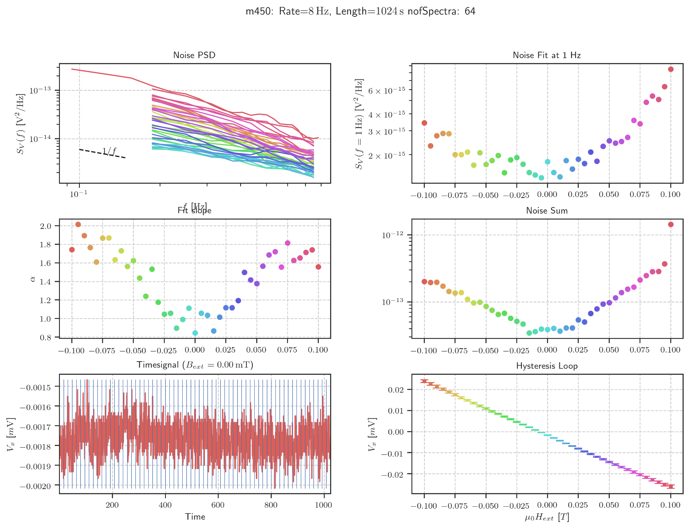

Contour Plot Info

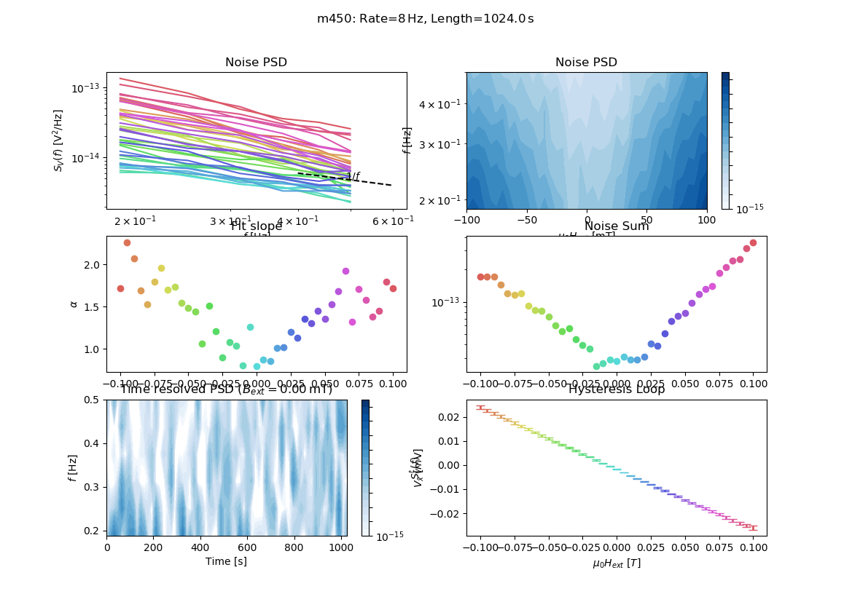

Samstag, 16. Mai 2020

19:13

m451: EMPTY rate:8 Hz 1024s Up (15K)

Mittwoch, 1. April 2020

14:03

|  |  |
| --- | --- |
| Angle of sensor θ | *+45* |
| Temp | 15 K |
|  | **Empty Cross #2** |
|  | |  |  |  |  | | --- | --- | --- | --- | |  | ***10-5*** |  | *6-8* | | ***Gate (0V)*** | ***9 - 4*** |  | ***7 - 14 (No Preamp)*** | |
|  | *Saturating at 0.3T sweeping from 100mT → -100mT*  *measuring every 5mT steps (41 different steps)* |
| Resistance Box | |  |  |  |  |  |  | | --- | --- | --- | --- | --- | --- | |  | *1 MΩ* |  | 13,5 |  |  | |  | *1 MΩ* |  | *1* |  | *1* | |
|  | |  |  |  |  |  |  | | --- | --- | --- | --- | --- | --- | | Sens | 500 μV |  | 5 V | *f* | *113 Hz* | | *τ* | *100 ms* | *Input A* | *AC* | *Ground* | *Normal Reserve* |   *DAQ settings: Rate: 8 Hz* |
| Period of measurement (min) | *1024 sec for each field* |
| Comment | After Filling Helium measured high signal! Changed Sensitivity to 500 μV |

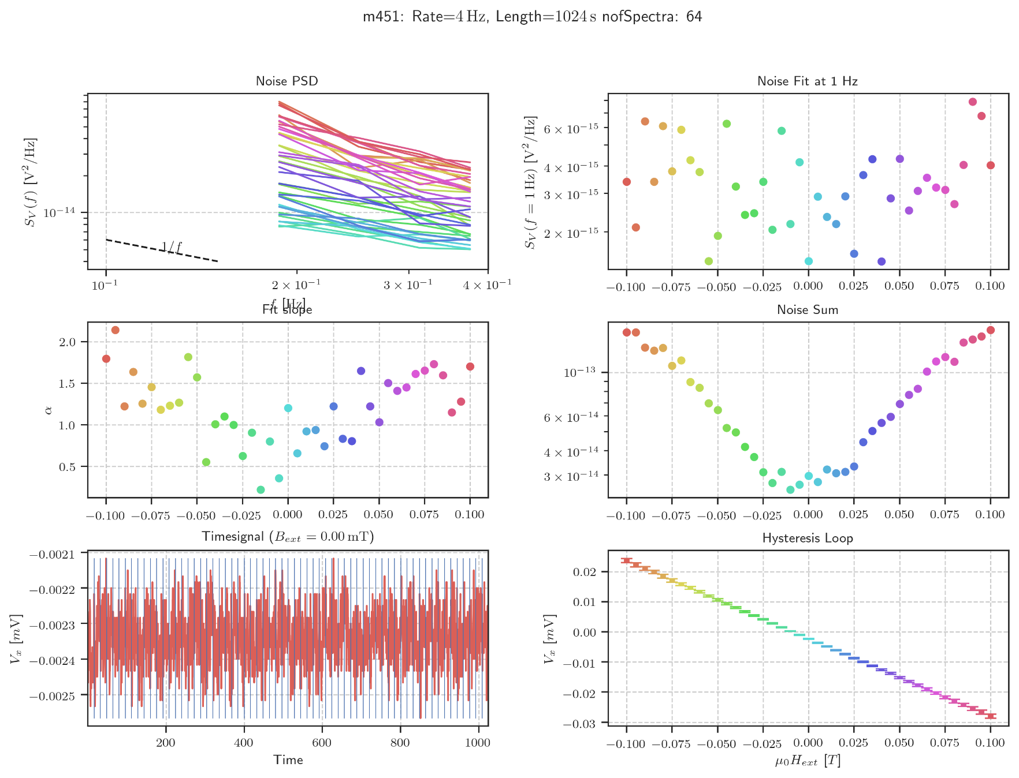

Contour Plot Info

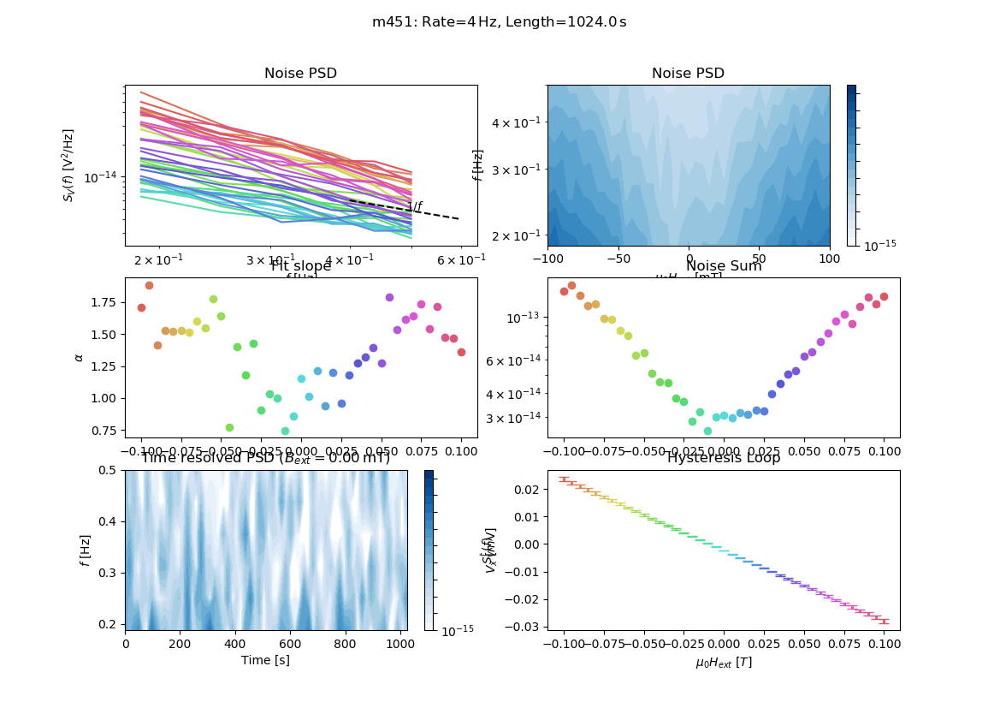

Samstag, 16. Mai 2020

19:14

Noise Hysteresis (Empty Reference)

Mittwoch, 22. April 2020

15:46

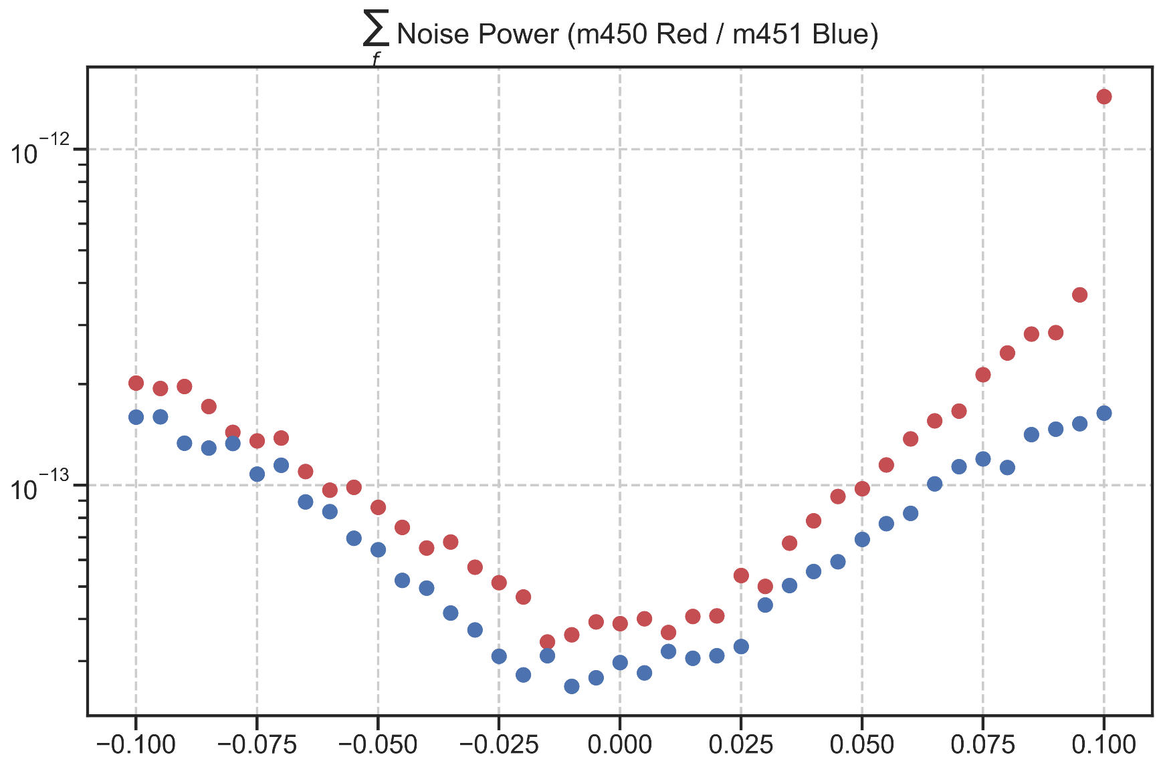

Changing Angle (80deg)

Donnerstag, 2. April 2020

15:26

|  |  |
| --- | --- |
| Angle of sensor θ | *80* |
|  |  |
|  |  |
|  | |  |  | | --- | --- | |  | *1* | |
|  |  |
| *Notes* | *Voltage before Changing Angle: -17,166 mV*  *Changing Angle to 0deg to measure new maximum Voltage: V_Max = - 25,023 mV* |

<<m452_ChangeAngle.dat>>

Aiming for Hall Voltage:



**Voltage measured:**



New Gradiometry Setup for this Angle (Plusses: 13-1): R_12 = 15 kΩ

m452: rate:8 Hz 2048s Down (15K)

Dienstag, 7. April 2020

16:26

|  |  |
| --- | --- |
| Angle of sensor θ | *+80* |
| Temp | 15 K |
|  | **Plusses** |
|  | |  |  |  |  | | --- | --- | --- | --- | |  | ***13-1*** |  | *6-8* | | ***Gate (0V)*** | ***9 - 4*** |  | ***7 - 14 (No Preamp)*** | |
|  | *Saturating at 0.4T sweeping from 300mT → -300mT*  *measuring every 15mT steps (41 different steps)* |
| Resistance Box | |  |  |  |  |  |  | | --- | --- | --- | --- | --- | --- | |  | *1 MΩ* |  | 15 |  |  | |  | *1 MΩ* |  | *7* |  | *1* | |
|  | |  |  |  |  |  |  | | --- | --- | --- | --- | --- | --- | | Sens | 50 μV |  | 5 V | *f* | *17 Hz* | | *τ* | *100 ms* | *Input A* | *AC* | *Ground* | *Normal Reserve* |   *DAQ settings: Rate: 8 Hz* |
| Period of measurement (min) | *1024 sec for each field* |
| Comment |  |

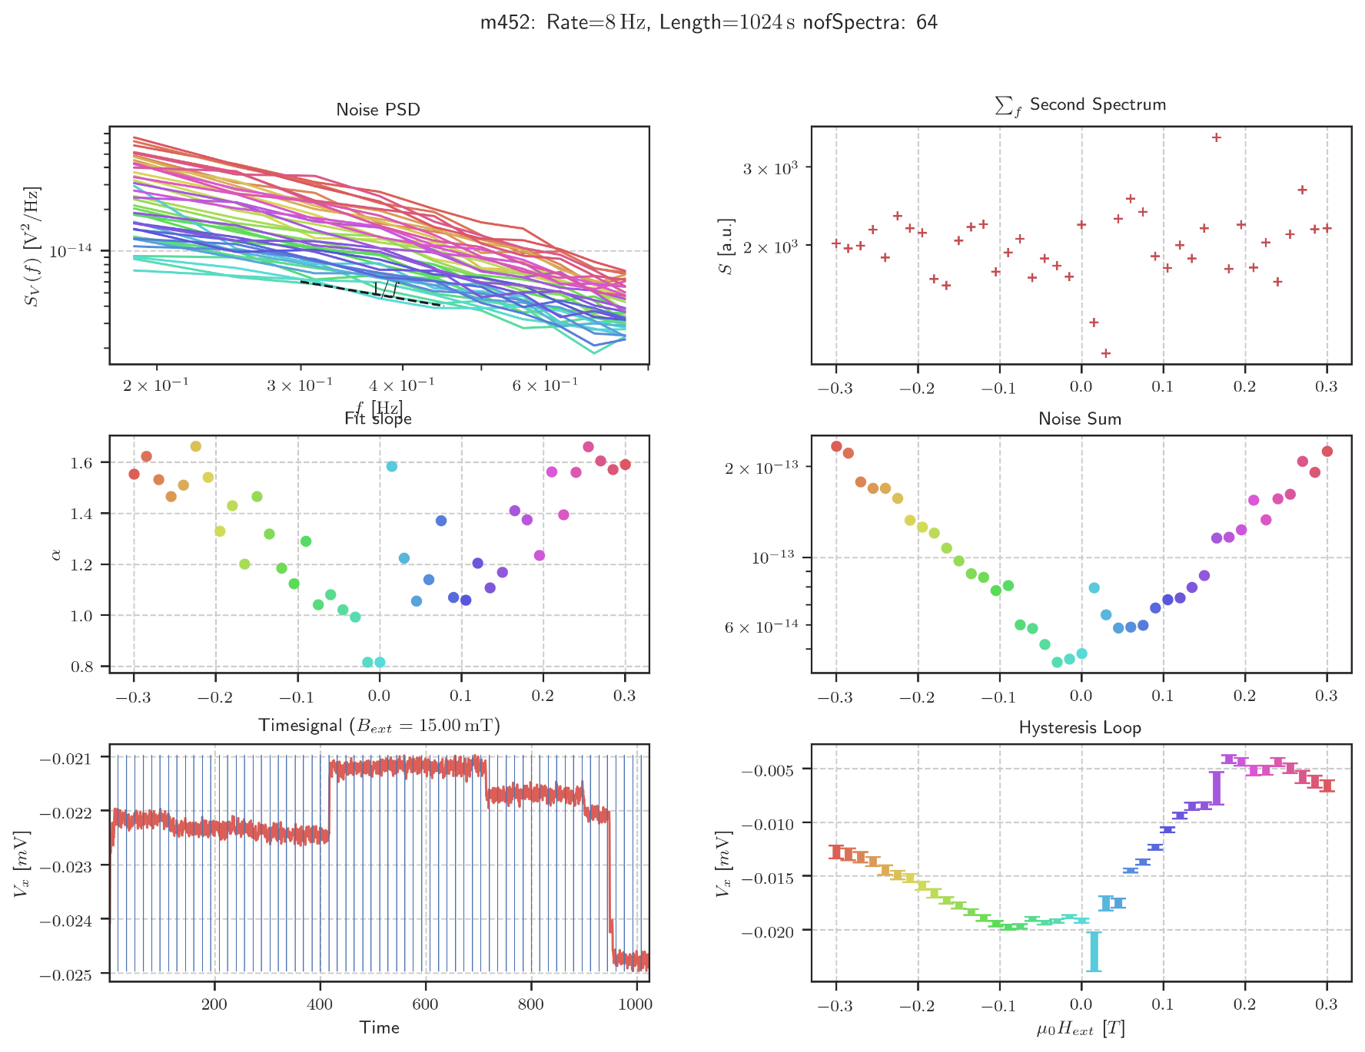

Contour Plot Info

Samstag, 16. Mai 2020

19:34

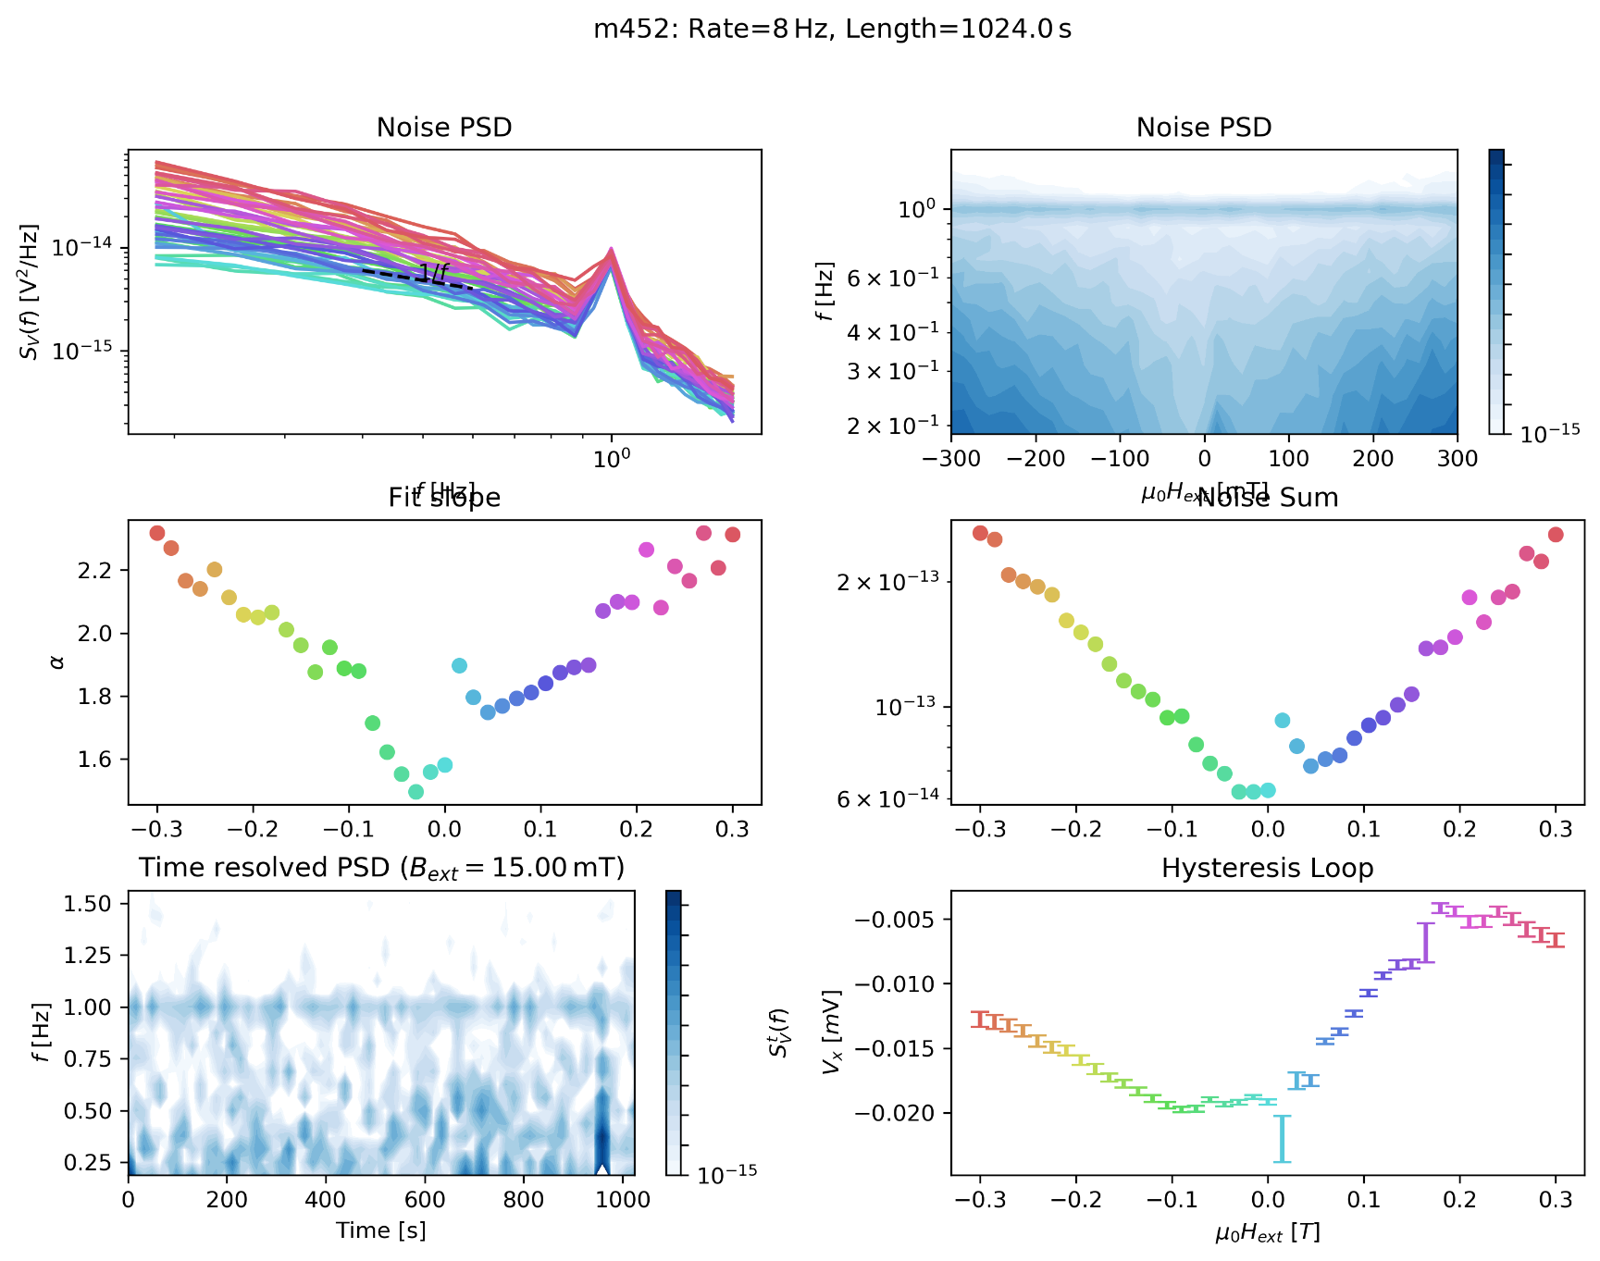

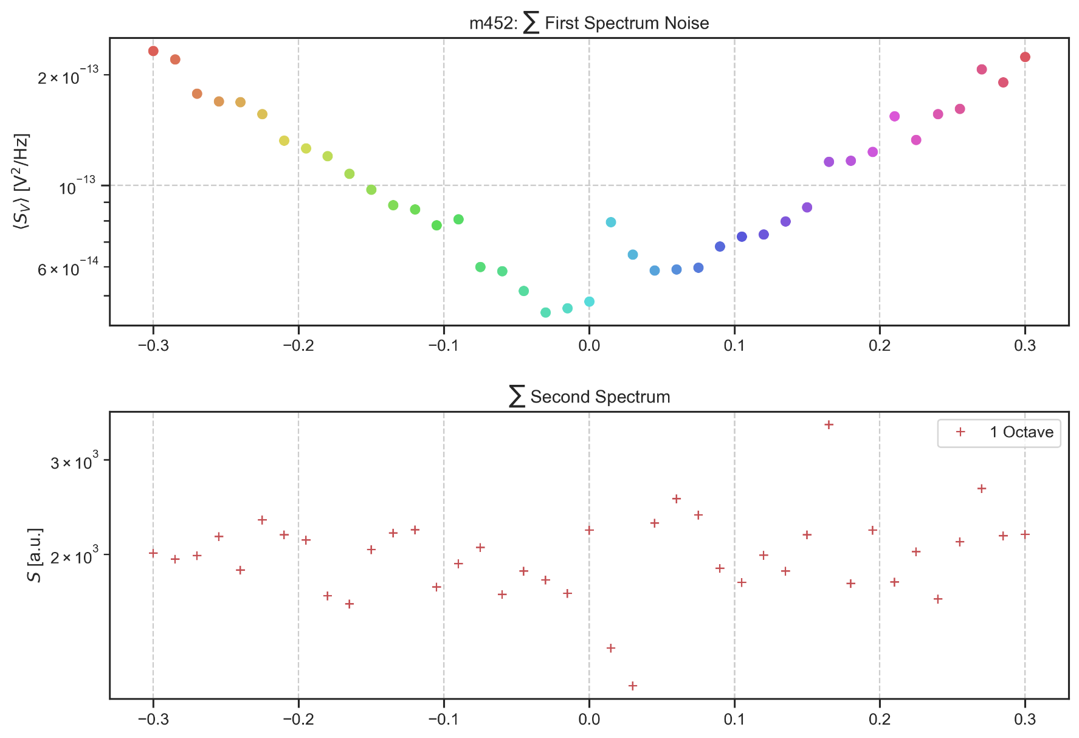

Second Spectrum

Mittwoch, 22. April 2020

15:58

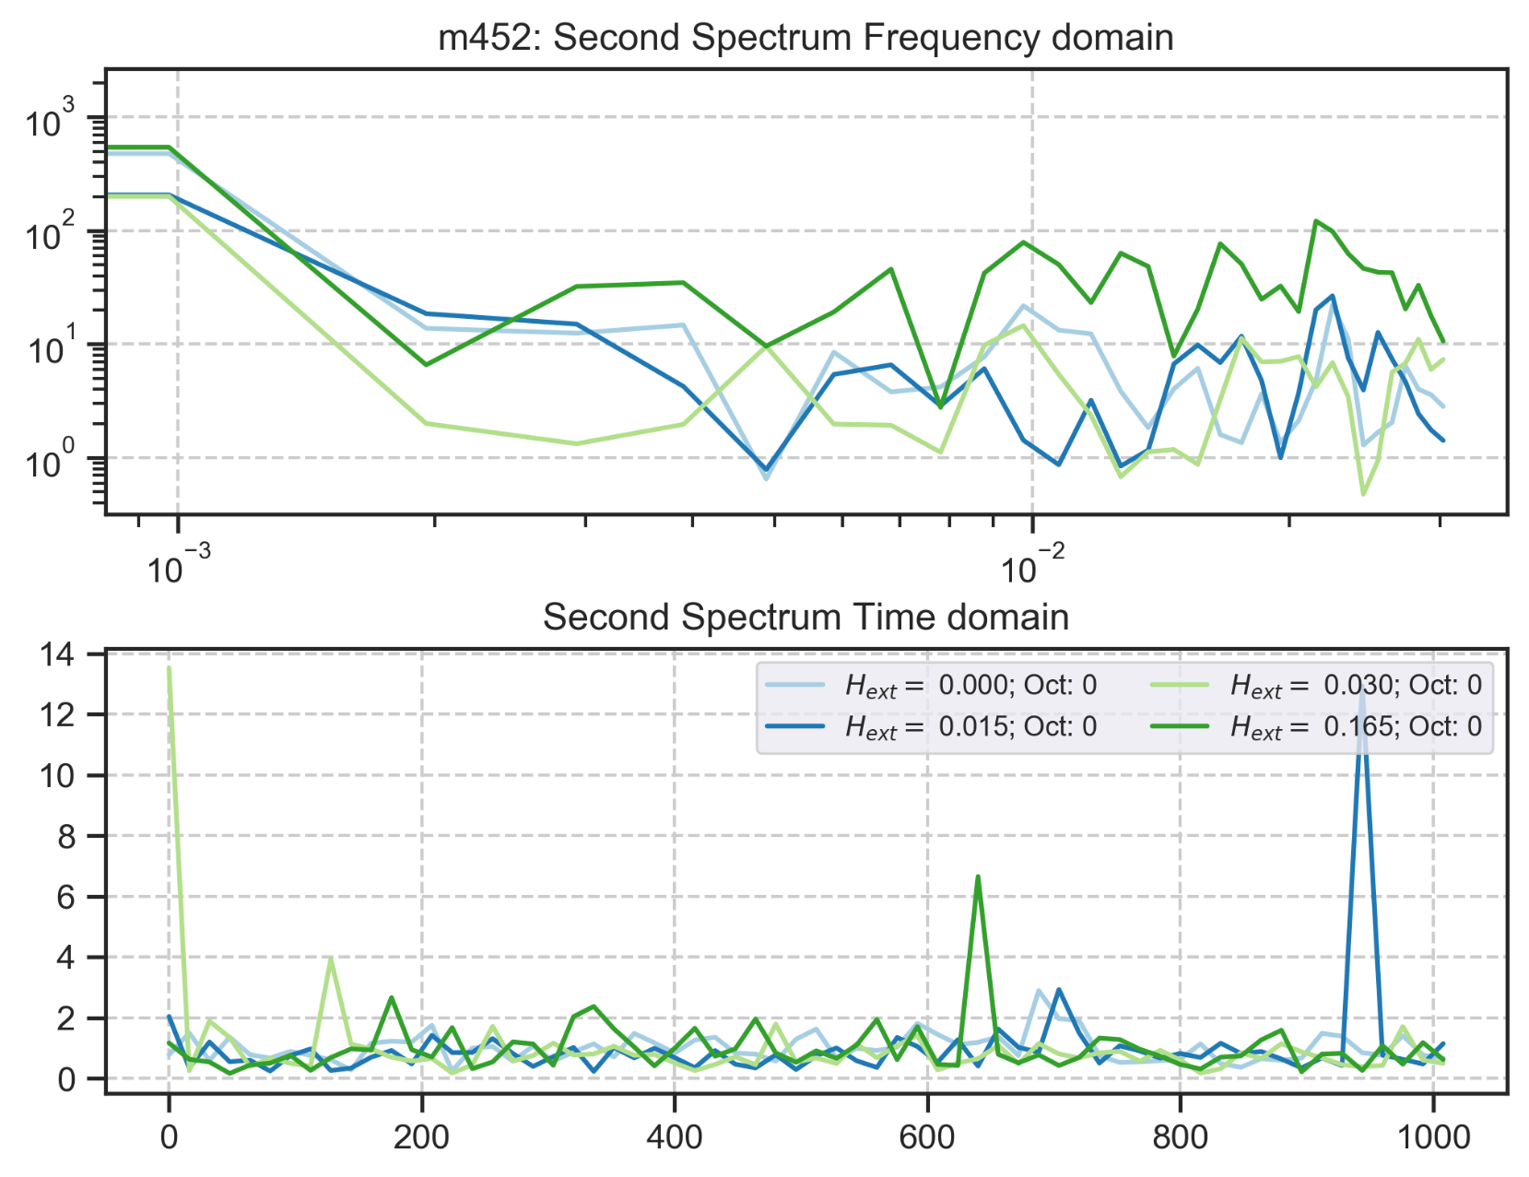

m453: rate:8 Hz 2048s Up (15K)

Freitag, 10. April 2020

10:41

|  |  |
| --- | --- |
| Angle of sensor θ | *+80* |
| Temp | 15 K |
|  | **Plusses** |
|  | |  |  |  |  | | --- | --- | --- | --- | |  | ***13-1*** |  | *6-8* | | ***Gate (0V)*** | ***9 - 4*** |  | ***7 - 14 (No Preamp)*** | |
|  | *Saturating at -0.5T sweeping from -300mT → 300mT*  *measuring every 15mT steps (41 different steps)* |
| Resistance Box | |  |  |  |  |  |  | | --- | --- | --- | --- | --- | --- | |  | *1 MΩ* |  | 15 |  |  | |  | *1 MΩ* |  | *7* |  | *1* | |
|  | |  |  |  |  |  |  | | --- | --- | --- | --- | --- | --- | | Sens | 50 μV |  | 5 V | *f* | *17 Hz* | | *τ* | *100 ms* | *Input A* | *AC* | *Ground* | *Normal Reserve* |   *DAQ settings: Rate: 8 Hz* |
| Period of measurement (min) | *1024 sec for each field* |
| Comment |  |

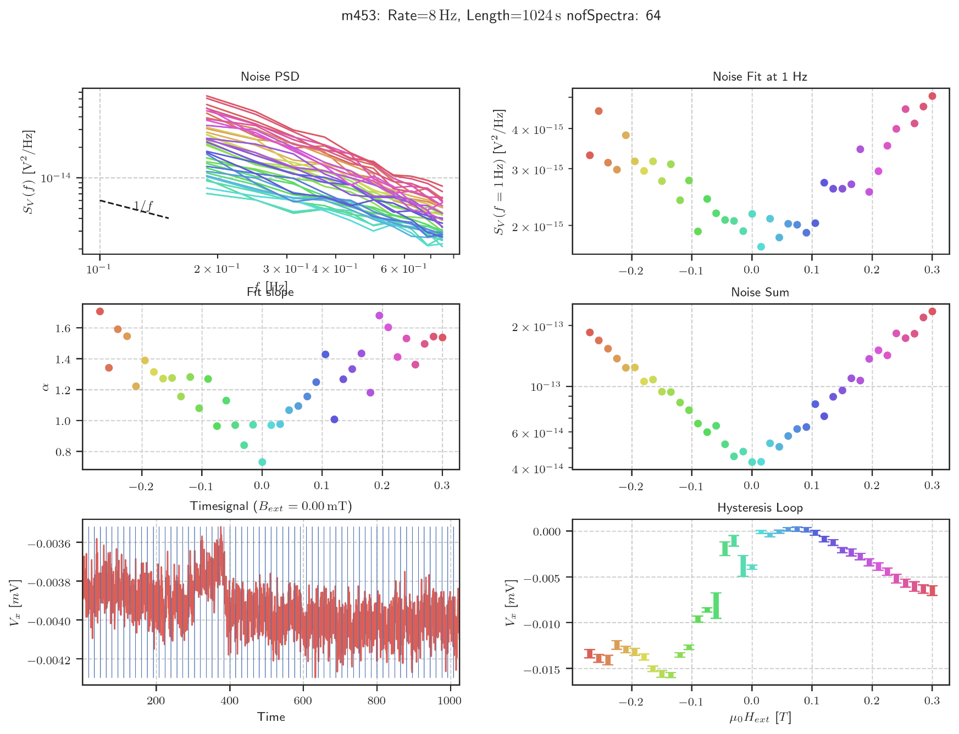

Contour Plot Info

Samstag, 16. Mai 2020

19:34

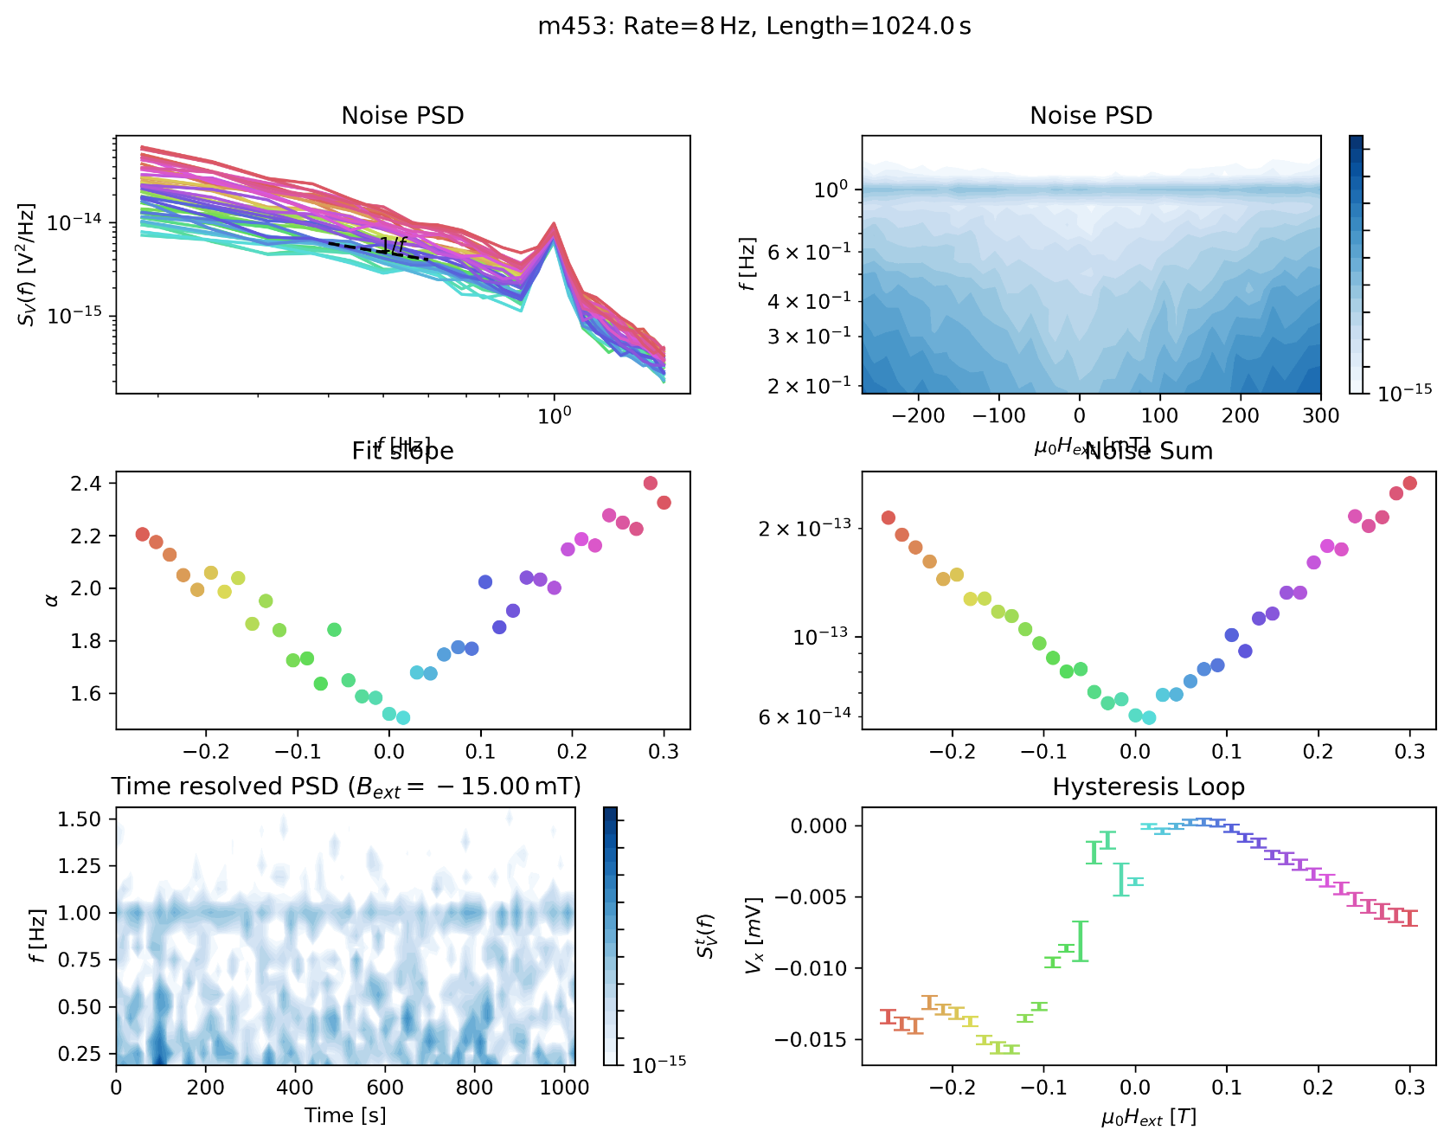

Second Spectrum

Mittwoch, 22. April 2020

16:07

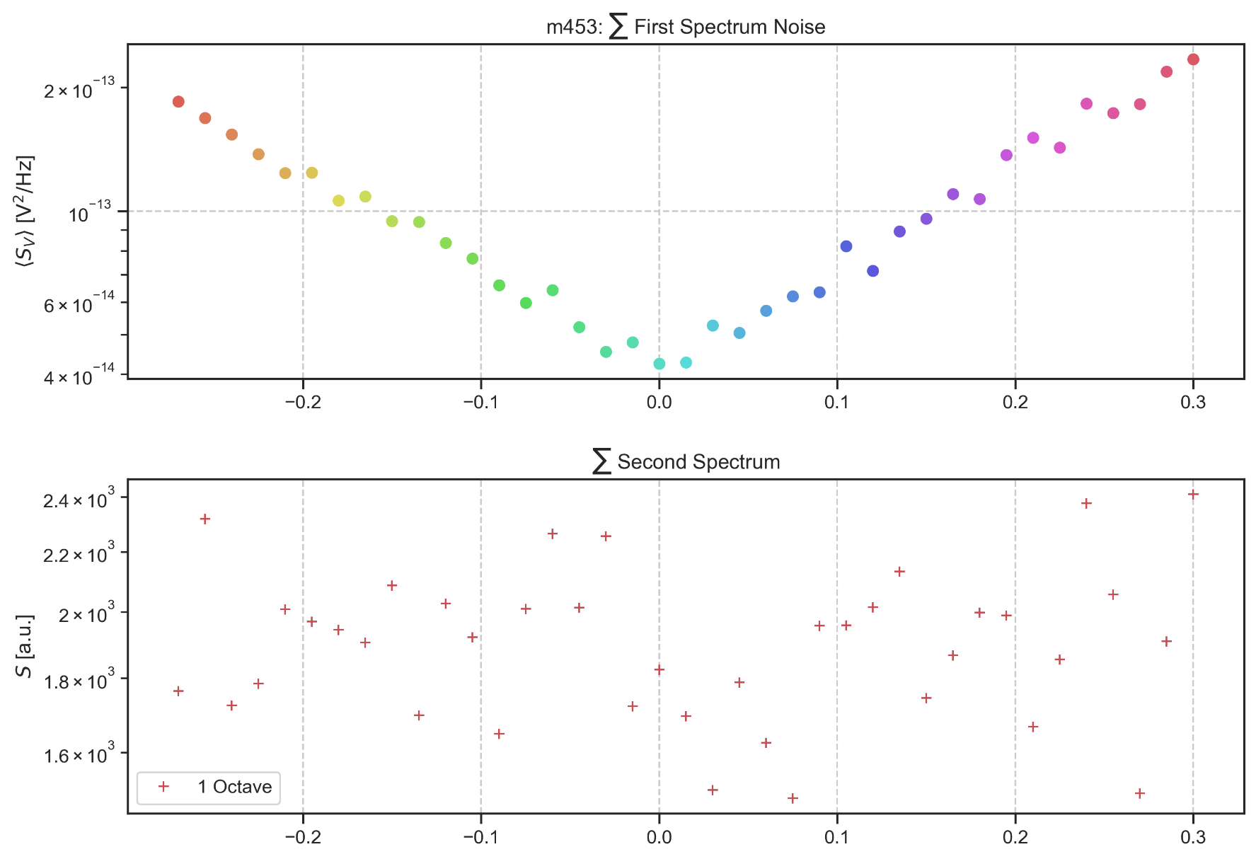

Noise Hysteresis

Mittwoch, 22. April 2020

16:04

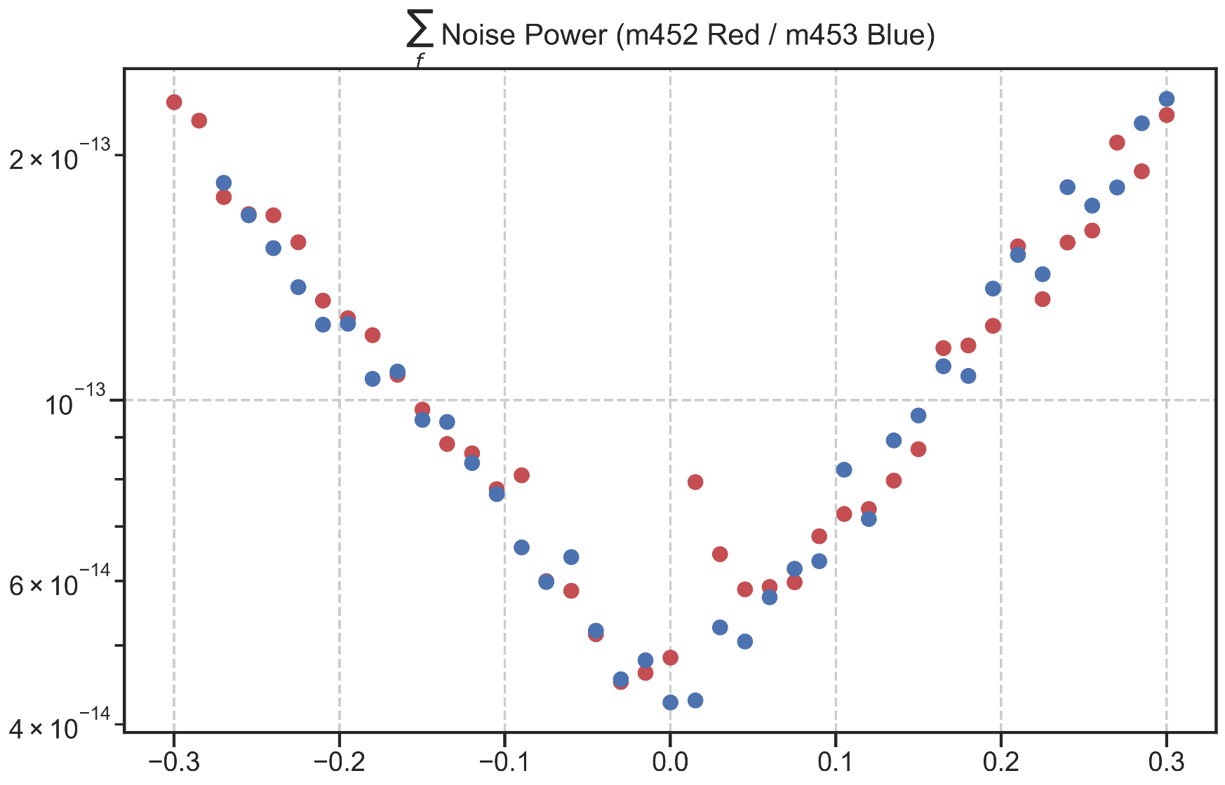

m454: rate:8 Hz 2048s Down (15K)

Freitag, 10. April 2020

10:51

|  |  |
| --- | --- |
| Angle of sensor θ | *+80* |
| Temp | 15 K |
|  | **Plusses** |
|  | |  |  |  |  | | --- | --- | --- | --- | |  | ***13-1*** |  | *6-8* | | ***Gate (0V)*** | ***9 - 4*** |  | ***7 - 14 (No Preamp)*** | |
|  | *Saturating at 0.5T sweeping from 100mT → 100mT*  *measuring every 5mT steps (41 different steps)* |
| Resistance Box | |  |  |  |  |  |  | | --- | --- | --- | --- | --- | --- | |  | *1 MΩ* |  | 15 |  |  | |  | *1 MΩ* |  | *7* |  | *1* | |
|  | |  |  |  |  |  |  | | --- | --- | --- | --- | --- | --- | | Sens | 50 μV |  | 5 V | *f* | *17 Hz* | | *τ* | *100 ms* | *Input A* | *AC* | *Ground* | *Normal Reserve* |   *DAQ settings: Rate: 8 Hz* |
| Period of measurement (min) | *2048 sec for each field* |
| Comment |  |

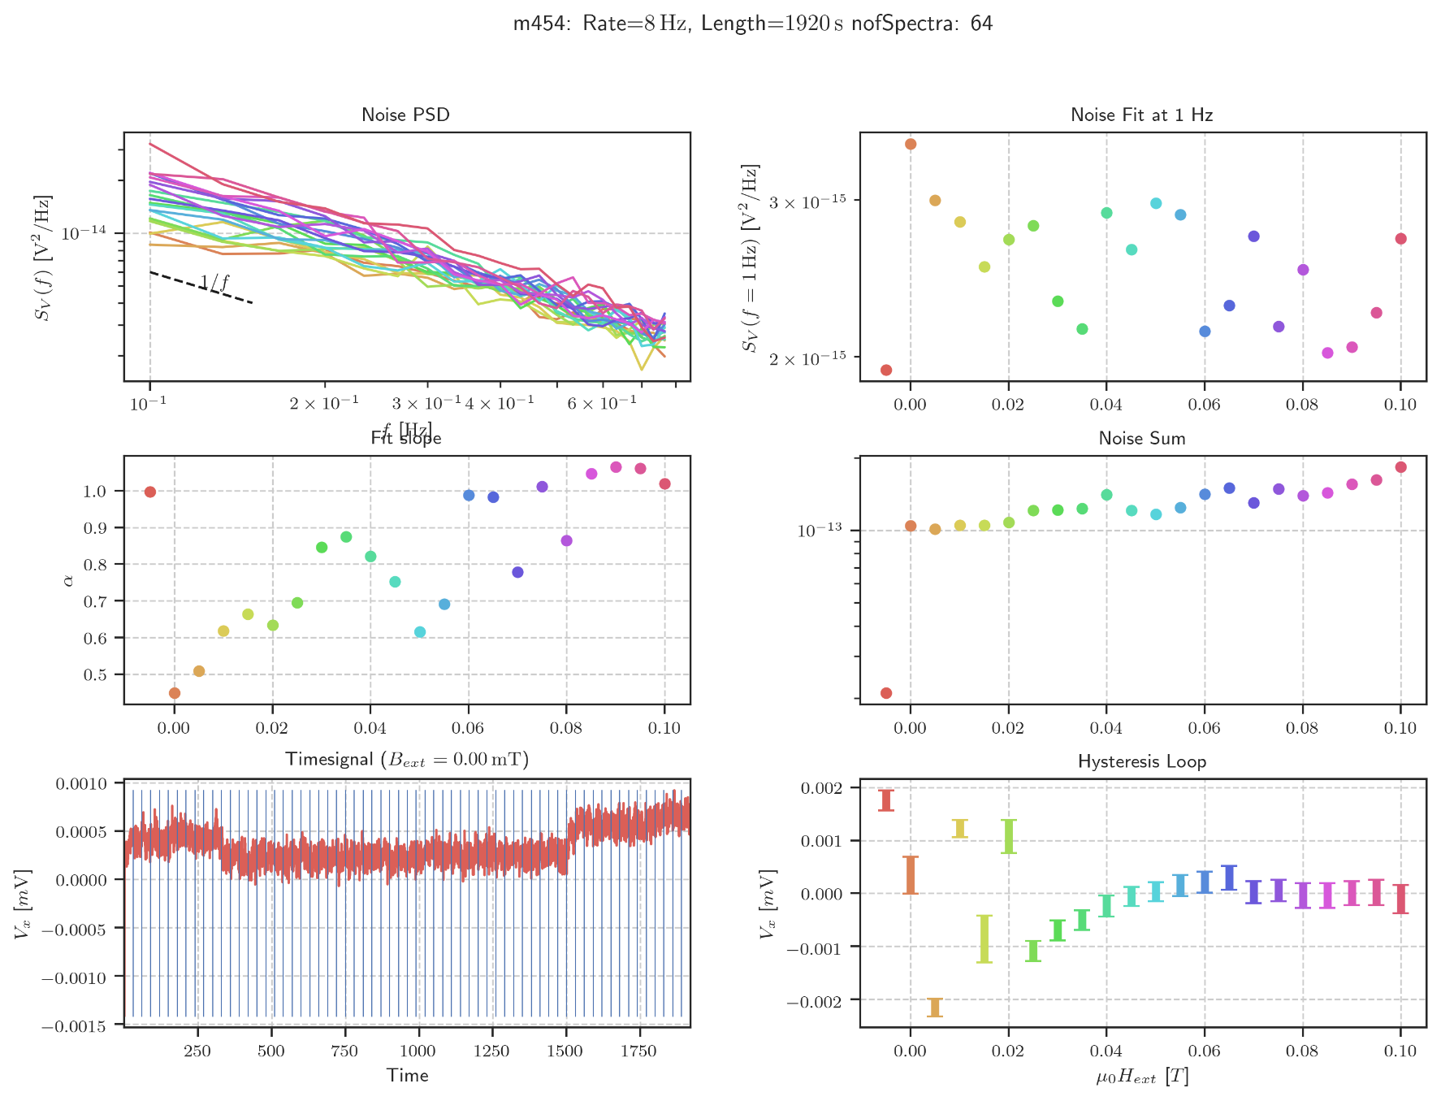

Error Measurement Length

Mittwoch, 22. April 2020

15:37

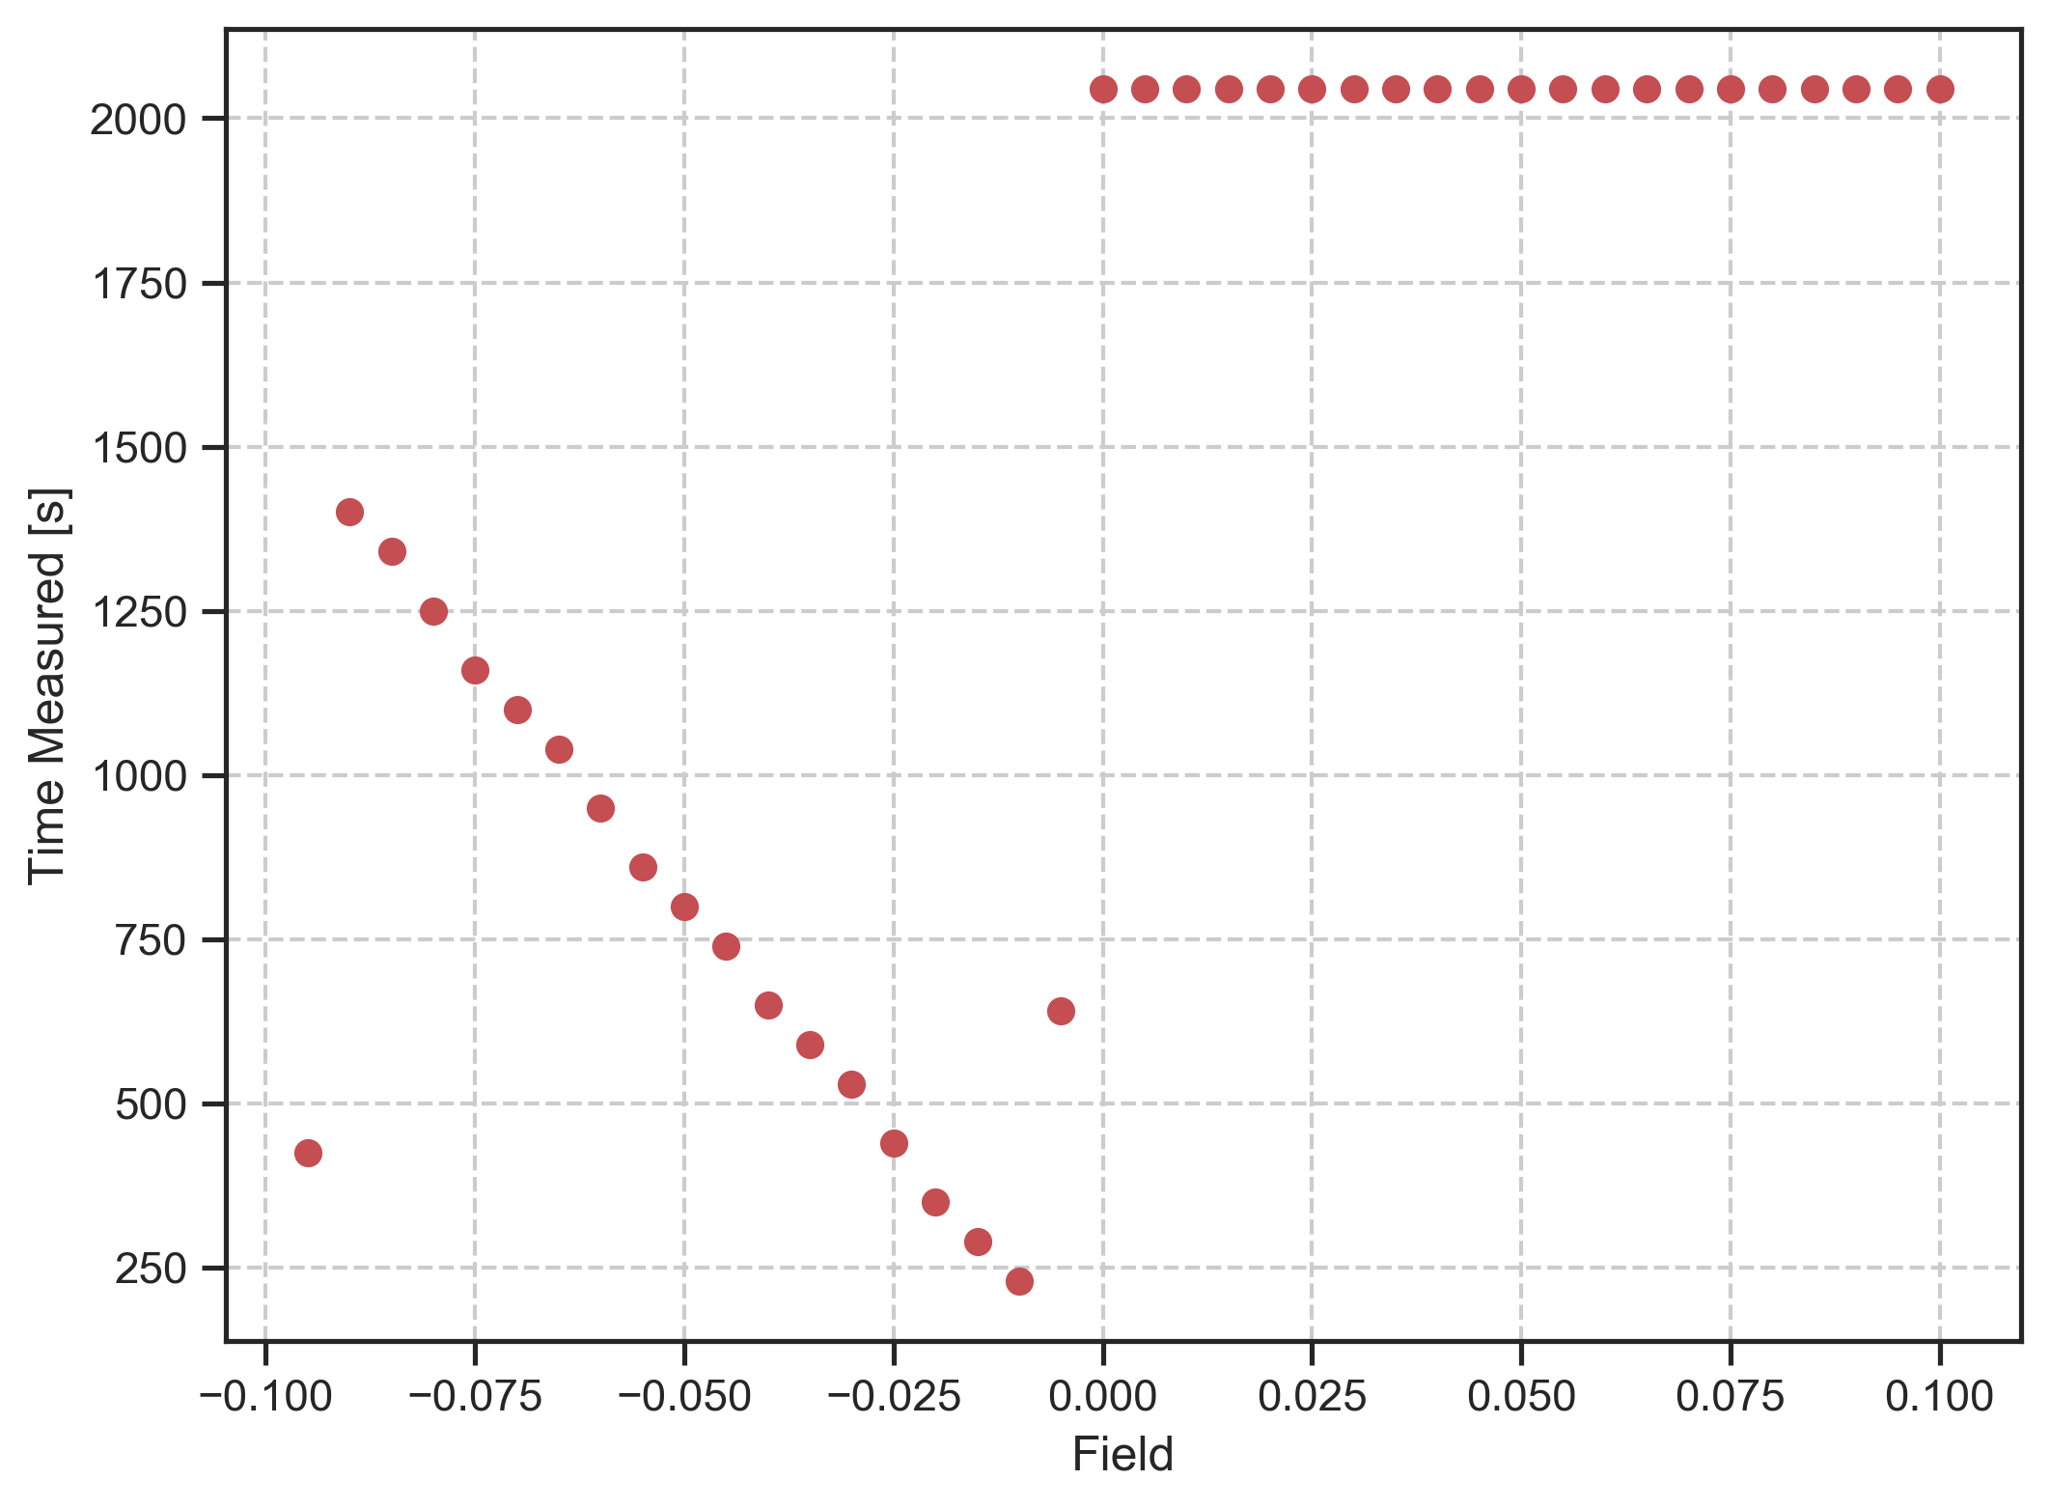

m455: rate:8 Hz 2048s Up (15K)

Freitag, 10. April 2020

10:52

|  |  |
| --- | --- |
| Angle of sensor θ | *+80* |
| Temp | 15 K |
|  | **Plusses** |
|  | |  |  |  |  | | --- | --- | --- | --- | |  | ***13-1*** |  | *6-8* | | ***Gate (0V)*** | ***9 - 4*** |  | ***7 - 14 (No Preamp)*** | |
|  | *Saturating at -0.5T sweeping from -150mT → 150mT*  *measuring every 5mT steps (61 different steps)* |
| Resistance Box | |  |  |  |  |  |  | | --- | --- | --- | --- | --- | --- | |  | *1 MΩ* |  | 15 |  |  | |  | *1 MΩ* |  | *7* |  | *1* | |
|  | |  |  |  |  |  |  | | --- | --- | --- | --- | --- | --- | | Sens | 50 μV |  | 5 V | *f* | *17 Hz* | | *τ* | *100 ms* | *Input A* | *AC* | *Ground* | *Normal Reserve* |   *DAQ settings: Rate: 8 Hz* |
| Period of measurement (min) | *2048 sec for each field* |
| Comment |  |

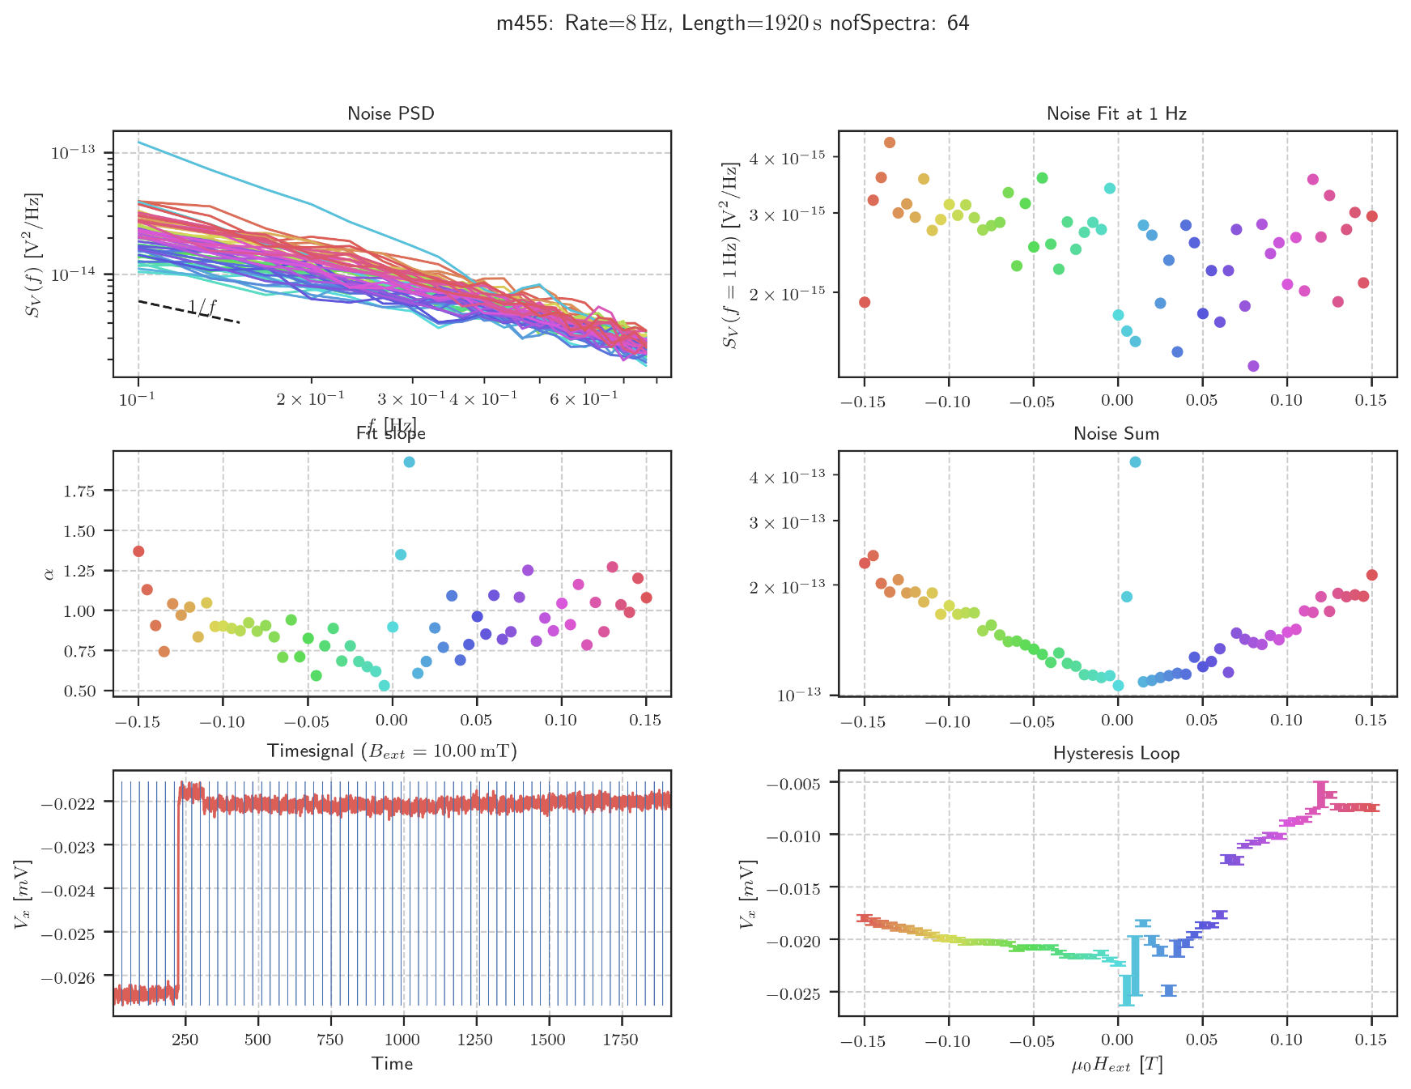

m456: rate:8 Hz multiple 2048s at 0 T

Freitag, 10. April 2020

10:53

|  |  |
| --- | --- |
| Angle of sensor θ | *+80* |
| Temp | 15 K |
|  | **Plusses** |
|  | |  |  |  |  | | --- | --- | --- | --- | |  | ***13-1*** |  | *6-8* | | ***Gate (0V)*** | ***9 - 4*** |  | ***7 - 14 (No Preamp)*** | |
|  | *Turn off magnet to save helium. Measuring while warming up.* |
| Resistance Box | |  |  |  |  |  |  | | --- | --- | --- | --- | --- | --- | |  | *1 MΩ* |  | 15 |  |  | |  | *1 MΩ* |  | *7* |  | *1* | |
|  | |  |  |  |  |  |  | | --- | --- | --- | --- | --- | --- | | Sens | 50 μV |  | 5 V | *f* | *17 Hz* | | *τ* | *100 ms* | *Input A* | *AC* | *Ground* | *Normal Reserve* |   *DAQ settings: Rate: 8 Hz* |
| Period of measurement (min) | *2048 sec for each file times 61 Files = around 35 Hours!!!* |

Slope (alpha):        0.742  
Intercept:        2.8610e-15  
Sum of Noise:        3.0521e-11

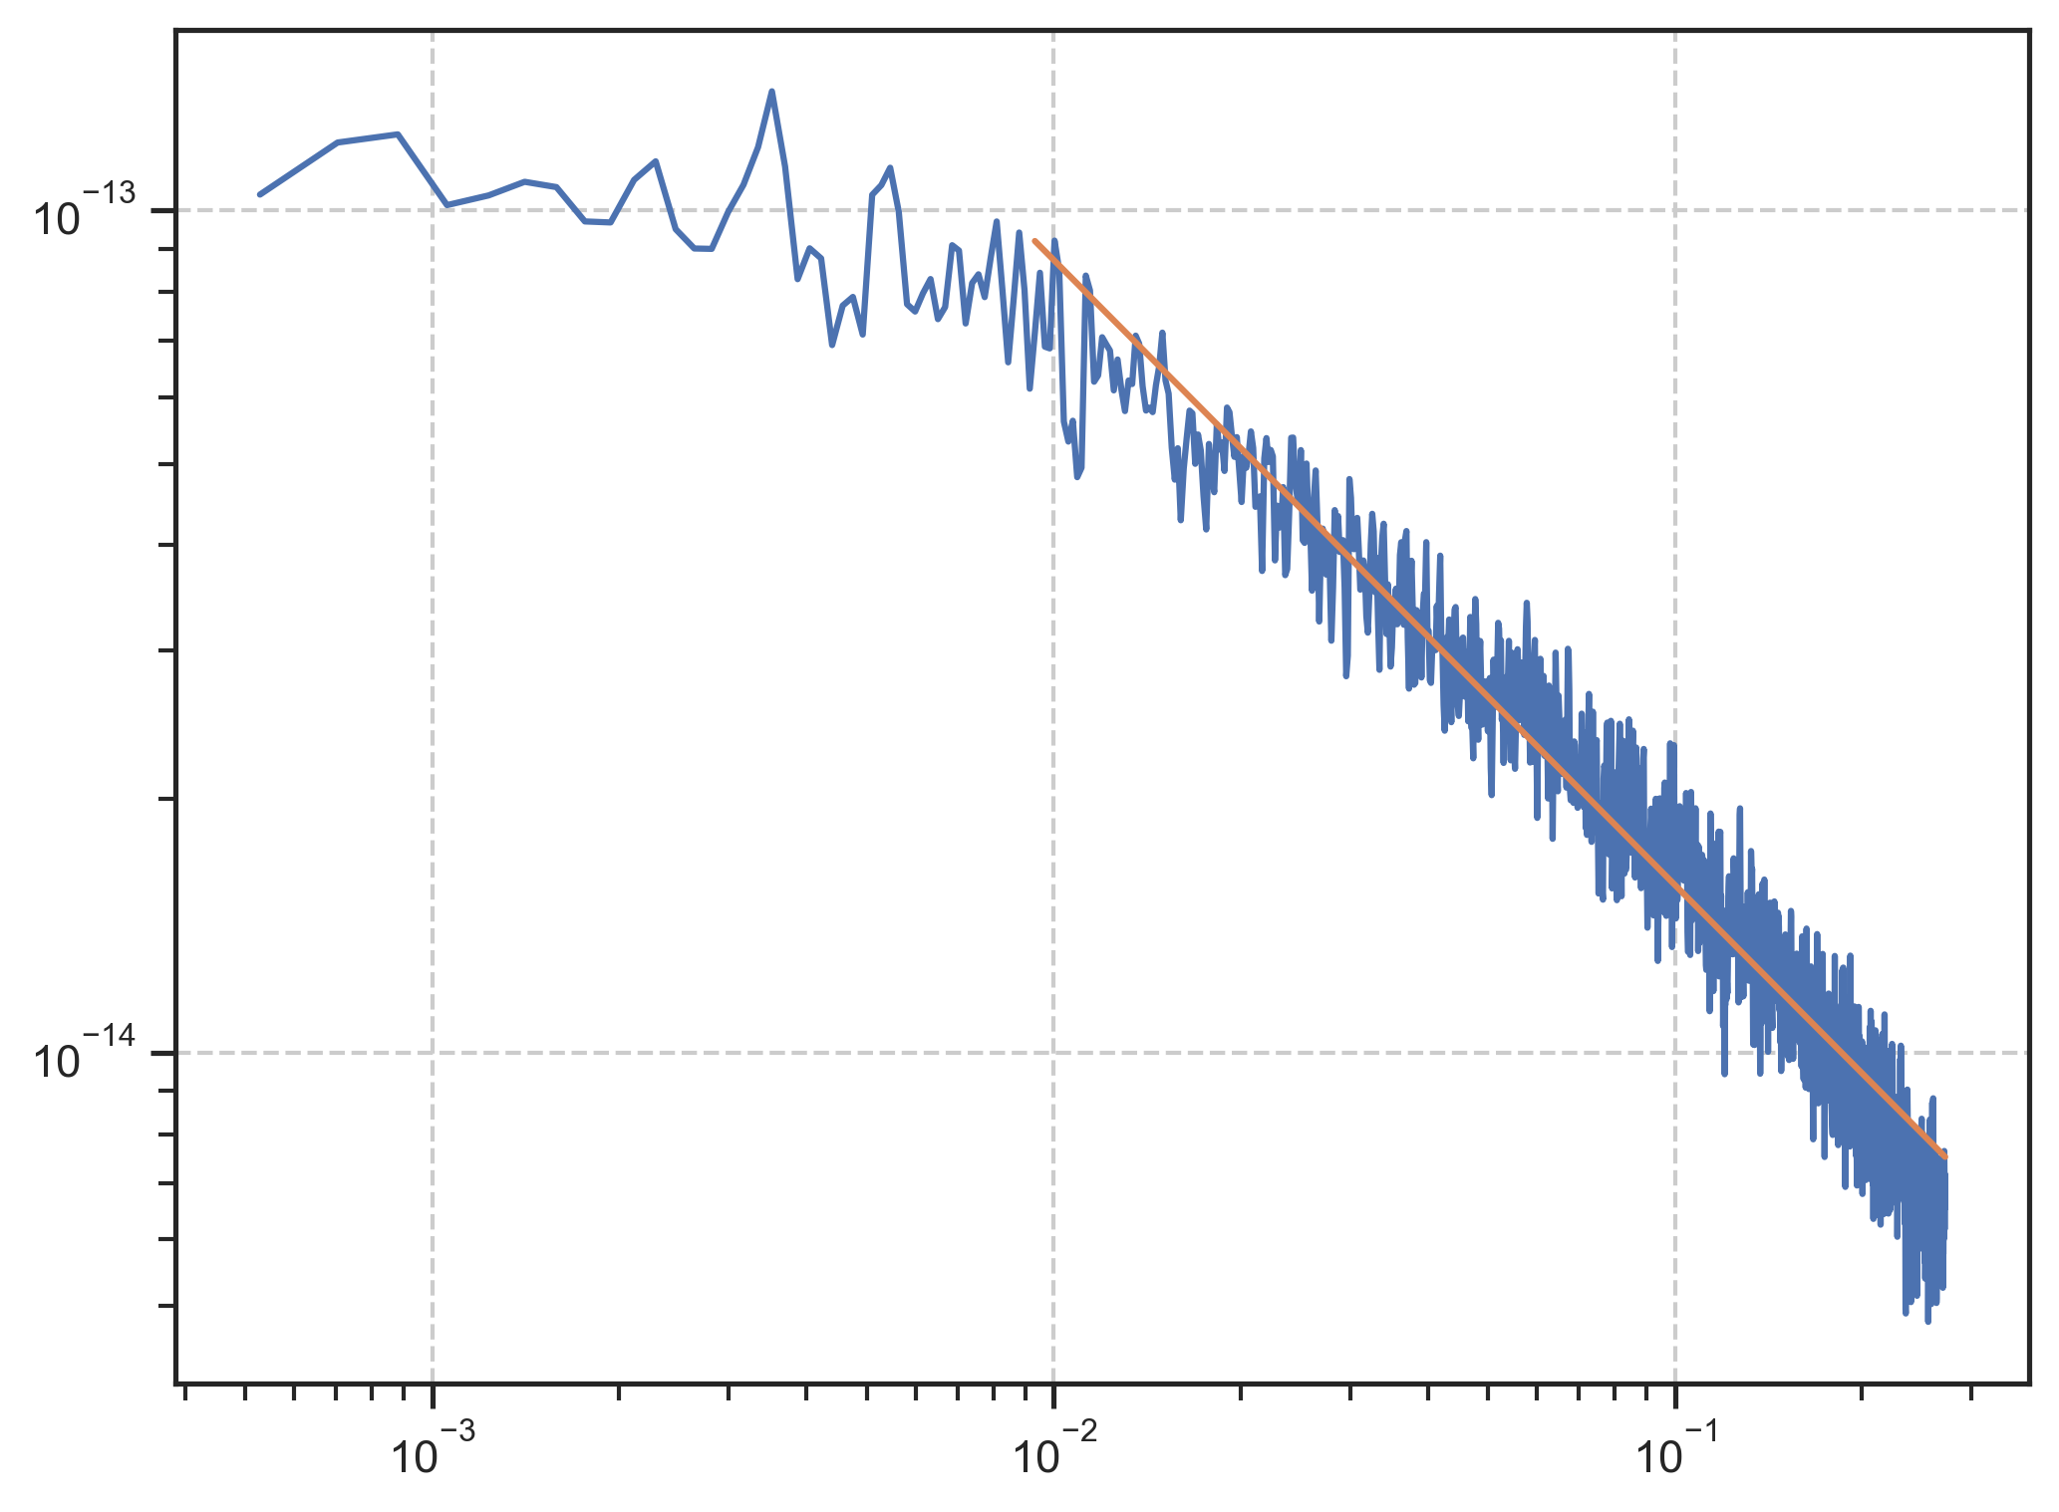

Histogram (Gaussian Data)

Dienstag, 21. April 2020

15:49

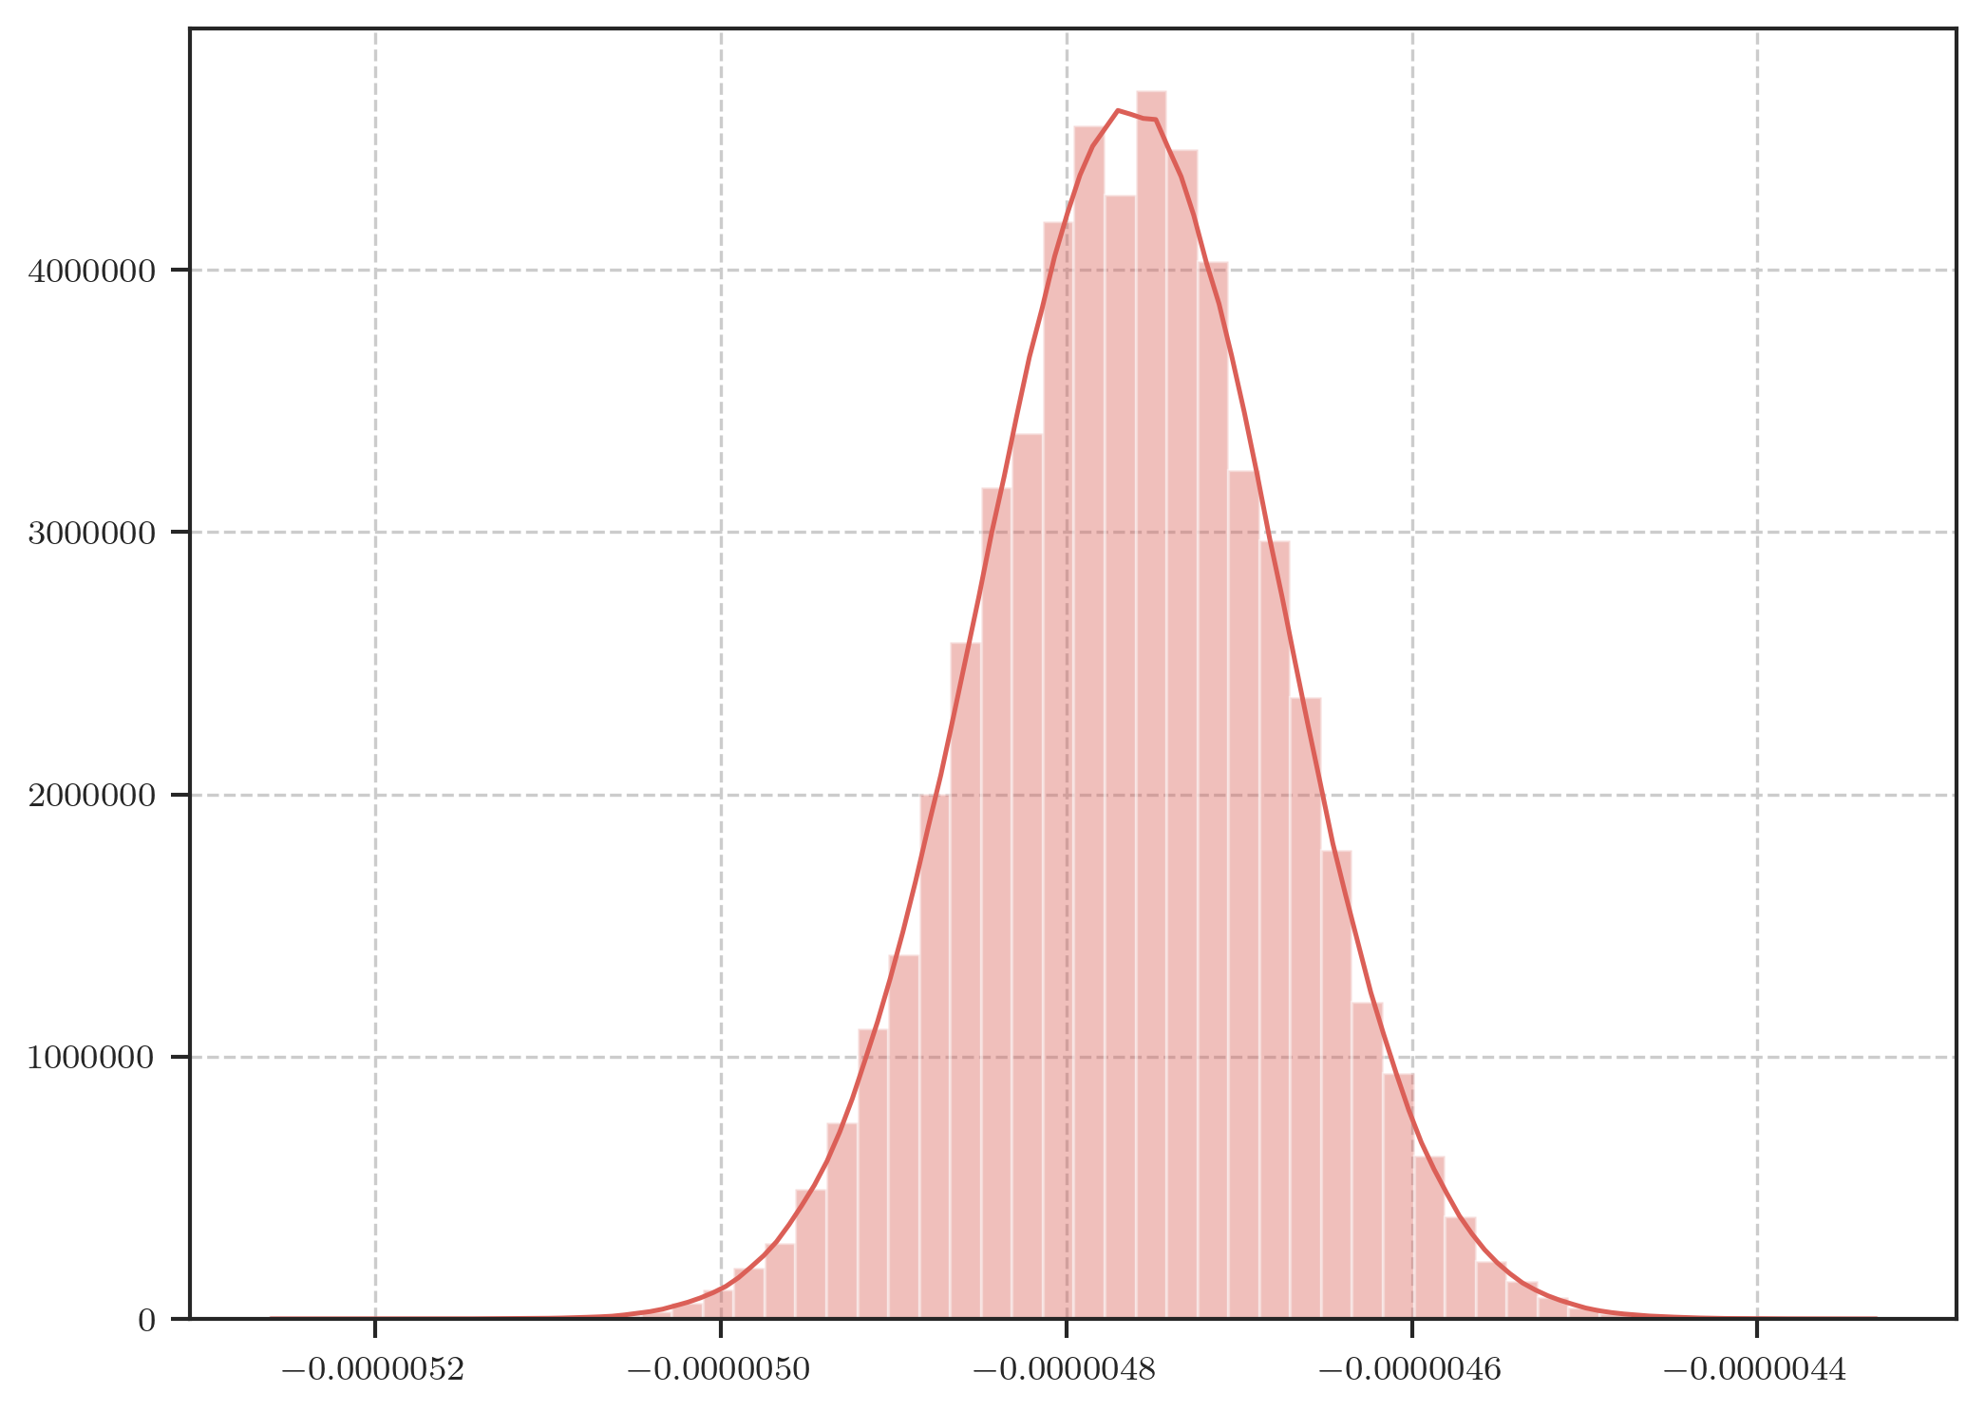

Second Spectrum

Mittwoch, 22. April 2020

16:46

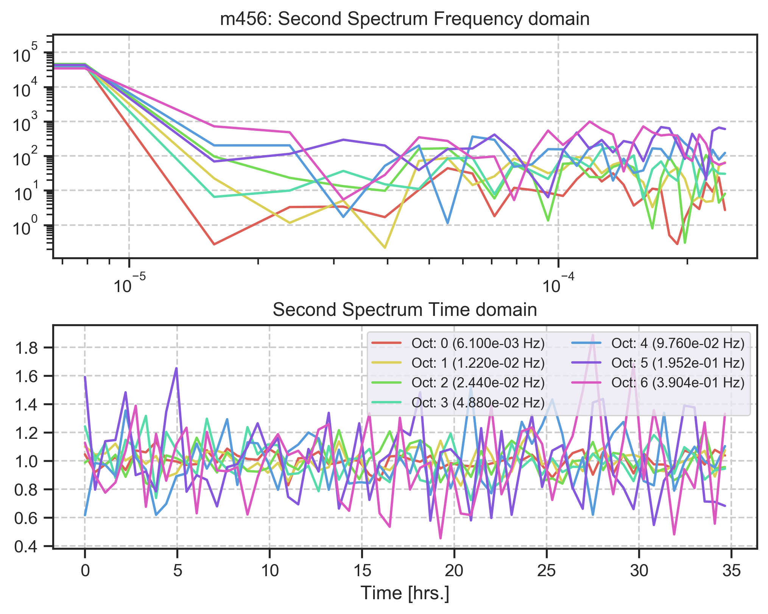

Analysis

Sonntag, 17. Mai 2020

14:01

45deg Plusses

Dienstag, 19. Mai 2020

15:34

8 Hz

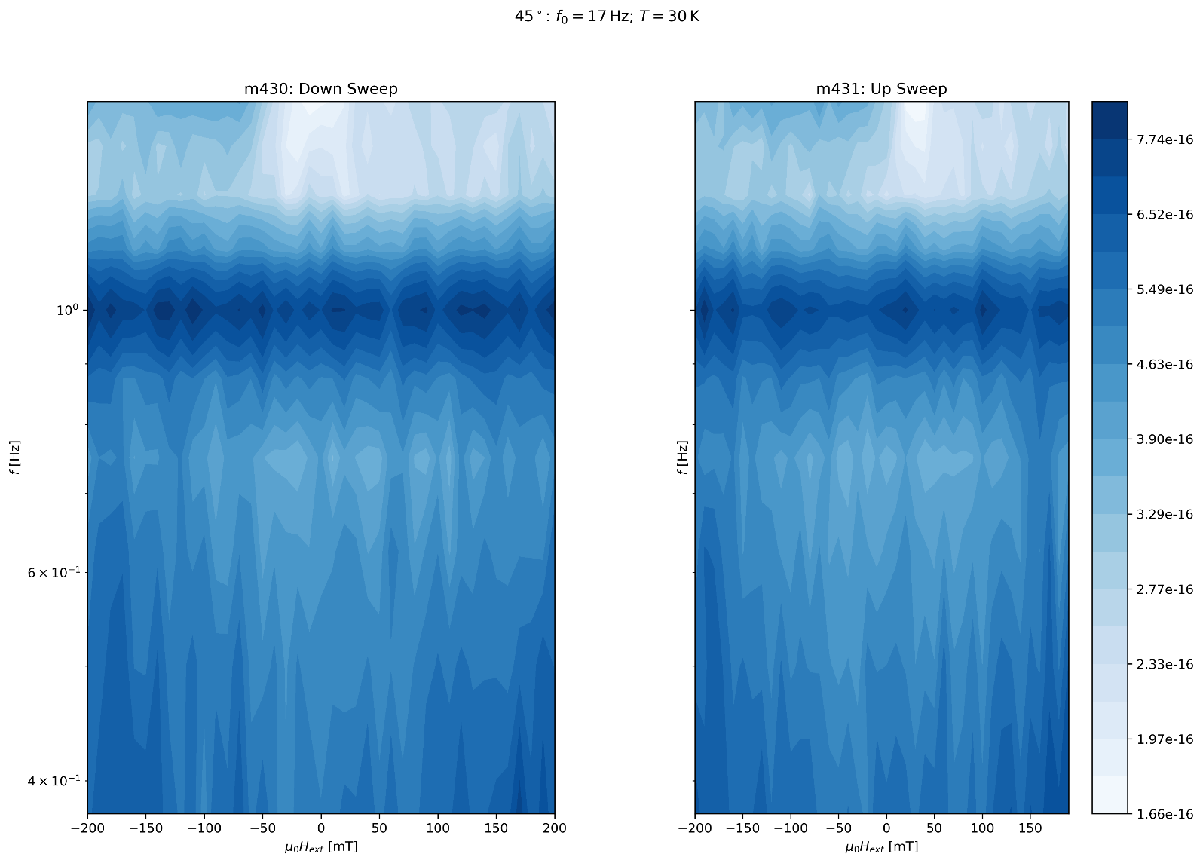

Sonntag, 17. Mai 2020

14:01

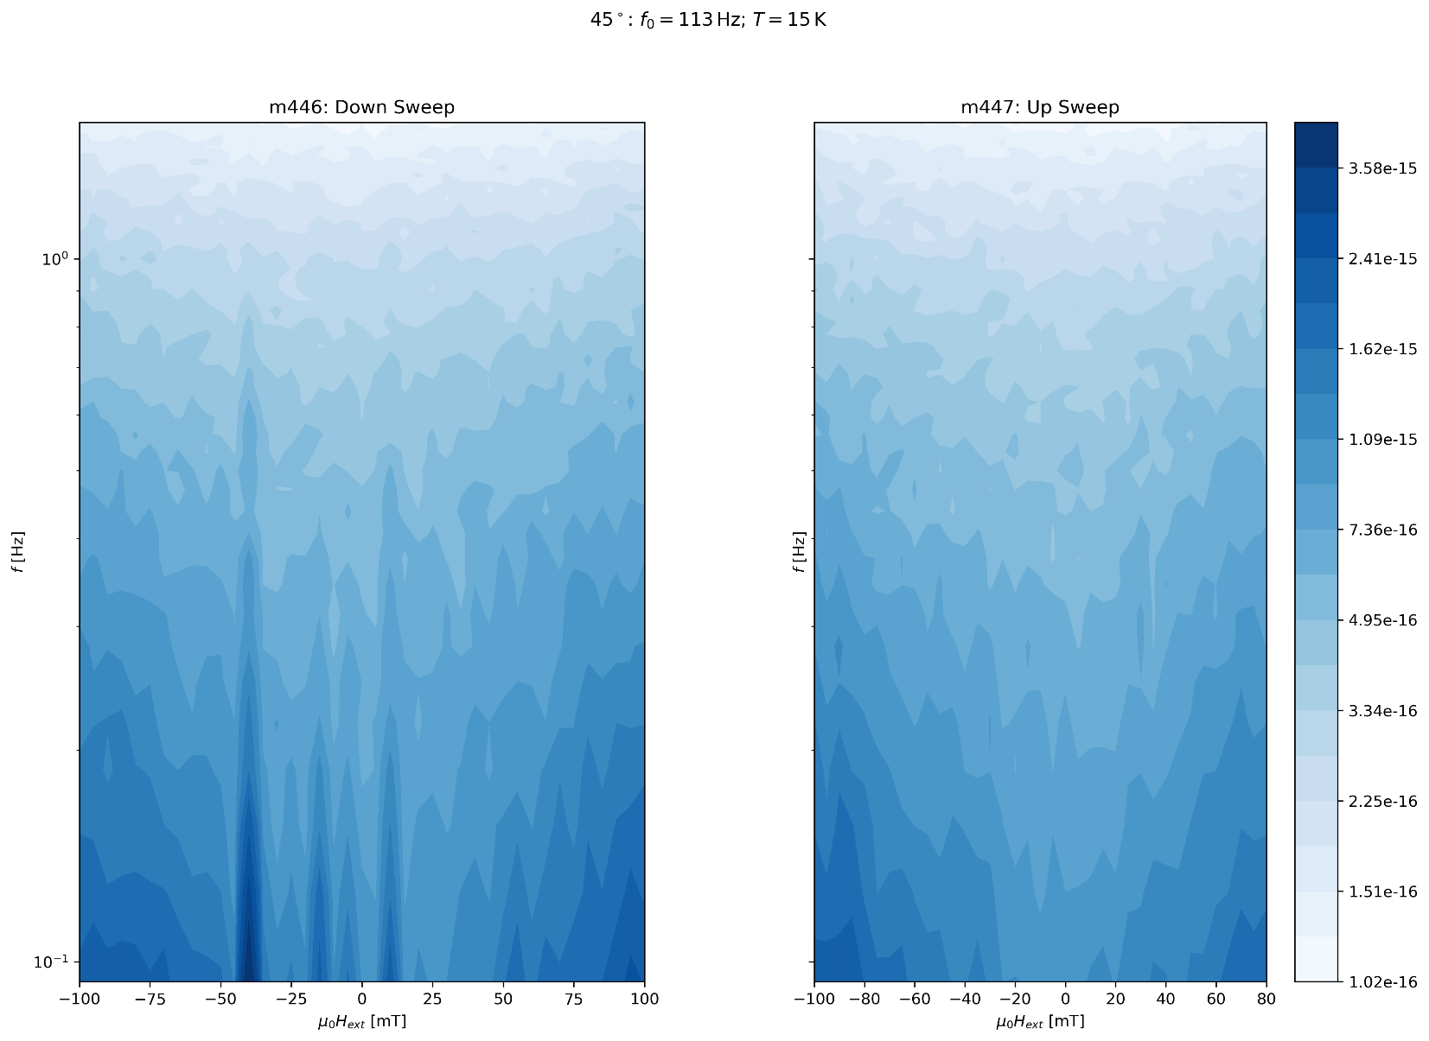

32 Hz

Dienstag, 19. Mai 2020

15:36

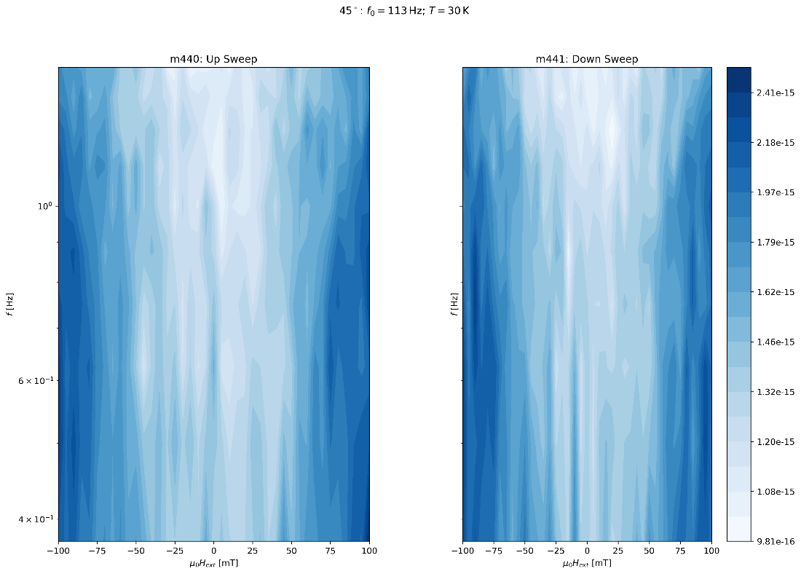

Empty Background 45deg (450/451)

Dienstag, 19. Mai 2020

09:51

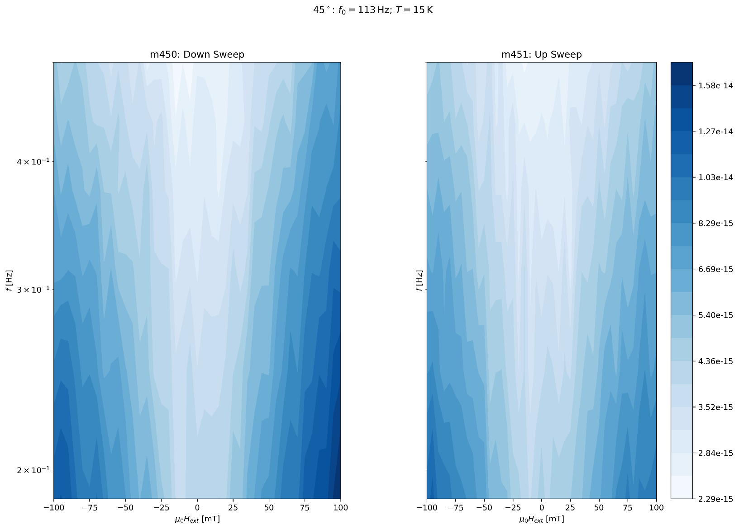

80deg wide sweep (452/453)

Dienstag, 19. Mai 2020

09:50

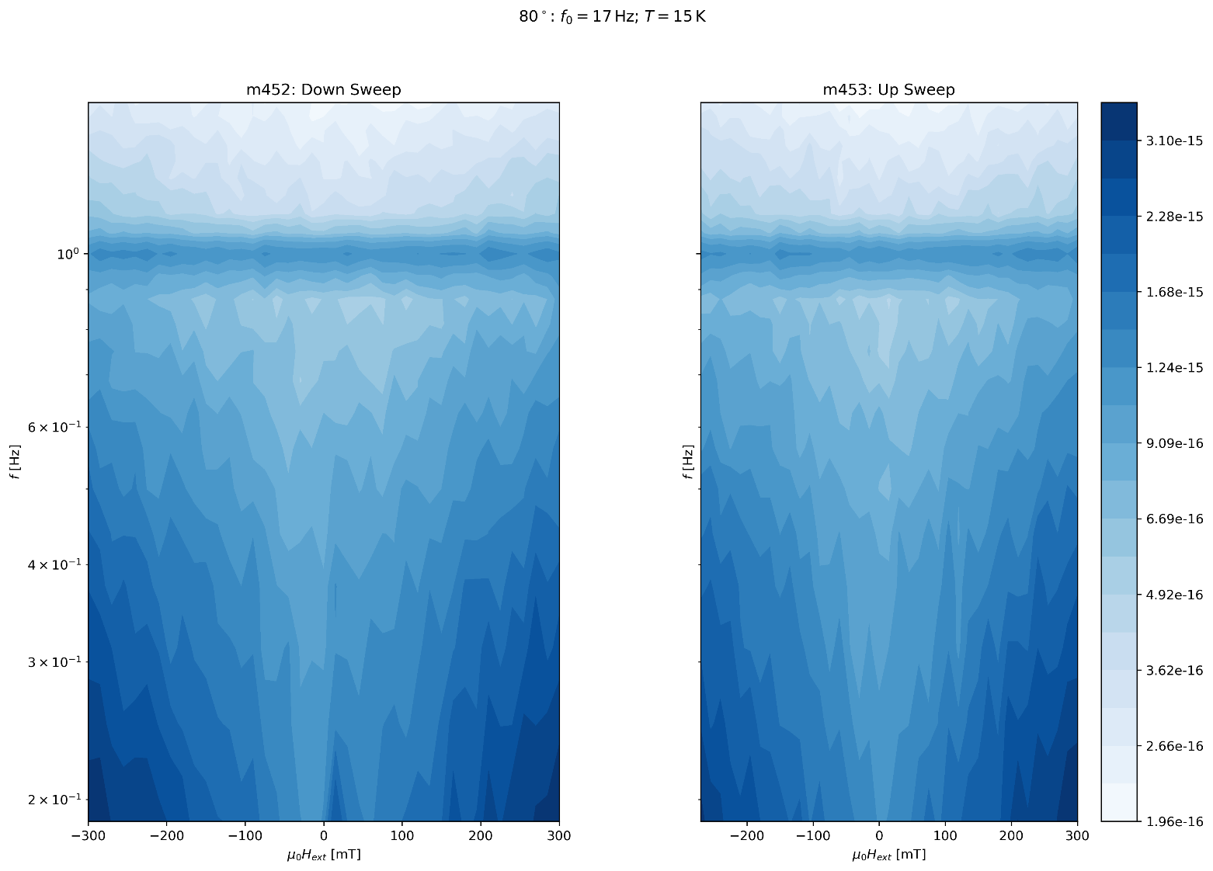

m458: rate:8 Hz 2048s Down (15K)

Samstag, 20. Juni 2020

13:14

|  |  |
| --- | --- |
| Angle of sensor θ | *+80* |
| Temp | 15 K |
|  | **Plusses** |
|  | |  |  |  |  | | --- | --- | --- | --- | |  | ***13-1*** |  | *6-8* | | ***Gate (0V)*** | ***9 - 4*** |  | ***7 - 14 (No Preamp)*** | |
|  | *Saturating at 0.4T sweeping from 100mT → -100mT*  *measuring every 5mT steps (41 different steps)* |
| Resistance Box | |  |  |  |  |  |  | | --- | --- | --- | --- | --- | --- | |  | *1 MΩ* |  | 15 |  |  | |  | *1 MΩ* |  | *7* |  | *1* | |
|  | |  |  |  |  |  |  | | --- | --- | --- | --- | --- | --- | | Sens | 100 μV |  | 5 V | *f* | *17 Hz* | | *τ* | *100 ms* | *Input A* | *AC* | *Ground* | *Normal Reserve* |   *DAQ settings: Rate: 8 Hz* |
| Period of measurement (min) | *2048 sec for each field* |
| Comment |  |

m459: rate:8 Hz 2048s Up (15K)

Samstag, 20. Juni 2020

13:14

|  |  |
| --- | --- |
| Angle of sensor θ | *+80* |
| Temp | 15 K |
|  | **Plusses** |
|  | |  |  |  |  | | --- | --- | --- | --- | |  | ***13-1*** |  | *6-8* | | ***Gate (0V)*** | ***9 - 4*** |  | ***7 - 14 (No Preamp)*** | |
|  | *Saturating at 0.4T sweeping from 100mT → -100mT*  *measuring every 5mT steps (41 different steps)* |
| Resistance Box | |  |  |  |  |  |  | | --- | --- | --- | --- | --- | --- | |  | *1 MΩ* |  | 15 |  |  | |  | *1 MΩ* |  | *7* |  | *1* | |
|  | |  |  |  |  |  |  | | --- | --- | --- | --- | --- | --- | | Sens | 100 μV |  | 5 V | *f* | *17 Hz* | | *τ* | *100 ms* | *Input A* | *AC* | *Ground* | *Normal Reserve* |   *DAQ settings: Rate: 8 Hz* |
| Period of measurement (min) | *2048 sec for each field* |
| Comment |  |

m460: rate:8 Hz 2048s Down (15K)

Samstag, 27. Juni 2020

12:00

|  |  |
| --- | --- |
| Angle of sensor θ | *+80* |
| Temp | 15 K |
|  | **Plusses** |
|  | |  |  |  |  | | --- | --- | --- | --- | |  | ***13-1*** |  | *6-8* | | ***Gate (0V)*** | ***9 - 4*** |  | ***7 - 14 (No Preamp)*** | |
|  | *Saturating at 0.5T sweeping from 100mT → 100mT*  *measuring every 5mT steps (41 different steps)* |
| Resistance Box | |  |  |  |  |  |  | | --- | --- | --- | --- | --- | --- | |  | *1 MΩ* |  | 15 |  |  | |  | *1 MΩ* |  | *7* |  | *1* | |
|  | |  |  |  |  |  |  | | --- | --- | --- | --- | --- | --- | | Sens | 100 μV |  | 5 V | *f* | *17 Hz* | | *τ* | *30 ms* | *Input A* | *AC* | *Ground* | *Normal Reserve* |   *DAQ settings: Rate: 8 Hz* |
| Period of measurement (min) | *2048 sec for each field* |
| Comment |  |

m461: rate:8 Hz 2048s Up (15K)

Samstag, 27. Juni 2020

12:00

|  |  |
| --- | --- |
| Angle of sensor θ | *+80* |
| Temp | 15 K |
|  | **Plusses** |
|  | |  |  |  |  | | --- | --- | --- | --- | |  | ***13-1*** |  | *6-8* | | ***Gate (0V)*** | ***9 - 4*** |  | ***7 - 14 (No Preamp)*** | |
|  | *Saturating at 0.5T sweeping from 100mT → 100mT*  *measuring every 5mT steps (41 different steps)* |
| Resistance Box | |  |  |  |  |  |  | | --- | --- | --- | --- | --- | --- | |  | *1 MΩ* |  | 15 |  |  | |  | *1 MΩ* |  | *7* |  | *1* | |
|  | |  |  |  |  |  |  | | --- | --- | --- | --- | --- | --- | | Sens | 100 μV |  | 5 V | *f* | *17 Hz* | | *τ* | *30 ms* | *Input A* | *AC* | *Ground* | *Normal Reserve* |   *DAQ settings: Rate: 8 Hz* |
| Period of measurement (min) | *2048 sec for each field* |
| Comment |  |

m462: rate:8 Hz 2048s Down (15K)

Samstag, 27. Juni 2020

12:00

|  |  |
| --- | --- |
| Angle of sensor θ | *+80* |
| Temp | 15 K |
|  | **Plusses** |
|  | |  |  |  |  | | --- | --- | --- | --- | |  | ***13-1*** |  | *6-8* | | ***Gate (0V)*** | ***9 - 4*** |  | ***7 - 14 (No Preamp)*** | |
|  | *Saturating at 0.5T sweeping from 100mT → 100mT*  *measuring every 5mT steps (41 different steps)* |
| Resistance Box | |  |  |  |  |  |  | | --- | --- | --- | --- | --- | --- | |  | *1 MΩ* |  | 15 |  |  | |  | *1 MΩ* |  | *7* |  | *1* | |
|  | |  |  |  |  |  |  | | --- | --- | --- | --- | --- | --- | | Sens | 100 μV |  | 5 V | *f* | *17 Hz* | | *τ* | *30 ms* | *Input A* | *AC* | *Ground* | *Normal Reserve* |   *DAQ settings: Rate: 8 Hz* |
| Period of measurement (min) | *2048 sec for each field* |
| Comment |  |